

Requirement & Design Specification

**ONLINE LEARNING SYSTEM (LearnGo)**

**Version: 1.0**

– Hanoi, February 2025 –

# 

# Record of Changes

| **Version** | **Date** | **A* M, D** | **In charge** | **Change Description** |
| --- | --- | --- | --- | --- |
| V1.0 |  |  |  |  |
|  |  |  |  |  |
|  |  |  |  |  |
|  |  |  |  |  |
|  |  |  |  |  |
|  |  |  |  |  |
|  |  |  |  |  |
|  |  |  |  |  |
|  |  |  |  |  |
|  |  |  |  |  |
|  |  |  |  |  |
|  |  |  |  |  |

*A - Added M - Modified D - Deleted

Contents

Record of Changes 2

I. Overview 6

1. System Context 6

2. User Requirements 6

2.1 Actors 6

2.2 Diagrams 7

2.3 Descriptions 11

2.4 Main Workflows 12

3. System Functionalities 12

3.1 Screens Flow 12

3.2 Screen Authorization 12

3.3 Non-UI Functions 14

II. Functional Requirements 15

1. Login 15

1.1 Admin login 15

1.2 User login 15

2. Register 16

3. Forgot password 19

4. Authorization 22

5. User profile 22

6. Course list (Admin) 23

7. Subject list (Admin) 24

8. User list (Admin) 25

9. Create User(Admin) 26

10. Update User (Admin) 27

11. User details (Admin) 28

12. Home page 29

13. Blog list (User) 31

14. Course list (User) 33

15. Blog details (User) 34

16. Admin dashboard 36

17. Quiz list (Admin) 37

18. Create quiz (Admin) 38

19. Update quiz (Admin) 39

20. List of students of a course (Admin) 40

21. Order list (Admin) 41

22. Course details (User) 42

23. Create subject 44

24. Create course 45

25. Create lessons 47

26. Update course 49

27. Question list 50

28. Course purchase 51

29. Lessons view 55

30. Update subject 57

31. Create question 58

32. Update question 59

33. Notifications (User) 60

34. Notifications details (User) 61

35. Notifications list (Admin) 62

36. Create notification 62

37. Notifications details (Admin) 64

38. Blog list (Admin) 65

39. Blog details (Admin) 66

40. Update blog 67

41. Create blog 68

42. AI Integration 69

43. Do quiz 71

44. Quiz review 72

45. Create/Update lessons 74

46. Rating a course 75

47. Create coupons 78

48. Update coupons 79

49. Coupons list(Admin) 80

50. Comment and like on blog 81

51. My order 82

52. Experts List (User) 83

53. My following experts (User) 84

54. My courses (User) 85

55. Course details (admin) 87

56. Course coupon (user) 88

57. List campaign (Admin) 89

58. Adding campaign (Admin) 90

59. Show campaign’s information (Admin) 91

60. Updating campaign (Admin) 92

**III. System Design 93**

1. Database Design 93

1.1 Database Schema 93

1.2 Table Descriptions 94

2. Code Packages 103

2.1 Package Diagram 103

2.2 Package Descriptions 104

# I. Overview

## 1. System Context

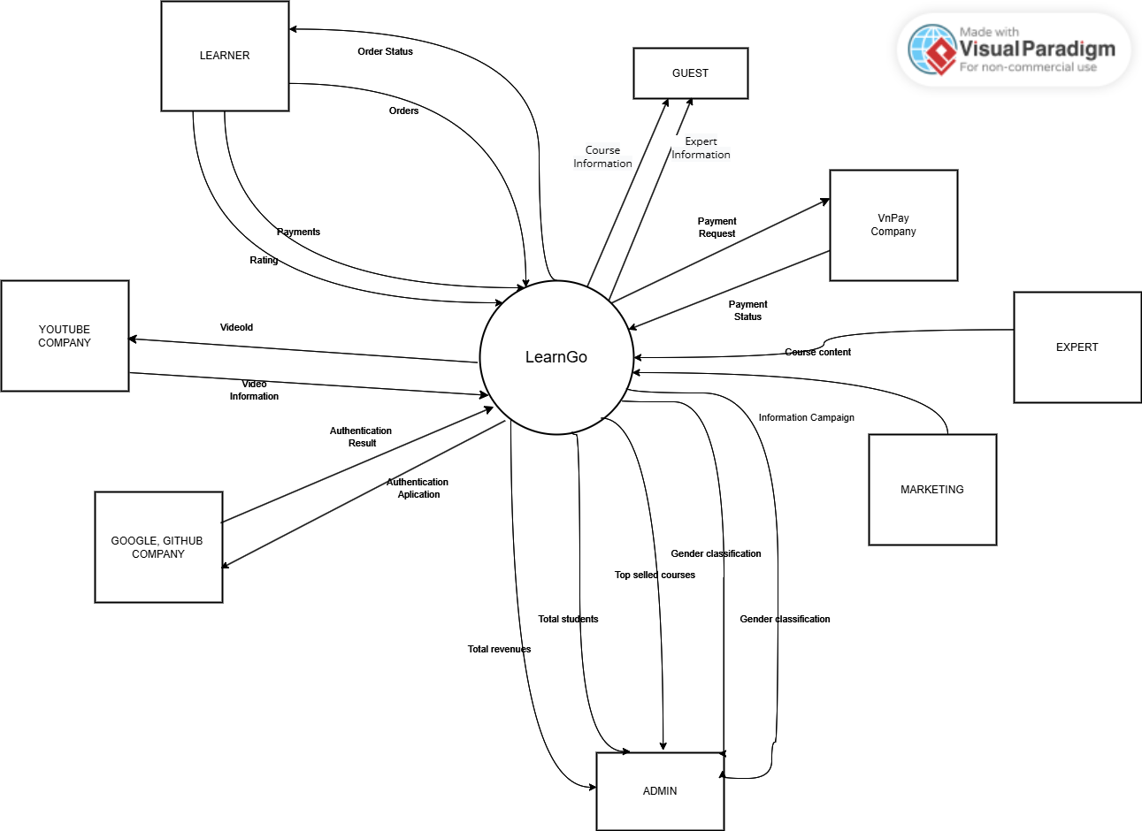

## 2. User Requirements

### 2.1 Actors

| **#** | **Actor** | **Description** |
| --- | --- | --- |
| 1 | Guest | Unsigned user |
| 2 | Expert | | Responsible for creating and publishing lectures and tests. | | --- | |
| 3 | Marketing | Manages blog content (adds, edits, deletes blogs), views statistics on blog views, likes, and comments. Edit price of the courses, replies user response, and give them code to unlock course. |
| 4 | Admin | Approves content posted by Expert, manages user information. This actor has the highest permission, this has full access to all system resources except some special feature like: create course, update course, delete course of e |
| 5 | Student | Students can view the home page, course/blog list, course/blog details, notifications, add course to the cart, purchase a course, like or comment in a blog, view/study course they purchased, complete lesson in course and see their progress. Student can follow an expert to get the notification about new course/blog when they created. They can also see their profiles, update profiles, course purchased,... |
| 6 | Youtube | Responsible for get duration of a video from youtube url. |
| 7 | VnPay | Responsible for payment. |
| 8 | Google,github | Responsible for login by users. |
| 9 | AI | Responsible for support user in learning |

### 2.2 Use Case Diagrams

#### 2.2.1 UCs for guest

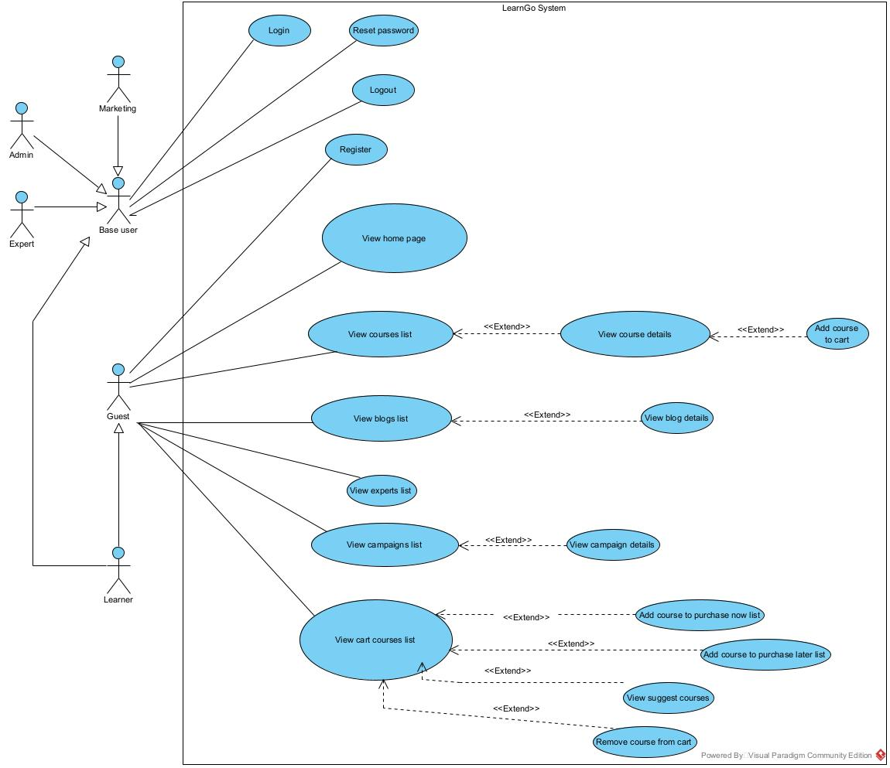

#### 2.2.2 UCs for learner

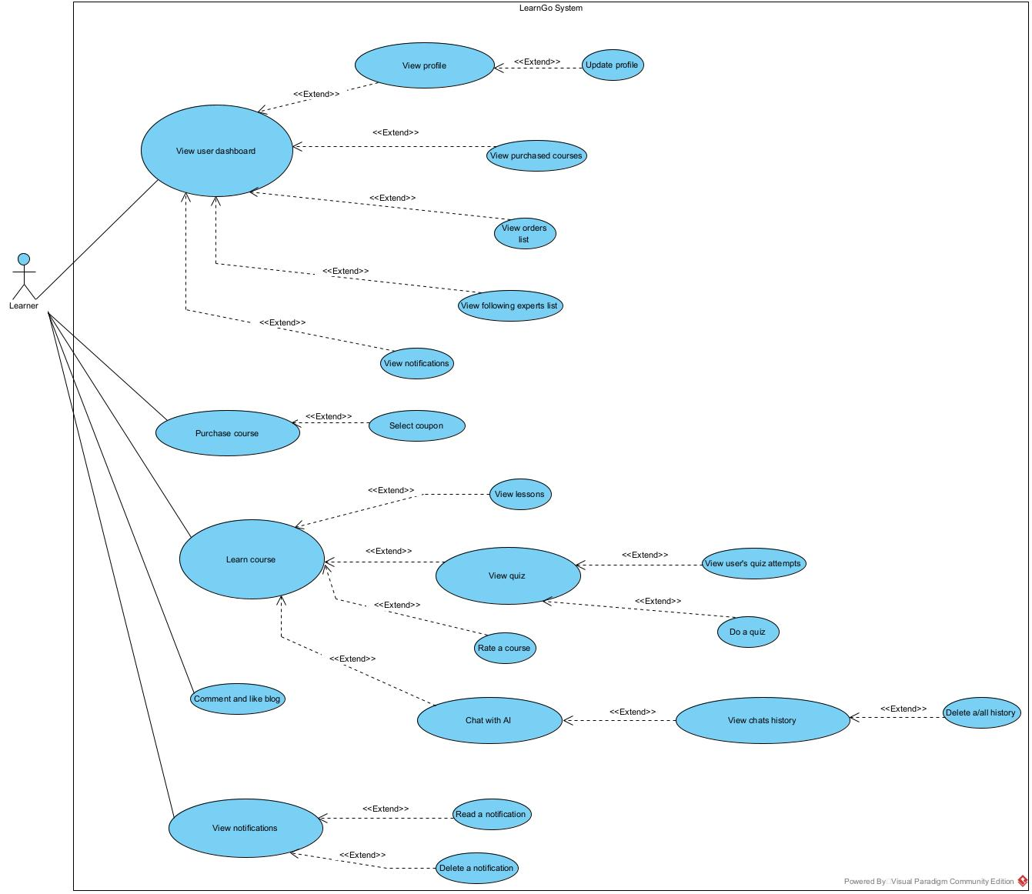

#### 2.2.3 UCs for marketing

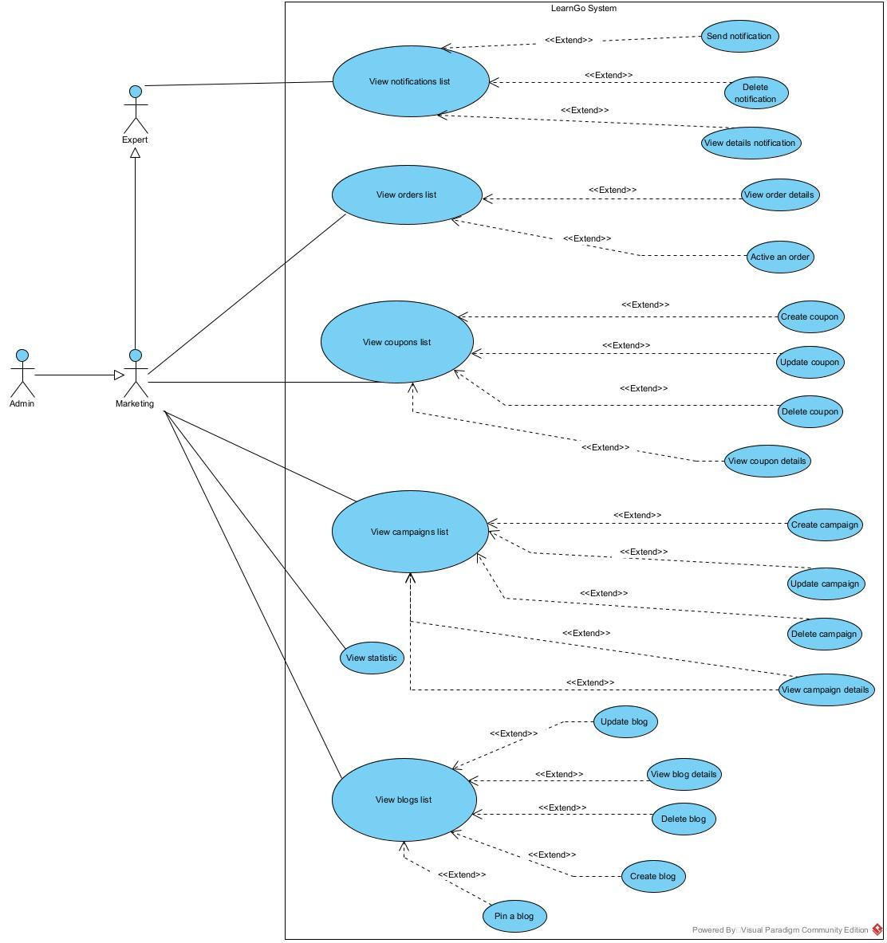

#### 2.2.4 UCs for expert

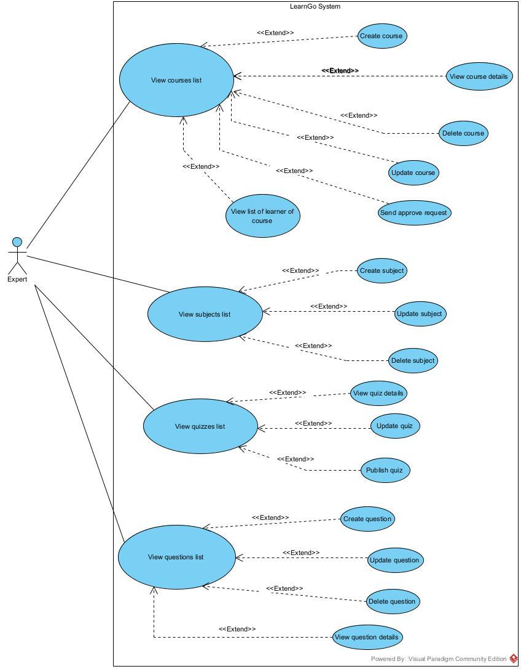

#### 2.2.5 UCs for admin

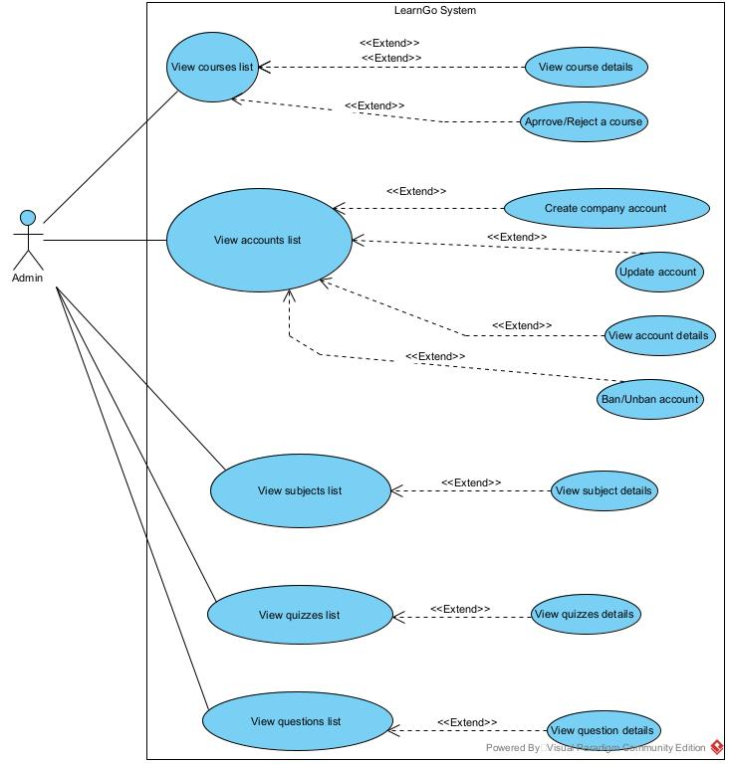

### 2.3 Descriptions

### 2.3.1 Guest

| **ID** | **Use Case** | **Actors** | **Use Case Description** |
| --- | --- | --- | --- |
| 1 | Login | Marketing, Admin, Expert | Guests must login into the system to buy the courses. They may login by Google, Github account and credentials. |
| 2 | Reset password | Marketing, Admin, Expert, Learner | Marketing, expert, admin, and learner can change the password when they forgot password. |
| 3 | Register | Guest, Learner | Guests can register a new account to login into the system to buy theo courses. |
|  | Logout | Learner, Admin, Marketing, Expert | Logout the account. |
| 4 | View home page | Guest, Learner | The first page when user, guests access our website. |
| 5 | View top 6 newest blog | Guest, Learner | This is a part of the home page. Display top 6 newest blogs based on their update date. |
| 6 | View top 6 subjects that have most courses | Guest, Learner | View top 6 subjects that have most courses. |
| 7 | View top 6 courses that have most learner | Guest, Learner | View top 6 courses that have most learner |
| 8 | View courses list | Guest, Learner | View course list, user can search, sort or filter to find the course they want |
| 9 | View courses details | Guest, Learner | View the details of a course include title, description, objectives, author, content (only see, cannot study). |
| 10 | Add course to cart | Guest, Learner | Add a course to the cart |
| 11 | View blogs list | Guest, Learner | View blog list, user can search, sort or filter to find the blog they want |
| 12 | View blog details | Guest, Learner | View blog details include title, updated at, content, comment and like of that blog |
| 13 | View expert list | Guest, Learner | View list of experts including name, description, achievement, total followers, courses, year of experiences. |
| 14 | View campaigns list | Guest, Learner | View list of campaigns. |
| 15 | View campaign details | Guest, Learner | View detailed information of the campaign including name, description, start time, end time, discount percent, thumbnail. |
| 16 | View cart courses list | Guest, Learner | View cart courses list |
| 17 | Add course to purchase now list | Guest, Learner | Add course to purchase now list (these courses be counted in order price) |
| 18 | Add course to purchase later list | Guest, Learner | Add course to purchase later list (these courses still in cart but do not count in order price) |
| 19 | View suggest courses | Guest, Learner | View suggest courses base on the courses in user cart |
| 20 | Remove course from cart | Guest, Learner | Remove course from cart |

### 2.3.2 Learner

### 

| **ID** | **Use Case** | **Actors** | **Use Case Description** |
| --- | --- | --- | --- |
| 1 | View profile | Learner | Learners can view detailed information including: email, username, date of birth, gender, avatar |
| 2 | Update profile | Learner | Learners can update detailed information including: username, date of birth, gender, avatar |
| 3 | View purchased courses | Learner | Learners can view all courses that they bought. They can get courses by status progress |
| 4 | View orders list | Learner | View orders list. |
| 5 | View following experts list | Learner | Learners can view their following expert list. They can view the top 12 of the latest course of the following expert. |
| 6 | View notification | Learner | The learner can view all notifications sent to it. |
| 7 | Read notification | Learner | Learners can read detail a notification. |
| 8 | Delete notification | Learner | Learners can delete a notification. |
| 9 | Purchase course | Learner | User can purchase a course, or courses in their cart. They will be redirected to VN Pay page to pay. |
| 10 | Select coupon for order | Learner | Before create purchase order, they can select coupon for the order. The coupon must be valid, and user can only select one coupon for a order. |
| 11 | View lessons | Learner | User can view the lessons of purchased course. The lesson are 2 type: Video, Document |
| 12 | View quiz | Learner | View information quiz include title, updated at, number of questions, duration of this quiz. |
| 13 | View user’s quiz attempts | Learner | Display all user attempts of this quiz. They can see their marks, submitted time and the answers of that quiz (if the expert allows) |
| 14 | Do quiz | Learner | Learners can do the quiz. While doing the test, the learner can click save quiz, select answers, move to previous and next answers, mark questions. After clicking the submit quiz, the quiz result will be displayed. |
| 15 | Rate a course | Learner | Learners can rate the course which they bought and had not rated before. |
| 16 | Chat with AI | Learner | In the learn course page, user can chat with the AI for supporting them during learning |
| 17 | View chats history in last 7 days | Learner | View chats history in last 7 days. User can select one of them to continue chat. |
| 18 | Delete a/all history | Learner | Delete a/all history |
| 19 | Comment and like a blog | Learner | Learners can like a blog, like comment, comment a blog and reply a comment |

### 2.3.2 Marketing

| **ID** | **Use Case** | **Actors** | **Use Case Description** |
| --- | --- | --- | --- |
| 1 | View notification list | Admin, Expert, Marketing | Admin can view all notifications in the system. Expert and marketing can see all notifications that they created. |
| 2 | Send notification | Admin, Expert, Marketing | Admin, expert, and marketing can create and send to all learners or some learners. |
| 3 | Delete notification | Admin, Expert, Marketing | Admin, expert, and marketing can delete notification that they created. |
| 4 | View orders list | Admin,  Marketing | Admin, marketing can view all orders into system. |
| 5 | View order details | Admin, Marketing | Admin, Expert, Marketing can view detail order. |
| 6 | Active an order | Admin,  Marketing | Admin, marketing can accept order. |
| 7 | Create coupon | Admin, Marketing | Admin , marketing can create coupon |
| 8 | Update coupon | Admin, Marketing | Admin , marketing can update coupon |
| 9 | Delete coupon | Admin, Marketing | Admin , marketing can delete coupon |
| 10 | View details coupon | Admin, Marketing | Admin , marketing can view detail coupon |
| 11 | View campaigns list | Admin, Marketing | Admin, Marketing can view campaign list |
| 12 | Create campaigns | Admin, Marketing | Admin, Marketing can create the new campaign |
| 13 | Update campaigns | Admin, Marketing | Admin, Marketing can update the chosen campaign |
| 14 | Delete campaigns | Admin, Marketing | Admin, Marketing can delete the chosen campaign |
| 15 | View campaigns details | Admin, Marketing | Admin, Marketing can view the detailed information of the chosen campaign |
| 16 | View dashboard | Admin, Marketing | Admin, Marketing can view the statistics of the system. |

### 

### 2.3.2 Expert

| **ID** | **Use Case** | **Actors** | **Use Case Description** |
| --- | --- | --- | --- |
| 1 | View course list | Expert | Expert only view course of theirs |
| 2 | Create course | Expert | Expert can create course , course when create successfully with have draft status,  and then they can send request to admin to approved |
| 3 | View course details | Expert | Admin and expert can view detail of course |
| 4 | Delete course | Expert | Expert can delete course of them |
| 5 | Update course | Expert | Expert can update course , course when update successfully with have draft status,  and then they can send request to admin to approved |
| 6 | Send approve request | Expert | after create or update success , expert can send approve request to admin to success |
| 7  8 | View list learner of course | Expert | Experts can view all learner registration into each course. |
| 9 | View subject list | Expert | Expert can view the subject list |
| 10 | Create subject | Expert | Expert can create the new subject |
| 11 | Update subject | Expert | Expert can update the chosen subject |
| 12 | Delete subject | Expert | Expert can delete the chosen subject |
| 13 | View quiz list | Expert | Experts can view all quizzes into the system. |
| 14 | View quiz details | Expert | Experts can view all questions and correct answers into each quiz. |
| 15 | Update quiz | Expert | Experts can update the quiz. |
| 16 | Publish quiz | Expert | Experts can publish a quiz or not. |
| 17 | View question list | Expert | Expert can view the subject list |
| 18 | Create question | Expert | Expert can create the new question |
| 19 | Update question | Expert | Expert can update the chosen question |
| 20 | Delete question | Expert | Expert can delete the chosen question |
| 21 | View question details | Expert | Admin, Admin can view the detailed information of the chosen question |

### 

### 2.3.2 Admin

| **ID** | **Use Case** | **Actors** | **Use Case Description** |
| --- | --- | --- | --- |
| 1 | View course list | Admin | Admin can view all courses. |
| 2 | View course details | Admin | Admin and expert can view detail of course |
| 3 | Approve/Reject a course | Admin | after create or update success , expert can send approve request to admin to success |
| 4 | View account list | Admin | Admin can view all accounts that exist in the system. |
| 5 | Create marketing, expert, admin account | Admin | Admin can create marketing, expert, admin account with following fields: email, password, role, gender, date of births, avatar. |
| 6 | Update account | Admin | Admin can update marketing, expert, admin account with following fields: password, role, gender, date of births, avatar. |
| 7 | View account details | Admin | Admin can view detailed information of the user into the system. |
| 8 | Ban/Unban account | Admin | Admin can ban or unban an account |
| 9 | View subject list | Admin | Admin can view the subject list |
| 10 | View quizzes list | Admin | Admin can view all quizzes that exist in the system. |
| 11 | View quizzes details | Admin | Admin can view all questions and correct answers into each quiz. |
| 12 | View questions list | Admin | Admin can view the questions list |
| 13 | View question details | Admin | Admin can view the detailed information of the chosen questions |
| 14 | View dashboard | Admin, Marketing | Admin, Marketing can view the statistics of the system. |

### **2.4 Main Workflows**

**2.4.1. Learner page**

* **View course list**: Guests and learners can view all courses in the system. Guests and learners can search by name of course, description or find by tag name, by expert, and by range price.
* **View course details**: Guests and learners can view all information of a course including name, description, objectives, price, rating,...
* **View course that has most students studying**: This allows guests and learners to filter the courses by the most student studying.
* **Add course to cart**: Learners and guests can add a course into the cart to buy it, a cart can have many courses.
* **View courses list in cart**: Learners and guests can view list of courses that they put into the cart
* **Add course in cart to purchase later list**: Learners and guests can move a course from the purchase now to buy later.
* **Add course in cart to purchase now list**: Learner and guests can move a course from the purchase later list to buy now.
* **Login**: If guests want to buy a course, they need to log in to complete the remaining steps of the checkout process.
* **Register**: If guests do not have an account, they must create an account to use functions such as payment, course reviews and article comments.
* **Purchase course**: Learners can buy 1 or more courses, when they create an invoice, they will be taken to VNPay's payment page and proceed to pay.
* **View user’s purchased courses**: Learner can view all courses that they bought, or view all by status progress.
* My orders: Learner can view all orders including payment and unpaid
* **Do quiz**: Learner can do the quiz. While doing the test, the learner can click save quiz, select answers, move to previous and next answers, mark questions. After clicking the submit quiz, the quiz result will be displayed.
* **Quiz review**: Learners can review answers and results of completed quizzes.
* **Learn course**: Learners can learn a course that they bought.
* **Select coupon for order**: Learner can choose a coupon to discount the order.
* **AI** : Learners can chat with AI during the learning process.

#### **2.4.2. Admin page**

* **Login**: If admin,expert and marketing want to go into the admin page, they need to log in to complete.
* **View course list** : expert and admin can view course list, admin can view all courses with status processing or approval of all experts, expert can only view courses with status draft, processing, approved and rejected.
* **Create course** : When an expert creates a course, course status is draft, expert can send a request to the admin to approve , when approved successfully course status will change to approved and will appear on learners page.
* **Update course**: Expert can update course, when update successful course , course status will back to draft and expert need to send request to admin to approve course again.
* **Delete course**: expert can delete course, if course have learners are learning, expert cannot delete course , if not have learners expert can delete course of theirs.
* **View user lis**t: only admin can view list user of system, admin can view user will status active or inactive and all roles.
* **Create a company account**: admin can create users with role admin, expert and marketing with valid information.
* **Delete user**: admin can ban or unban users with role marketing, expert and user.
* **Update user**: admin can update information of user with role expert and marketing
* **View campaign list**: view all campaign are existing and will have in system
* **Create campaign**: admin, expert and marketing can create campaigns to apply for all courses or some course. Campaign only has sales with percent.
* **Update campaign**: admin,expert and marketing can update information of a campaign.
* **Delete campaign**: admin, expert and marketing can delete campaign.
* **View coupon list**: view all coupons are expiring and will be in the system.
* **Create coupon**: admin,expert and marketing can create coupons to apply for orders with valid information.
* **Update coupon**: admin, expert and marketing can update information of coupon
* **Delete coupon:** admin,expert and marketing can delete coupon.
* **View quizzes list**: admin can view all quizzes in the system. Experts can only view quizzes of their course.
* **Create quiz**: only experts can create quizzes, experts can create quizzes for each chapter of their courses.
* **Update quiz**: only experts can update quizzes, experts can update quizzes for each chapter of their courses.
* **Published quizzes:** Admin, expert can open or close the quiz.

## 3. System Functionalities

### 3.1 Screens Flow

### 3.1.1 User Screens Flow

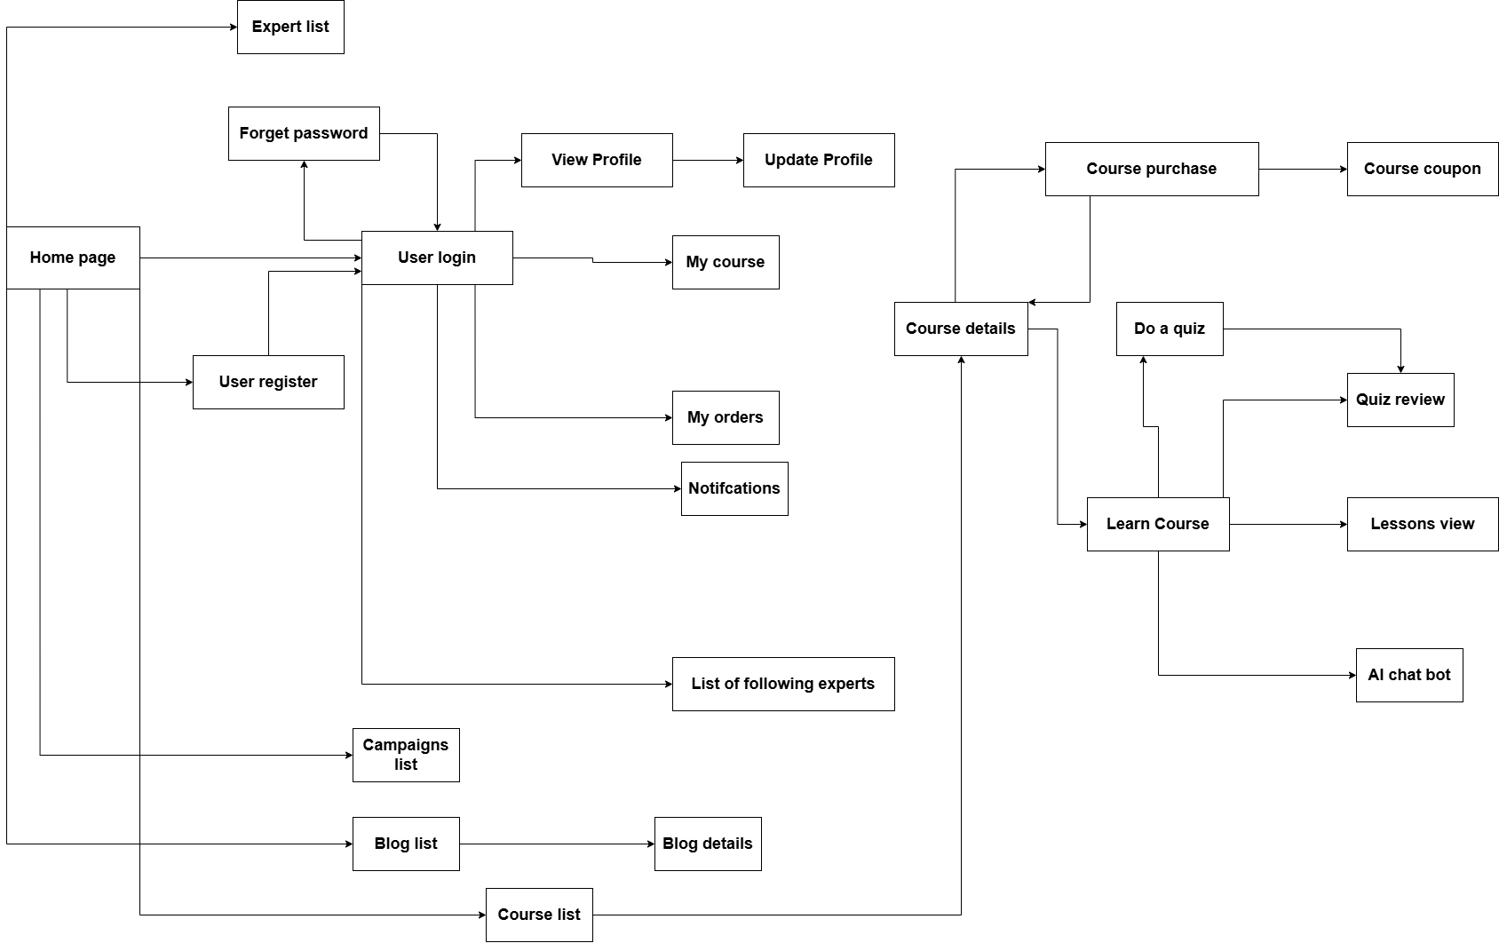

### 3.1.2 Admin Screens Flow

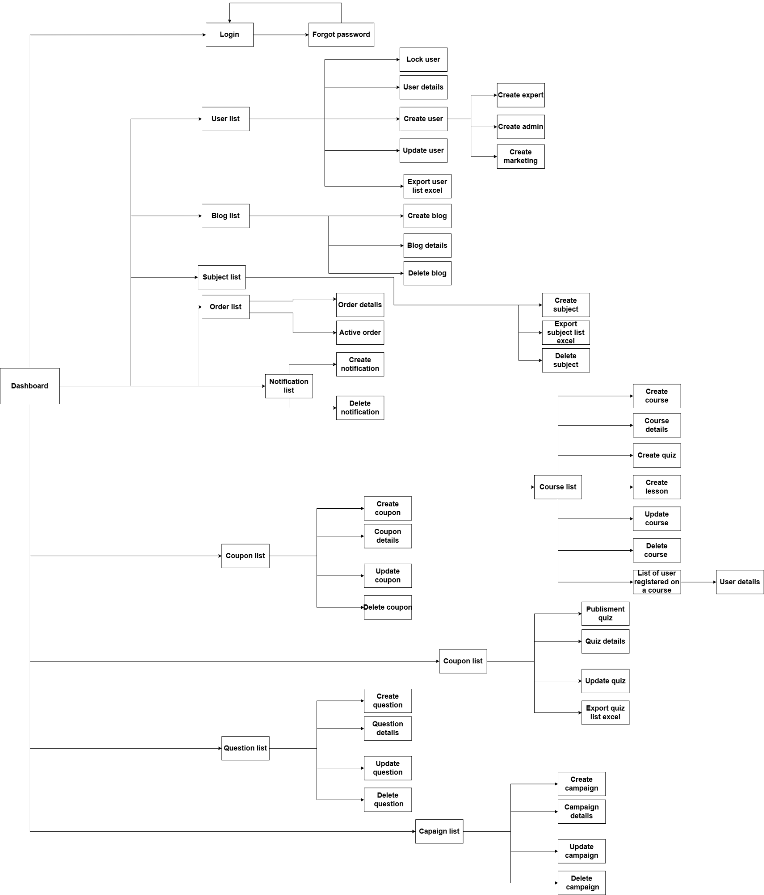

### 3.2 Screen Authorization

| **Number** | **Screen** | **Learner** | **Admin** | **Marketing** | **Expert** | **Guest** |
| --- | --- | --- | --- | --- | --- | --- |
| 1 | Home page |  |  |  |  |  |
| 2 | Course list(User) |  |  |  |  |  |
| 3 | Blog Details (User) |  |  |  |  |  |
| 4 | User Profile |  |  |  |  |  |
| 5 | User List |  |  |  |  |  |
| 6 | User Detail |  |  |  |  |  |
| 7 | Login |  |  |  |  |  |
| 8 | User Authorization |  |  |  |  |  |
| 9 | Blog list (User) |  |  |  |  |  |
| 10 | Register |  |  |  |  |  |
| 11 | Subject List |  |  |  |  |  |
| 12 | Forget Password |  |  |  |  |  |
| 13 | Course List (Admin) |  |  |  |  |  |
| 14 | Course Purchase |  |  |  |  |  |
| 15 | Lesson view |  |  |  |  |  |
| 16 | Course Details (User) |  |  |  |  |  |
| 17 | Dashboard |  |  |  |  |  |
| 18 | My Course |  |  |  |  |  |
| 19 | Update blog |  |  |  |  |  |
| 20 | Create blog |  |  |  |  |  |
| 21 | Blog List (Admin) |  |  |  |  |  |
| 22 | Create question |  |  |  |  |  |
| 23 | Update question |  |  |  |  |  |
| 24 | Question List |  |  |  |  |  |
| 25 | Create expert |  |  |  |  |  |
| 26 | Comment and like on blogs |  |  |  |  |  |
| 27 | Notification |  |  |  |  |  |
| 28 | Create subject |  |  |  |  |  |
| 29 | Subject Update |  |  |  |  |  |
| 30 | List of users registered for the course |  |  |  |  |  |
| 31 | Order list, order details |  |  |  |  |  |
| 32 | Export file to excel |  |  |  |  |  |
| 33 | Update course |  |  |  |  |  |
| 34 | Create course |  |  |  |  |  |
| 35 | Quizzes List |  |  |  |  |  |
| 36 | Quizz Review |  |  |  |  |  |
| 37 | Create Quiz, Update Quiz |  |  |  |  |  |
| 38 | Integrated AI |  |  |  |  |  |
| 39 | Course coupon (User) |  |  |  |  |  |
| 40 | Course event(Admin) |  |  |  |  |  |
| 41 | Course event (User) |  |  |  |  |  |
| 42 | Course coupon (Admin) |  |  |  |  |  |
| 43 | Create/update lessons |  |  |  |  |  |
| 44 | Rating a course |  |  |  |  |  |
| 45 | Automatic notifications |  |  |  |  |  |
| 46 | My orders |  |  |  |  |  |
| 47 | Do a quiz |  |  |  |  |  |
| 48 | List of followed expert |  |  |  |  |  |
| 49 | See list of experts and their course |  |  |  |  |  |
| 50 | Following an expert |  |  |  |  |  |
| 51 | Campaign list |  |  |  |  |  |

### 

### 3.3 Non-UI Functions

| **#** | **Feature** | **System Function** | **Description** |
| --- | --- | --- | --- |
| 1 | Authorization | Credential login(User) | only user can login into user page |
| Credential login (Admin) | admin,expert and marketing can login into admin page |
| Course list (Admin) | expert and admin can view course list, admin can view all courses with status processing or approval of all experts, expert can only view courses with status draft, processing, approved and rejected |
| View user list | only admin can view list user of system, admin can view user will status active or inactive and all roles. |
| View blog list (Admin ) | admin can view all blog, marketing and expert can view blog of theirs |
| View campaign, coupon list (Admin) | only admin and marketing can view , create,update and delete campaign and coupon |
| View subject | admin and expert can view all subject |
| crud subject | only expert can crud subject |
| View course list (Admin) | admin can view all course and reject or approved course, expert can only view theirs course |
| Crud course | only expert can crud course |
| Quizzes list | only admin,expert can view quizzes list |
| Crud quizzes | only expert can crud quizzes |
| View question | admin and expert can view all question |
| Crud question | only expert can crud question |
| Crud blog | Admin, expert, and marketing can create, update, delete of their blog |
| View notification | User can view all notification |
| Read notification | User can read details notification |
| Delete notification (User) | User can delete a notification |
| Crud notification (Admin) | Admin, expert, and marketing can crud notification. |

# II. Functional Requirements

## 1. Login

### 1.1 Admin login

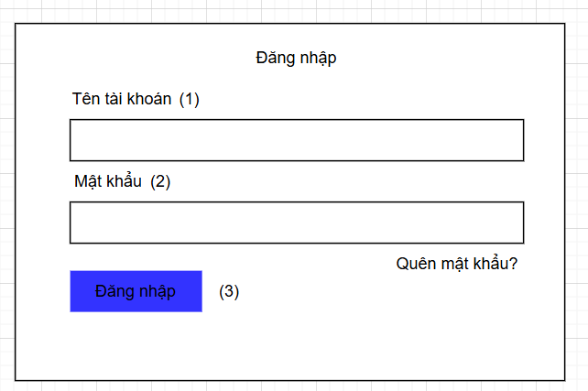

* Allow only admin,expert,marketing to login
* After login admin can manage blog, manage subject, manage bill, manage notifications,manage course,manage coupon and quizzes,
* Expert can create,update , delete course and lesson and expert can only see their courses
* Marketing can create , update, delete blog, and they can only see their blog.

| **No** | **Field** | **Description/Function of field** |
| --- | --- | --- |
| *01* | *Email* | *Allow user input email, check email exists or not* |
| *02* | *Password* | *Allow user input password, check password is more than 8 characters* |
| *03* | *Login button* | *if email and password valid, allow user to login into admin page* |

### 1.2 User login

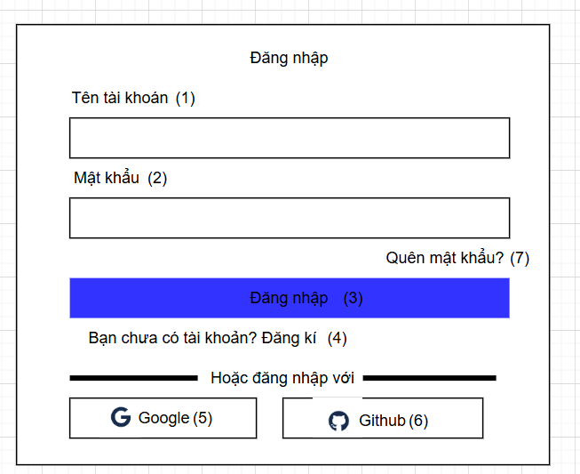

* Allow only user to login, after user login,they can see homepage, buy course, see course detail, view blog list, view blog detail.

| **No** | **Field** | **Description/Function of field** |
| --- | --- | --- |
| *01* | *Email* | *Allow user input email, check email exists or not* |
| *02* | *Password* | *Allow user input password, check password is more than 8 characters* |
| *03* | *Login button* | *if email and password valid, allow user to login into admin page* |
| *04* | *Register* | *if user not have account, they can register , they can move to register page* |
| *05* | *Forgot password* | *if user forgot password, the can click to forgot and move to forgot password page* |
| *06* | *Google login* | *they login with account google* |
| *07* | *Github login* | *they login with account github* |

## 2. Register

| **No** | **Field** | **Description/Function of field** |
| --- | --- | --- |
| *01* | *Fullname* | *Allow user input fullname* |
| *02* | *Password* | *Allow user input password, check password is more than 8 characters* |
| *03* | *Re-password* | *Allow user input password once again, check re-password is more than 8 characters and the same as the password.* |
| *04* | *Login* | *if user have already had the account, they can login, they can move to login page* |
| *05* | *Register button* | *if email and password valid, allow user to login into admin page* |
| *06* | *Email* | *Allow user input email, check email exists or not* |
| *07* | *Google Login* | *User can login with account google* |
| *08* | *Github Login* | *User can login with github google* |
| *09* | *Roll back icon* | *User can move back the login page* |
| *10* | *Home icon* | *User can move back the home page* |
| *11* | *OTP code* | *Users must input OTP sent to the registered email to verify the account.* |
| *12* | *Resend OTP code* | *Users can send the request to provide the other OTP code* |
| *13* | *Back button* | *Users can move back the register page* |
| *14* | *Continue button* | *Users click to this button to register* |

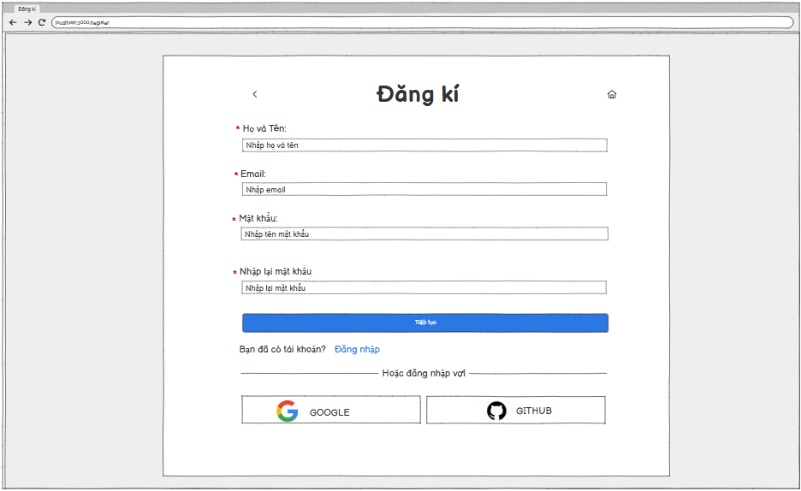

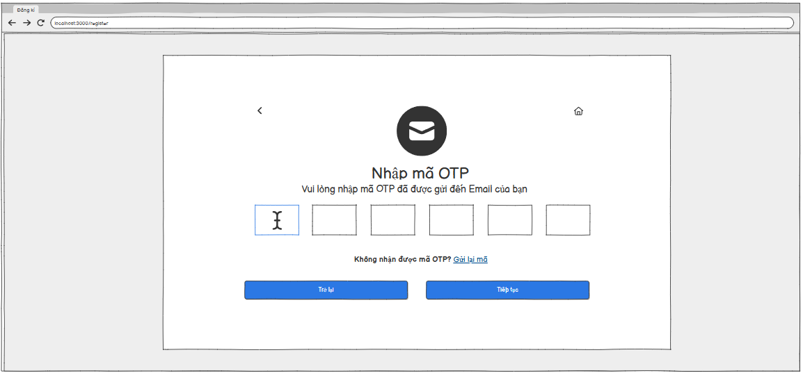

* This page allows users (Student) to register a new account if they do not have the account to access the system’s functionality.
* Users must fill in all the fields like fullname, email, password, rePassword.
* When users click on “Tiếp tục” button to register. A new page will appear to users input the OTP code that they have just sent into the registered email.
* If users do not get the OTP code. They can request another code.
* The OTP code must be correct to verify the account.
* If users have already had the account. Users can click on the “Đăng nhập” button to move the login page.
* Users can login by Google account by clicking on the “GOOGLE” button. In addition, users can login by Github by clicking on the “GITHUB” button as well.

## 3. Forgot password

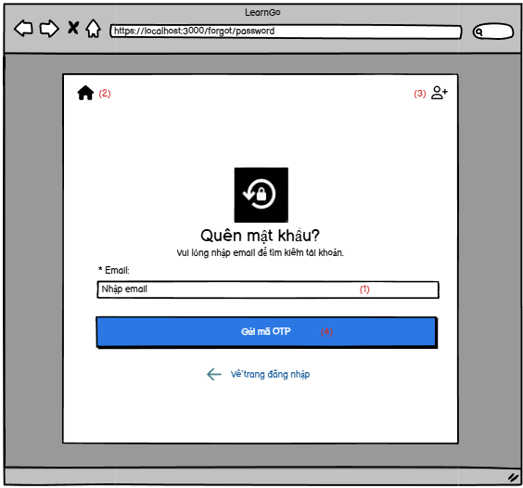

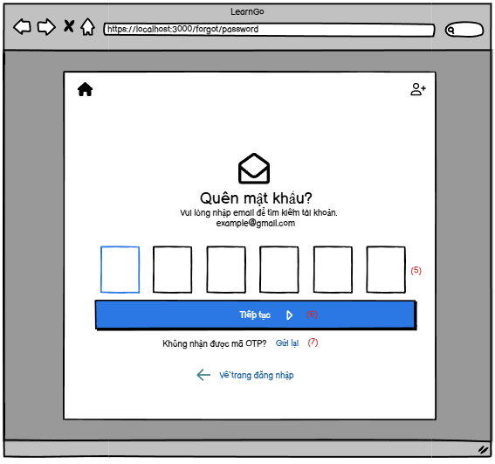

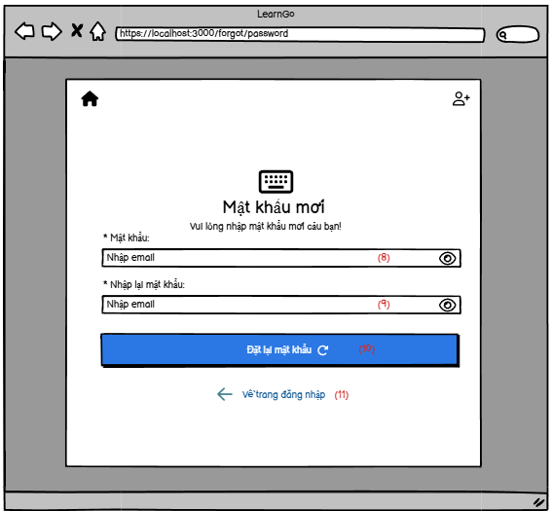

* User clicks on "forgot password" in login section to go to change password section.
* User must enter the email used to register, then they must click button “Send OTP”
* The system will send a OTP code to user’s email. If the user does not receive the code, they can press "resend". However, after the first resend press, they will have to wait another 60 seconds to press again.
* After the user enters the otp, they go to the screen change password. They must enter new password and re-enter new password. Then they click the button to change password.

| **No** | **Field** | **Description/Function of field** |
| --- | --- | --- |
| *01* | *Enter email* | *Allow user input email that used to resigter* |
| *02* | *Go to home page* | *Click the icon to go to home page* |
| *03* | *Register* | *Click to go to form register* |
| *04* | *Send OTP button* | *Click the button to receive the otp code via email* |
| *05* | *Enter OTP code* | *Input OTP code* |
| *06* | *Continue button* | *Next the step* |
| *07* | *New password* | *Input new password* |
| *08* | *Re-send OTP code* | *Allows resending of new codes to users (after the first time will have to wait 60 seconds each time)* |
| *09* | *Re-enter new password* | *Re-enter new password* |
| *10* | *Reset password button* | *Confirm new password* |
| *11* | *Back to login* | *Allow user return form login* |

## 4. Authorization

* With user login, only user can login
* With admin login, only expert, admin and marketing can login.
* With manage course, only expert can create,update,delete and they can only see their courses
* With manage blog, only blog can create,update ,delete, and they can only see their blog

## 5. User profile

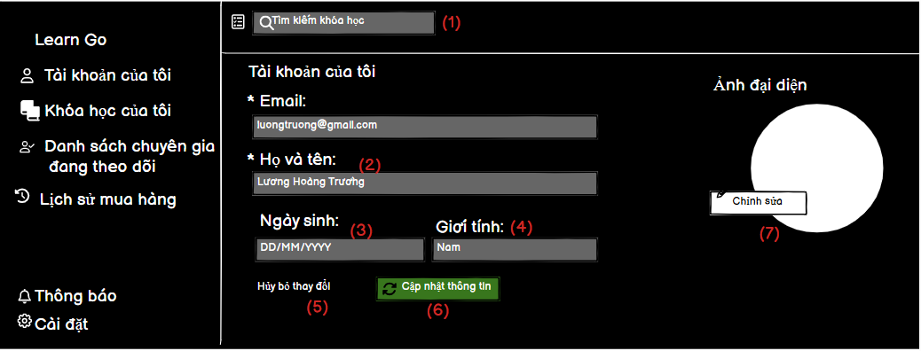

* When the user clicks on the profile and clicks on my account, the user's information will be * displayed.
* The user can view the email, but cannot edit it.
* The user can change the username, date of birth, gender and avatar.
* If you want to change, click update information, otherwise click cancel.

| **No** | **Field** | **Description/Function of field** |
| --- | --- | --- |
| *01* | *Search Course* | *Allows user can search by course* |
| *02* | *Username* | *Allow user input username* |
| *03* | *Date of births* | *Allow user can select dob* |
| *04* | *Gender* | *Allow user can select gender* |
| *05* | *Cancel* | *Allow user cancel if do not want to change your profile* |
| *06* | *Update information* | *Allow user can update information* |
| *07* | *Update Avatar* | *Allow user can upload avatar* |

## 6. Course list (Admin)

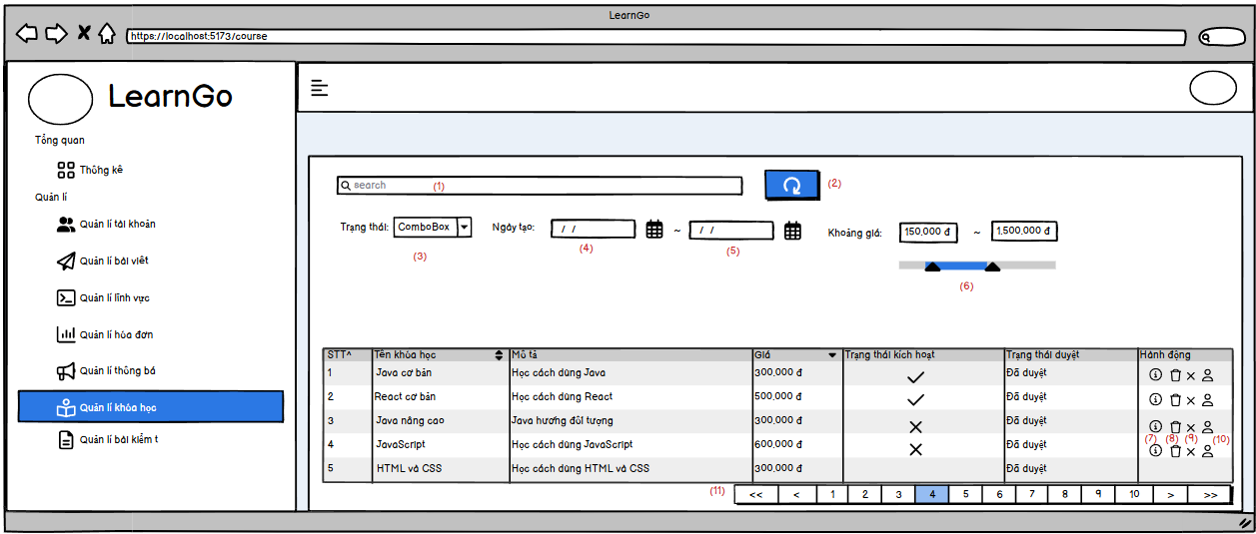

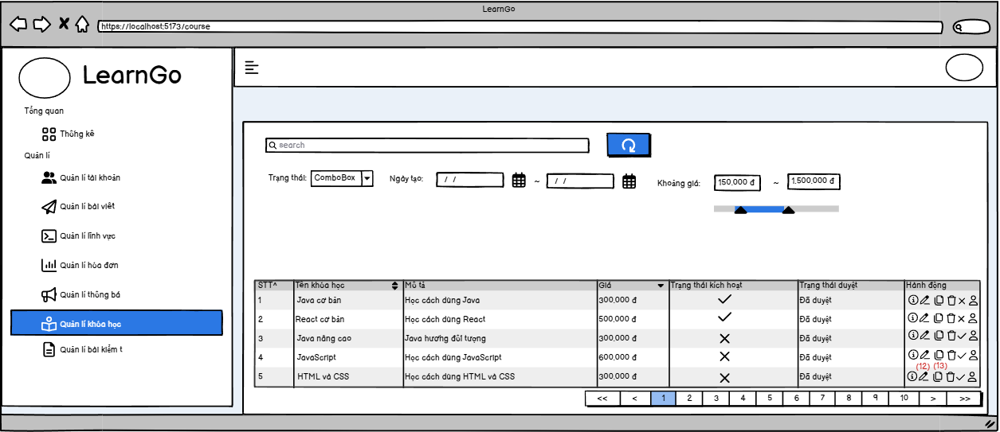

* Admin can view the list of courses in the system, can accept a course or hide a course, view course details, and course registrants
* Experts can create a course, update a course, create lessons for the course, view learners, and delete a course.
* Admin and expert can find a course by name, created at, price range.

| **No** | **Field** | **Description/Function of field** |
| --- | --- | --- |
| *01* | *Search course* | *Allow search course by name* |
| *02* | *Button reset* | *Click to refresh page* |
| *03* | *Status* | *Search by status* |
| *04* | *Created From* | *Find by created at greater than or equal created from* |
| *05* | *Created To* | *Find by created at less than or equal created to* |
| *06* | *Price range* | *Find course by range of price* |
| *07* | *Course detail* | *View details of 1 course* |
| *08* | *Delete course* | *Allow expert and admin can delete a course that do not have student* |
| *09* | *Accepted/ Unaccepted course* | *Admin can accept or unaccept a course* |
| *10* | *View student resigter course* | *View all students that register this course* |
| *11* | *Change the page* | *Each page has 10 item, so that admin and expert can change page to see more course* |
| *12* | *Update course* | *Allow expert update a course* |
| *13* | *Create resources of course* | *Allow expert add resources for course.* |

## 7. Subject list (Admin)

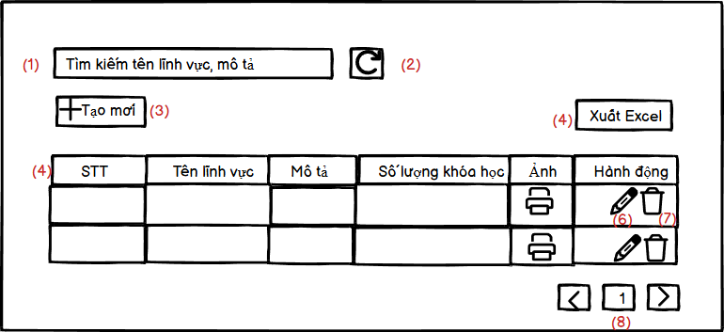

* This page allows Admin/Expert to view the information of the list subject.
* Admin/Expert can search for a subject by name or description.
* When Admin/Expert click on the Refresh button. The table will be refresh.
* Only experts can create a new subject. When Expert click on the “Tạo mới” button, the modal screen will be appeared to create a new subject.
* Admin/ Expert can export the data from the table by clicking on the “Xuất Excel” button.
* Experts can view detailed information of the subject by clicking on the pen icon. And can delete the subject by clicking on the trash icon if the subject does not have any course using this subject.
* Admin/Expert can move the page by using the pagination function.

| **No** | **Field** | **Description/Function of field** |
| --- | --- | --- |
| *01* | *Search subject* | *Allow admin/ expert search subject by inputting name or description* |
| *02* | *Refresh button* | *Allow admin/ expert refresh the page* |
| *03* | *Create button* | *Allow expert move to the create page* |
| *04* | *Excel export* | *Allow admin/ expert export the data from table to file excel* |
| *05* | *Table* | *Show admin/ expert information of subject like name, description, number of course* |
| *06* | *Update icon* | *Allow expert move to update page* |
| *07* | *Delete icon* | *Allow admin/ expert delete subject if that subject does not have any courses that using that subject* |
| *08* | *Pagination button* | *Allow admin/expert to switch to other pages of the board* |
| *09* | *Roll back icon* | *User can move back the login page* |
| *10* | *Home icon* | *User can move back the home page* |
| *11* | *OTP code* | *Users must input OTP sent to the registered email to verify the account.* |

## 

## 

## 

## 

## 

## 

## 

## 8. User list (Admin)

## 

## 

## 

* This page is displayed after the user clicks on ‘Manage Accounts’ in the sidebar.
* This page is for the administrator to manage all users in the system and view all current users.
* Admin can search for users by name, email or role
* Admin can refresh the filter
* Allows filtering by status such as: active or locked
* Allows filtering by role such as: ADMIN, EXPERT, MARKETING, USER
* Allows filtering by gender such as: Male, Female or Unknown
* When clicking on add user, a screen will appear allowing you to enter information to create a new user.
* When clicking on the view details icon, the user details will be displayed.
* When the user clicks on the update icon, the user update form will be displayed.
* When the user clicks on the lock icon, the system will ask the user if they want to lock this user or unlock this user.
* Allows exporting all data to soft copy using Excel file
* Allows sorting data in the table in alphabetical order (Ascending, Descending or default)

| **No** | **Field** | **Description/Function of field** |
| --- | --- | --- |
| *01* | *Search User* | *Allow admin* *can search for users by name, email or role* |
| *02* | *Refresh button* | *Admin can clear all fields searching for user* |
| *03* | *Select Option* | *Allow admin to filter by status* |
| *04* | *Select Option* | *Allow admin to filter by role* |
| *05* | *Select Option* | *Allow admin to filter by gender* |
| *06* | *Create button* | *Allows admin to create users* |
| *07* | *Export file excel* | *Allows users to export excel files with information in tables* |
| *08* | *Pagination button* | *Allow admin to switch to other pages of the board* |
| *09* | *Table field* | *The fields in the table include: status, username, email, role, gender, statusUser can move back the login page* |
| *10* | *Detail icon* | *Allow admin to view user information details* |
| *11* | *Update icon* | *Allow admin to update user information* |
| *12* | *Lock icon* | *Allow admin to lock user* |

## 

## 

## 

## 9. Create User(Admin)

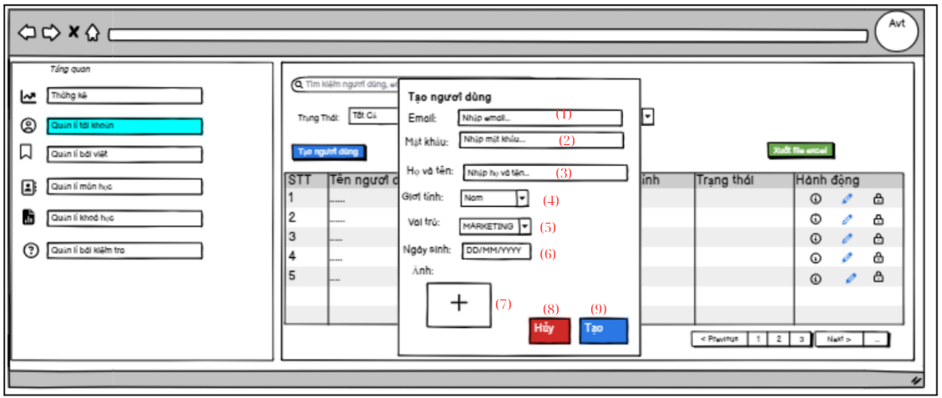

* When the admin clicks on the create user button, a creation form will be displayed with the following information: email, password, full name, gender, role, date of birth, photo.
* Each attribute will be validated as follows:

**Email** must not be left blank and must be entered in the correct email format.

**Passwords** cannot be blank and must be at least eight characters long, including both letters and numbers.

**Full name** cannot be left blank.

Default role will be **MARKETING**. Users can choose **ADMIN** or **EXPERT**. If the **EXPERT** role is selected, the form will display four additional fields:

* Years of experience
* Description
* Job
* Achievements

**Date of birth** cannot be left blank, and the user must be over 18 years old.

**Avatar**is optional. If a photo is uploaded, only the following formats are allowed: **PNG, JPG, JPEG**. If the file format is not supported, an error message will be displayed. After uploading, users will have the option to re-select the photo if needed.

| **No** | **Field** | **Description/Function of field** |
| --- | --- | --- |
| *01* | *Email* | *Allow admin input email* |
| *02* | *Password* | *Admin can input password* |
| *03* | *Username* | *Allow admin input username* |
| *04* | *Gender* | *Allow admin select gender* |
| *05* | *Role* | *Allow admin select role* |
| *06* | *Date of birth* | *Allows admin input date of birth* |
| *07* | *Avatar* | *Allows users upload avatar* |
| *08* | *Cancel Button* | *Admin can cancel form if don’t want to create user* |
| *09* | *Create Button* | *Admin can create user* |

## 10. Update User (Admin)

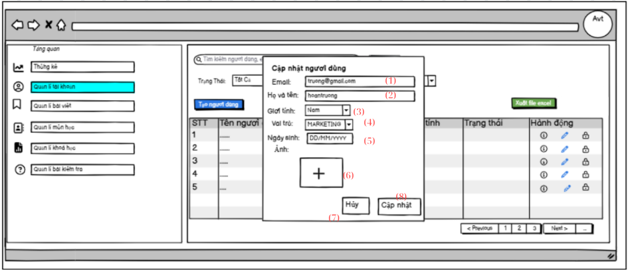

* When the administrator clicks on the update user button, a creation form will be displayed with the following information: email, password, full name, gender, role, date of birth, photo.
* If the user changes the information in the form and clicks the update button, the new information will be updated.

| **No** | **Field** | **Description/Function of field** |
| --- | --- | --- |
| *01* | *Email* | *Allow admin cannot input email* |
| *02* | *Username* | *Allow admin input username* |
| *03* | *Gender* | *Allow admin select gender* |
| *04* | *Role* | *Allow admin select role* |
| *05* | *Date of birth* | *Allows admin input date of birth* |
| *06* | *Avatar* | *Allows users upload avatar* |
| *07* | *Cancel Button* | *Admin can cancel form if don’t want to update user* |
| *08* | *Create Button* | *Admin can update user* |

## 11. User details (Admin)

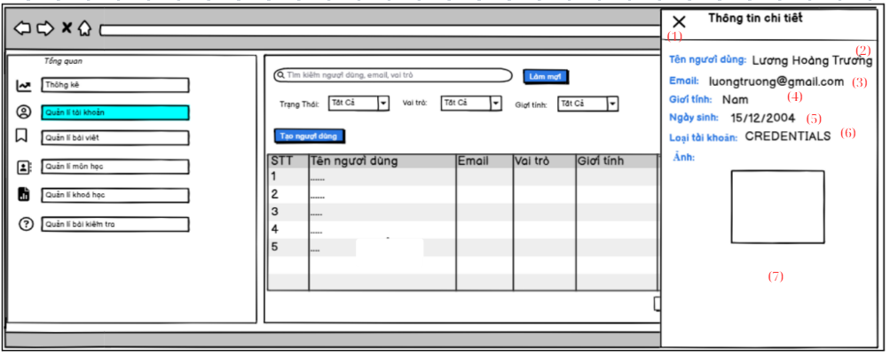

* When the admin clicks on the view details icon, a user details form will appear with information including: username, email, gender, date of birth, account type, avatar.

| **No** | **Field** | **Description/Function of field** |
| --- | --- | --- |
| *01* | *Cancel form* | *Admin can can cancel form view user detail* |
| *02* | *Username* | *Admin can view username* |
| *03* | *Email* | *Admin can view email* |
| *04* | *Gender* | *Admin can view gender* |
| *05* | *Date of birth* | *Admin can view date of birth* |
| *06* | *Avatar* | *Admin can view avatar* |

## 12. Home page

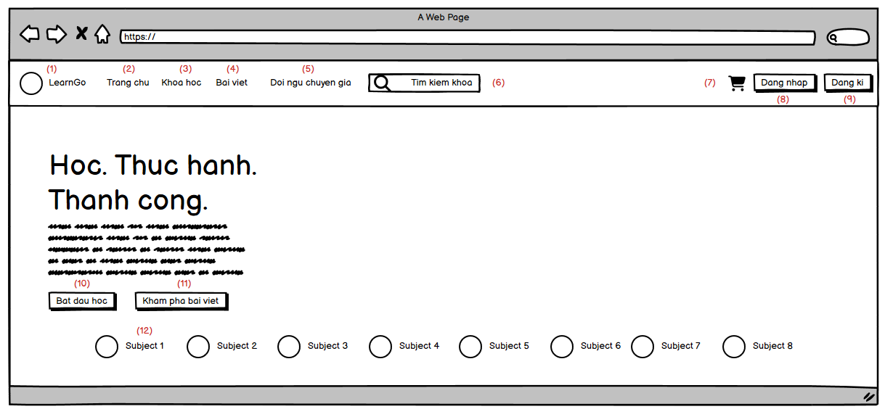

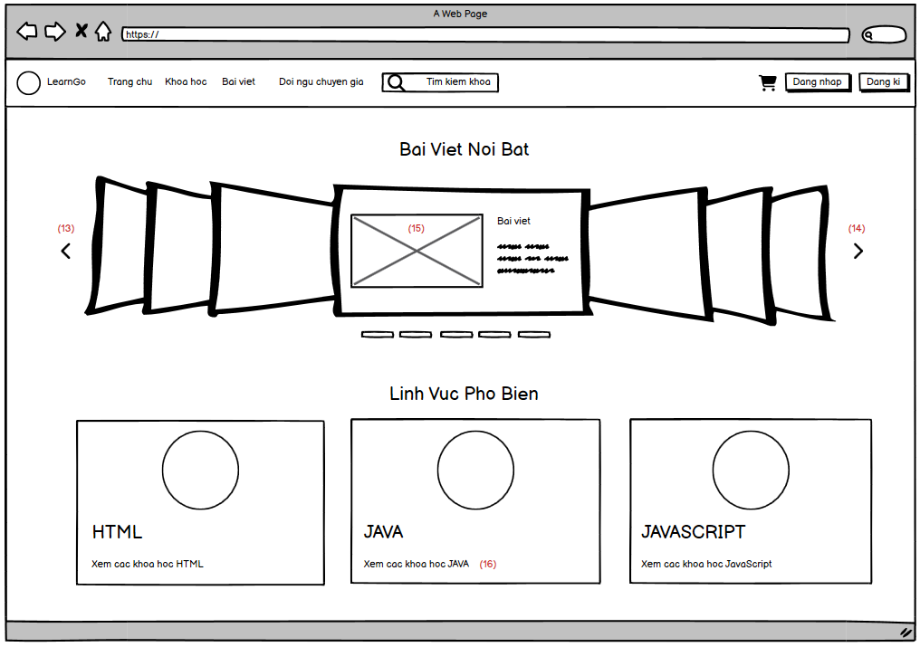

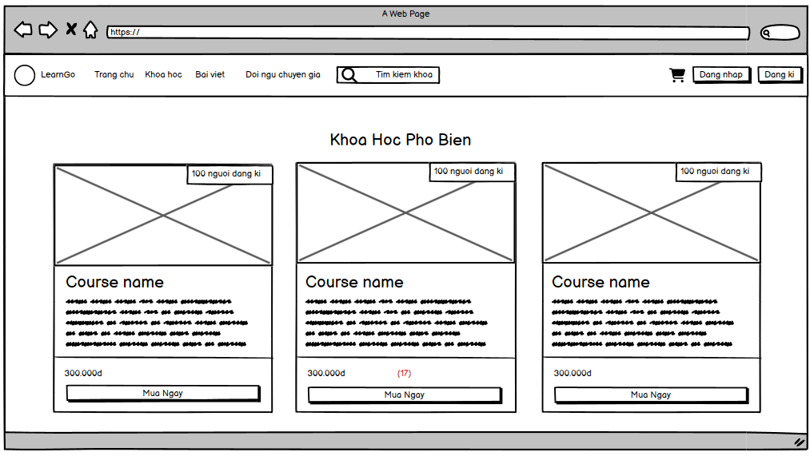

* This home page is displayed both to guest and login user (student)
* In the home page, there are 5 main parts:
  + Header: The website logo, navigation links, search box (For searching course by name, description), cart button and login/register button
  + Home page banner: The user can see the website slogan, infinite slider of course’s subjects
  + Blog list: slider of blog list (which are the newest)
  + Subject list: the list of subjects that have most courses (view in grid)
  + Course list: the list of courses that have most students (view in grid)

| **No** | **Field** | **Description/Function of field** |
| --- | --- | --- |
| 01 | Logo button | When click, redirect to the home page (/home) |
| 02 | Trang chu | When click, redirect to the home page (/home) |
| 03 | Khoa hoc | When click, redirect to the course list page (/course) |
| 04 | Bai viet | When click, redirect to the blog list page (/blog) |
| 05 | Doi ngu chuyen gia | When click, redirect to the experts list page (/expert) |
| 06 | Search box | User can input text they want to search, when enter, they will be redirected to the course page and search all course by name and description which contain the keyword user input. |
| 07 | Cart button | When click, open the cart modal. |
| 08 | Login button | When click, redirect to the login page. (/login) |
| 09 | Register button | When click, redirect to the register page. (/register) |
| 10 | Bat dau hoc | When click, redirect to the course page. (/course) |
| 11 | Kham pha bai viet | When click, redirect to the blog page. (/blog) |
| 12 | The single element in slider | When click, redirect to the course page and search all course that have the subject equals the subject user clicked. |
| 13 | Previous button | When click, go to the previous blog of the slider |
| 14 | Next button | When click, go to the next blog of the slider |
| 15 | Blog image thumbnail | When click, redirect to the blog details page of the blog user click |
| 16 | View all course with subject | When click, redirect to the course page and search all course that have the subject equals the subject user clicked. |
| 17 | Purchase button | When click, redirect to the course details page of the course user clicked. |

## 13. Blog list (User)

| **No** | **Field** | **Description/Function of field** |
| --- | --- | --- |
| 01 | Search title,content,author | Allow user to search blog with title, content,author of a blog |
| 02 | Search hashtag | Allow user to search hashtag |
| 03 | Search button | Search with filter already fill |
| 04 | Refresh button | refresh filter search |
| 05 | All category | to see all blog |
| 06 | Like blog | allow user to see blog their have like |
| 07 | Comment blog | allow user to see blog their have comment |

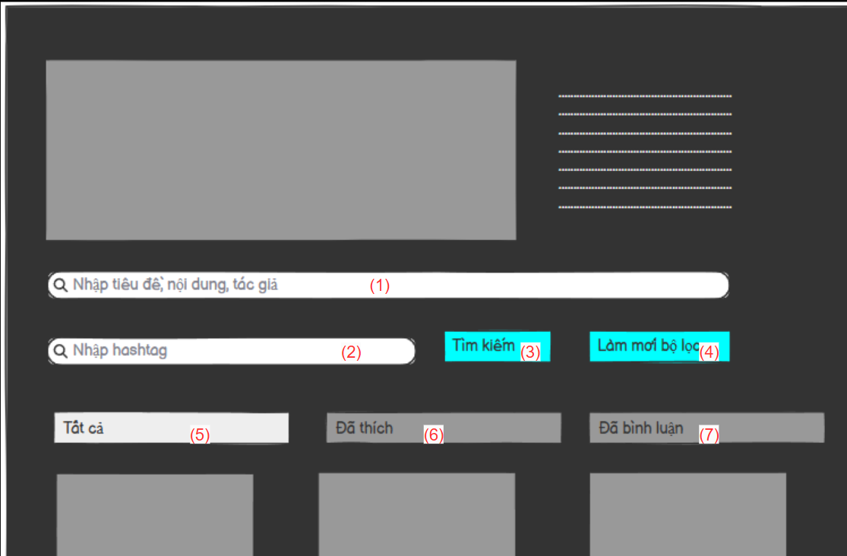

* Allow user to search blog with filter: title, content,author,hashtag.
* Allow user to see all blog, liked blog, comment blog.

## 14. Course list (User)

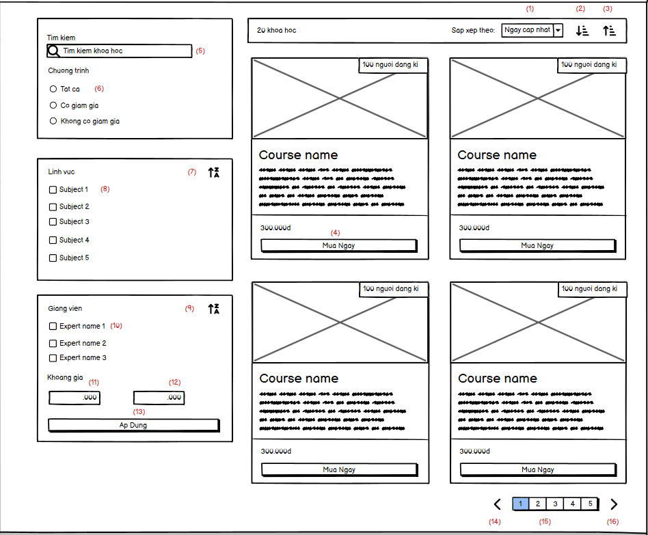

* Display the course list. The page includes:
  + The course header contains: Sort button (sort course by update date, price, purchased number, rating). Ascending order and descending order button.
  + The left sidebar are some filter options, search box. The user can also input the price range of course to search.
  + The bottom of the page are pagination.

| **No** | **Field** | **Description/Function of field** |
| --- | --- | --- |
| 01 | Sort by options | The sort options for course list. They are sort by: |
| 02 | Descending order button | Sort course by descending order. This will combine with the sort option (1) to display the result. |
| 03 | Ascending order button | Sort course by ascending order. This will combine with the sort option (1) to display the result. |
| 04 | Purchase button | When click, the user to redirected to the course details page |
| 05 | Search box | User can input text they want to search, when enter, they will be redirected to the course page and search all course by name and description which contain the keyword user input. |
| 06 | Event filter | Search all course with: no-event or having event or all courses (no filter - default) |
| 07 | Sort by alphabet button | When click sort the subjects list by alphabetic orders of subject name (asc or desc). |
| 08 | Single subject checkbox | When checked, search all course that have the subject equals to subjects checked (user can check many subjects) |
| 09 | Sort by alphabet button | When click sort the expert list by alphabetic orders of expert name (asc or desc). |
| 10 | Single expert checkbox | When checked, search all course that have the expert name equals to expert name checked (user can check many expert name) |
| 11 | From price button | User can input the number to search course price that >= the input price. The input is auto * 1000 (suitable for the currency in Viet Nam) |
| 12 | To price button | User can input the number to search course price that <= the input price. The input is auto * 1000 (suitable for the currency in Viet Nam) |
| 13 | Ap dung button | When click user the can search course with all the input, options, filter they choose/select/input. |
| 14 | Previous page | When click, go to the previous course page (if the current page is 1, the button will be disabled) |
| 15 | Page number | User can click on the page number in pagination bar to router to the course page with page = the number the clicked |
| 16 | Next page | When click, go to the next course page (if the current page is the last page, the button will be disabled) |

## 15. Blog details (User)

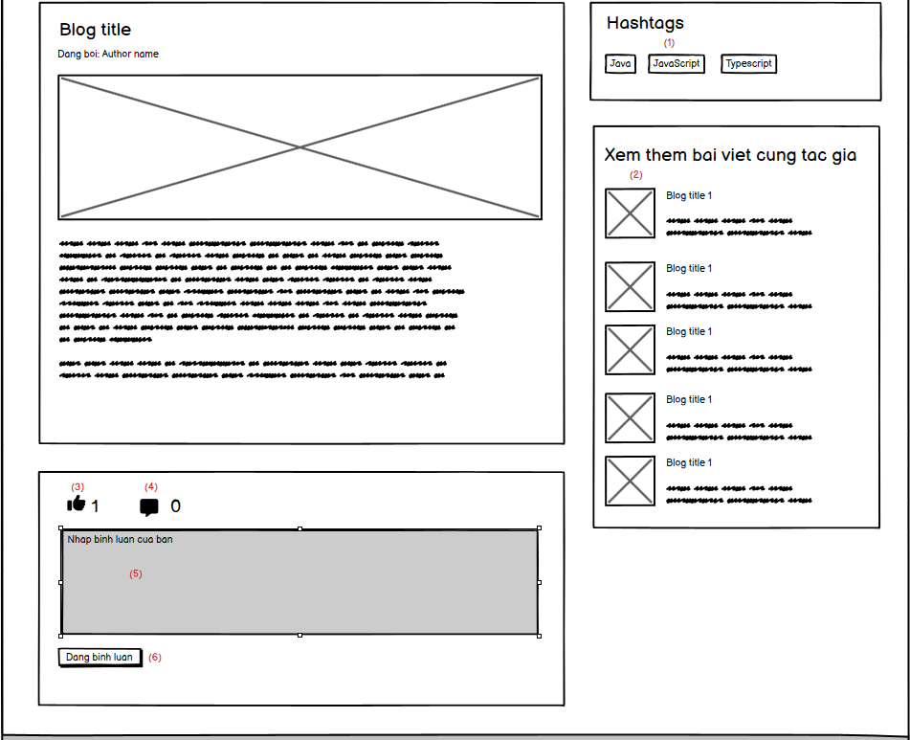

* Allow user to view detail of a blog, user can like, comment on blog.
* Allow user can view some blogs that have same author
* User can see all the hashtags of current blog

| **No** | **Field** | **Description/Function of field** |
| --- | --- | --- |
| 01 | Single blog’s hashtag | When click, user will be redirected to the blog list and search all blog that contains the clicked hashtags |
| 02 | Single suggested blog | When click, user will be redirected to the blog details of the blog the clicked |
| 03 | Like button | When click, user can dislike and like the blog |
| 04 | Comment icon | When click, if user login, focus the comment input |
| 05 | Comment textarea | User can input their comment. If they not login, the textarea will be disabled |
| 06 | Push comment button | When click, push the comment the user inputted, if user not login, the button will be disabled |

## 16. Admin dashboard

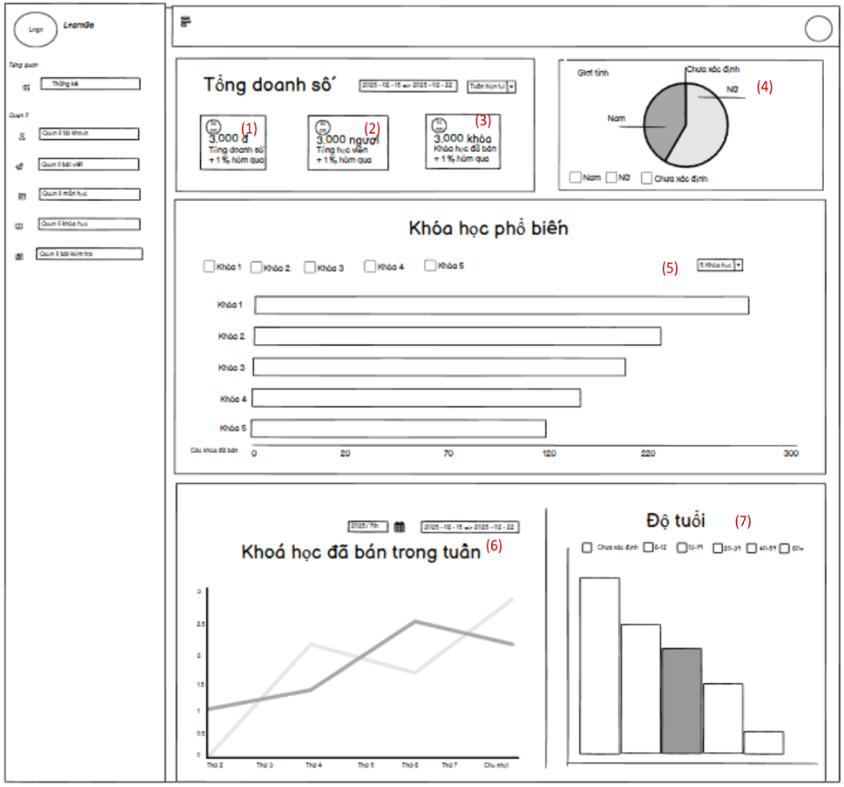

* This page allows the admin/ salement to view the statistics of the system like total number of sales, student, purchased course, gender, age range.
* Admin/ salement can view total number of sale, student, purchased course by week, month, quarter and year.
* Admin/ salement can view the total number of male, female and unknown.
* Admin/ salement can view the most purchased course by week.
* Admin/ salement can view the total number of age range.

| **No** | **Field** | **Description/Function of field** |
| --- | --- | --- |
| 01 | Total sale | Admin/ salement can view the total sale by week, month, quarter, year. |
| 02 | Total student | Admin/ salement can view the total student by week, month, quarter, year. |
| 03 | Total purchased course | Admin/ salement can view the total purchased course by week, month, quarter, year. |
| 04 | Number of course displayed | When the admin/ salement clicks on this. They can choose the number of the course that will be displayed. |
| 05 | Purchased course in week | When the admin/ expert clicks on this. They can choose the week to display the number of purchased courses from Monday to Sunday. |
| 06 | Age range | Admin/ salement can view the number of user in each range of age. |

## 17. Quiz list (Admin)

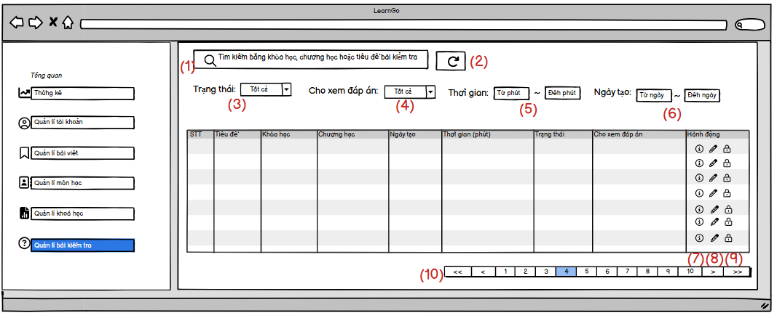

* When admin clicks on test management, a table of tests appears, admin can search by course, chapter, test title. ADMIN can see all tests in the system, EXPERT can only see tests that exist in their course.
* Admin can filter by status fields, allowing to view answers, time, date created.
* There is also a button to refresh the searched and filtered information.
* The table displays the following information: STT, Test title, Course, Chapter, Date created, Status, Show answers.
* On this page admin can view test details, update tests, lock test status.

| **No** | **Field** | **Description/Function of field** |
| --- | --- | --- |
| 01 | Search Quiz | Admin, Expert can search quiz by quiz title, course name, chapter name |
| 02 | Refresh button | When click, all search fields become empty |
| 03 | Select Field | Allow admin, expert select status to filter |
| 04 | Select Field | Allow admin, expert select allow see answer to filter |
| 05 | Input Duration | Allow admin, expert can input range of duration to filter |
| 06 | Date Field | Allow admin, expert can select Date to filter |
| 07 | Information Buuton | Allow admin, expert can see detail information of quiz |
| 08 | Update Button | Allow admin, expert can update quiz |
| 09 | Lock Button | Allow admin, expert can lock the quiz |
| 10 | Pagination | Allow admin, expert can change page |

## 18. Create quiz (Admin)

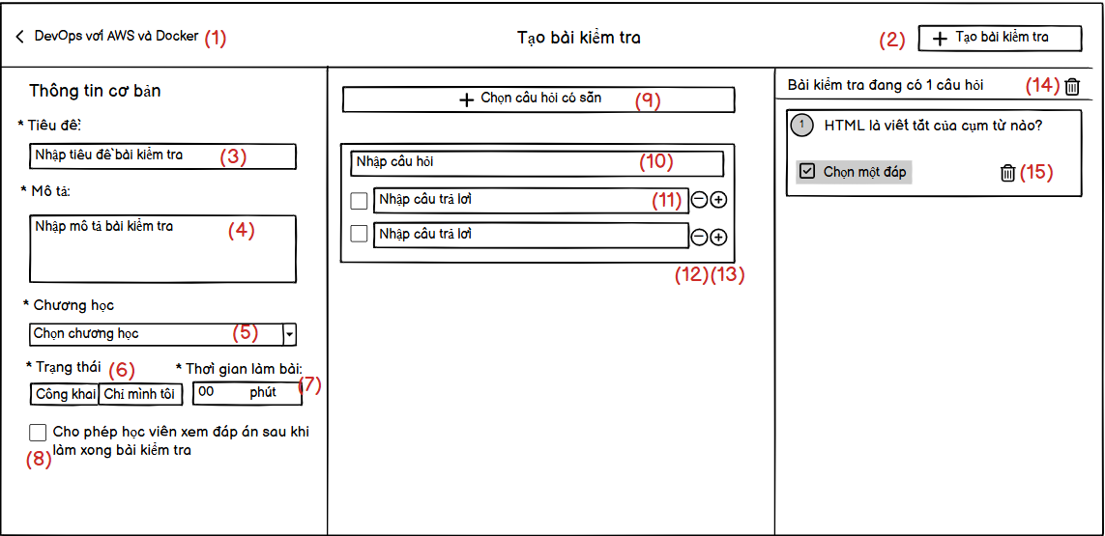

* When the Expert clicks on Add Test in the Course List, a test creation form will appear.
* The creation form will allow the Expert to enter the test title, description, select the course, status, test time, and allow students to view the answers.
* The Expert can create questions and answers or take available questions from the question bank.
* The questions created or taken will be displayed in the far right column, and all questions or one question can be deleted.

| **No** | **Field** | **Description/Function of field** |
| --- | --- | --- |
| 01 | Back | Expert can come back course list page |
| 02 | Create Button | When click, a new quiz will create |
| 03 | Title input | Allow expert can input quiz title |
| 04 | Description input | Allow expert can input quiz description |
| 05 | Chapter select | Allow expert can select chapter |
| 06 | Status | Allow expert can select status |
| 07 | Duration | Allow expert can input quiz duration |
| 08 | Check box | Allow expert can check allow student can view answer after do quiz |
| 09 | Select question from bank | Allow expert can select question from bank |
| 10 | Question input | Allow expert input question to create new question |
| 11 | Answer input | Allow expert input answer for that question |
| 12 | Add answer | Allow expert add answer |
| 13 | Remove answer | Allow expert remove answer |
| 14 | Delete all question | Allow expert delete all question |
| 15 | Delete question | Allow expert delete this question |

## 19. Update quiz (Admin)

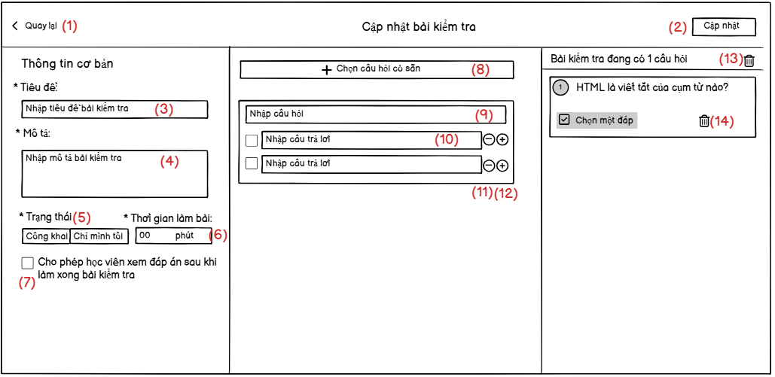

* When Expert clicks on update quiz, a quiz update form will appear.
* Expert can edit title, description, status, duration, view answers after completion, add or remove questions.

| **No** | **Field** | **Description/Function of field** |
| --- | --- | --- |
| 01 | Back | Expert can come back quiz list |
| 02 | Update Button | When click, a quiz will be update |
| 03 | Title input | Allow expert can input quiz title |
| 04 | Desciption input | Allow expert can input quiz description |
| 05 | Status | Allow expert select status |
| 06 | Duration | Allow expert can input quiz duration |
| 07 | Check box | Allow expert can check allow student can view answer after do quiz |
| 08 | Select question from bank | Allow expert can select question from bank |
| 09 | Question input | Allow expert input question to create new question |
| 10 | Answer input | Allow expert input answer for that question |
| 11 | Add answer | Allow expert add answer |
| 12 | Remove answer | Allow expert remove answer |
| 13 | Delete all question | Allow expert delete all question |
| 14 | Delete question | Allow expert delete this question |

## 20. List of students of a course (Admin)

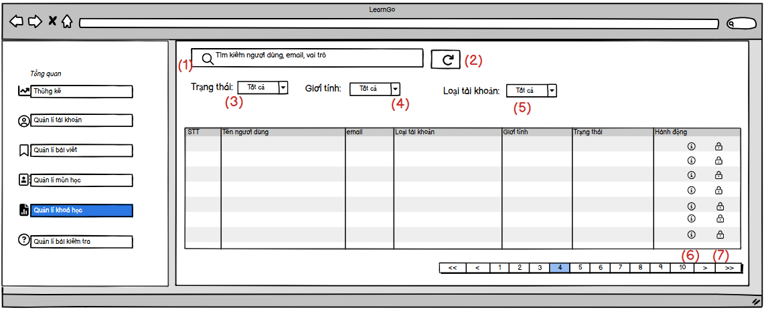

* When clicking on the icon to view all users registered for the course on the course management page, a table of users registered for that course will be displayed.
* Admin can search by username, email, can filter the fields of status, gender, account type,
* Admin can view detailed information of users, block users.

| **No** | **Field** | **Description/Function of field** |
| --- | --- | --- |
| 01 | Search | Admin can search by username, email, role |
| 02 | Refresh Button | When click, all search fields will be empty |
| 03 | Status Select | Allow admin can select status to filter |
| 04 | Gender Select | Allow admin can select gender to filter |
| 05 | Account Type Select | Allow admin can select account type to filter |
| 06 | Detail Information | Allow admin can view detail information of user |
| 07 | Lock Icon | Allow admin can lock user |

## 21. Order list (Admin)

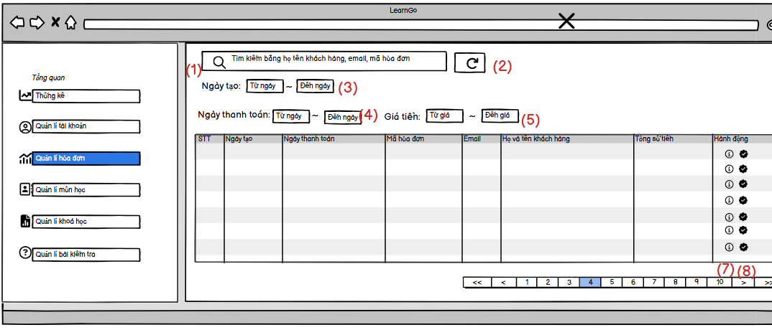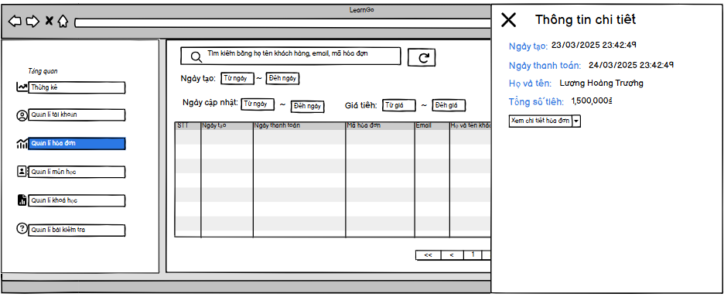

* When admin clicks on invoice management, a table of information will appear including the fields: STT, Creation date, Payment date, invoice code, Email, username, Total amount.
* Admin can search by username, email, invoice code and filter by creation date, payment date, amount.
* Admin can view invoice details, confirm paid invoices.

| **No** | **Field** | **Description/Function of field** |
| --- | --- | --- |
| 01 | Search | Admin can search by username, email, order code |
| 02 | Refresh Button | When click, all search fields will be empty |
| 03 | CreatedAt | Allow admin can filter by create at |
| 04 | PaidAt | Allow admin can filter by paid aat |
| 05 | Price | Allow admin can filter by price |
| 06 | Detail Information | Allow admin can view detail information of order |
| 07 | Lock Icon | Allow admin can accept order |



## 22. Course details (User)

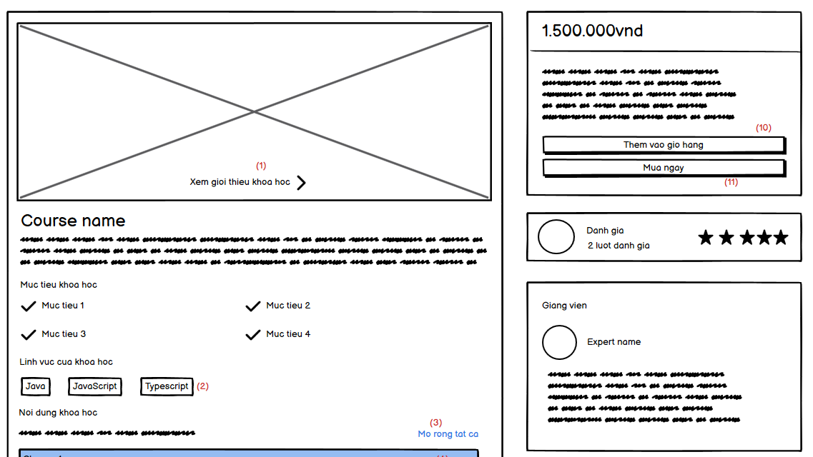

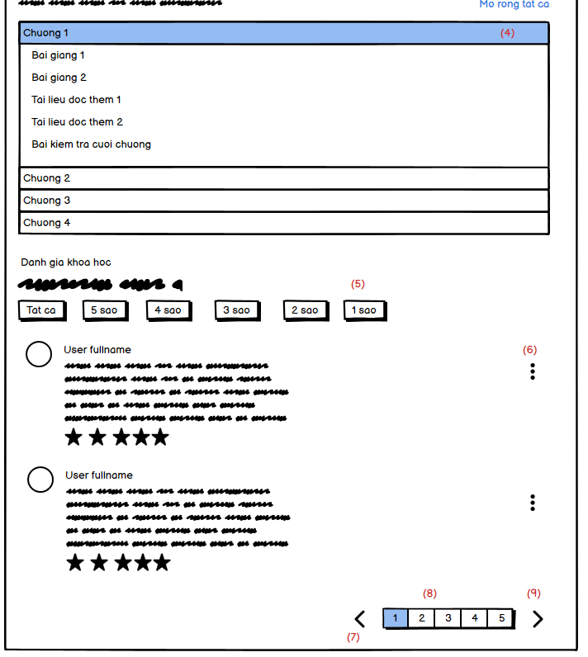

* The course details page include:
  + The course information
  + Course chapters content and lessons of each chapter
  + Course rating: all the rating of this course
  + Price of course, purchase button, add to cart button
  + Expert of this course and he/she base information

| **No** | **Field** | **Description/Function of field** |
| --- | --- | --- |
| 01 | View course intro video | When click, open the modal and play the course video in here. |
| 02 | Single course subject button | When click, redirect user to course list page and search all course that have the subject equals the subject user clicked |
| 03 | Open/close all chapters | When click, if all the chapters are open, close them. Else open all chapters. |
| 04 | Single chapter | When click, open/close the chapter view. When open, the user can see all lessons of that chapter and quiz (if existed). |
| 05 | Star filter | When click, display only the rating that have stars equals the star clicked. If they click on all (default), display all rating. |
| 06 | Dot button | Display report button |
| 07 | Previous page button | When clicked, go to the previous rating page. If the current page is 1, disable the button |
| 08 | Page number button | When clicked, go to the rating page that equals number user clicked |
| 09 | Next page button | When clicked, go to the next rating page. If the current page is last page, disable the button |
| 10 | Add to cart button | Add course to cart. |
| 11 | Purchased button | Open the modal for user review the order. |

## 23. Create subject

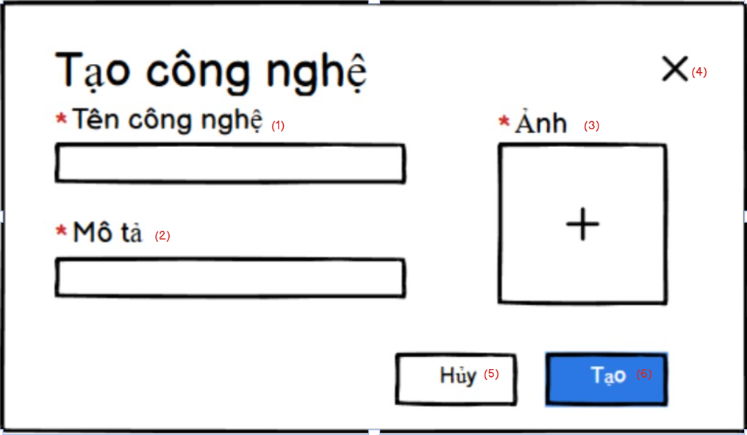

* This page allows the expert create a new subject by inputting name, description and thumbnail of subject.
* Expert can cancel the create process by clicking on the “Hủy” button or the “X” icon..
* Expert click on the “Tạo” button to finish the create process.

| **No** | **Field** | **Description/Function of field** |
| --- | --- | --- |
| 01 | Name | Experts input the name of the subject. This field can not be duplicated |
| 02 | Description | Experts input the description of the subject |
| 03 | Thumbnail | Experts input the description of the subject. The numbnail must be JPG, JDPG, PNG |
| 04 | “X” icon | Experts can cancel the create process by clicking on this icon. |
| 05 | “Hủy” button | Experts can cancel the create process by clicking on this icon. |
| 06 | “Tạo” button | Experts can finish the create process by clicking on this button. |

## 24. Create course

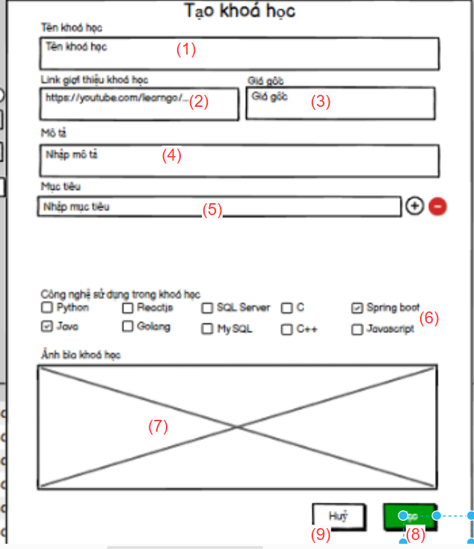

* Allow expert to create course, all information cannot be empty, with each expert name cannot be duplicate.If valid expert can create course

| **No** | **Field** | **Description/Function of field** |
| --- | --- | --- |
| 01 | Course name | input name of course, name not more than 20 words |
| 02 | Link course | input youtube link of course |
| 03 | Price of course | input price of course |
| 04 | Course description | input description of course, description not more than 1000 words |
| 05 | Objectives list | input objectives list of course |
| 06 | Subject list | input subject of courses |
| 07 | Images of course | input images of course |
| 08 | Create button | to create course if all information valid |
| 09 | Cancel button | to back to course page |

## 25. Create lessons

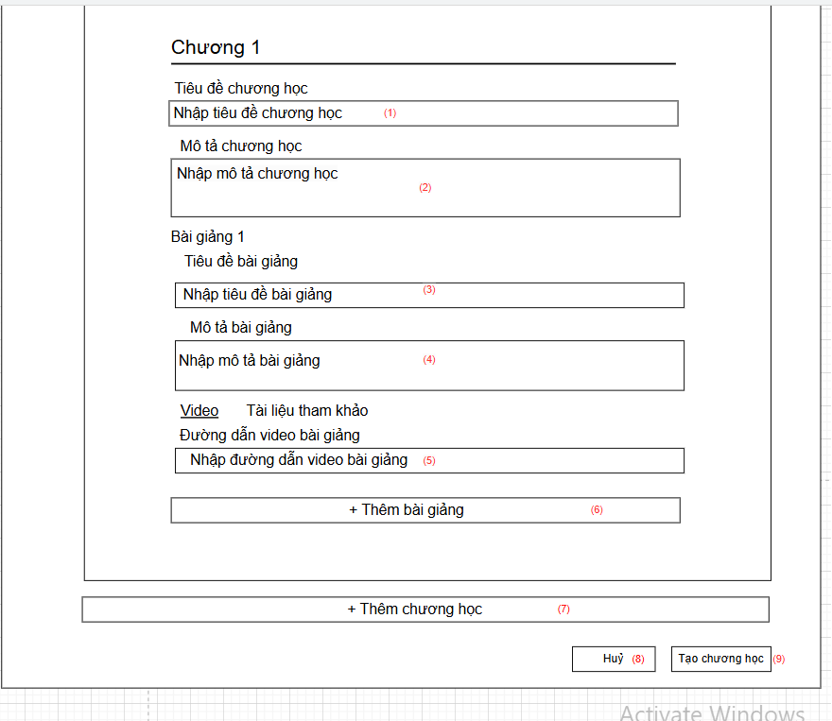

* Allow expert to create chapter and lesson for a course, all information cannot be empty, each chapter only have video or document

| **No** | **Field** | **Description/Function of field** |
| --- | --- | --- |
| 01 | Chapter name | input name of chapter, name not more than 20 words |
| 02 | Chapter description | input chapter description |
| 03 | Lesson name | input lesson name |
| 04 | Lesson description | input description of lesson, description not more than 1000 words |
| 05 | Link video / content of document | input video url or content of document |
| 06 | Add lesson | add 1 more lesson |
| 07 | Add chapter | add 1 more chapter |
| 08 | Cancel button | to back to course page |
| 09 | Create button | create new chapter |

## 26. Update course

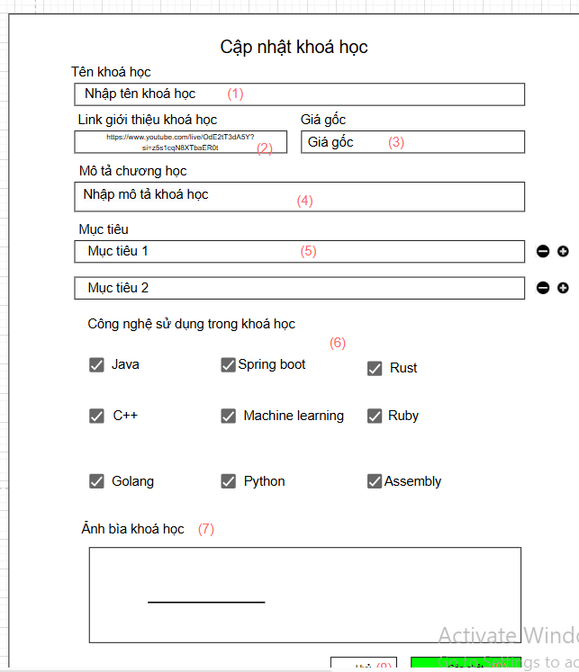

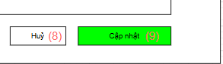

Allow expert to update courses, if information is valid, expert can update courses.all information cannot be empty, with each expert name cannot be duplicate.

| **No** | **Field** | **Description/Function of field** |
| --- | --- | --- |
| 01 | Course name | input name of course, name not more than 20 words |
| 02 | Link course | input youtube link of course |
| 03 | Price of course | input price of course |
| 04 | Course description | input description of course, description not more than 1000 words |
| 05 | Objectives list | input objectives list of course |
| 06 | Subject list | input subject of courses |
| 07 | Images of course | input images of course |
| 08 | Create button | to create course if all information valid |
| 09 | Cancel button | to back to course page |

## 27. Question list

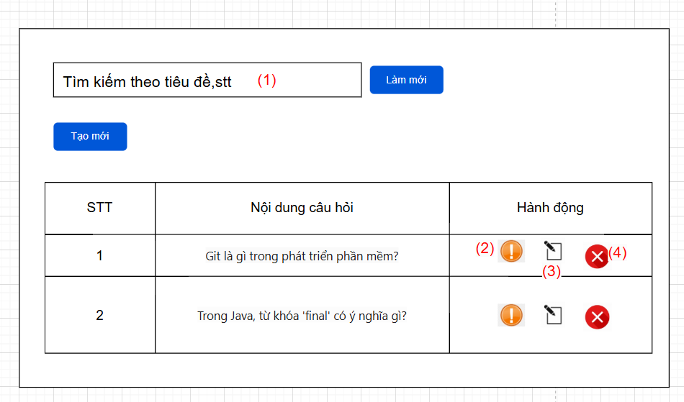

Can see all question and search question filter by id, title

| **No** | **Field** | **Description/Function of field** |
| --- | --- | --- |
| 01 | Search bar | search by filter title, id |
| 02 | View detail question | see detail of question include: answer and quiz it belong |
| 03 | Update question | update information of question |

## 28. Course purchase

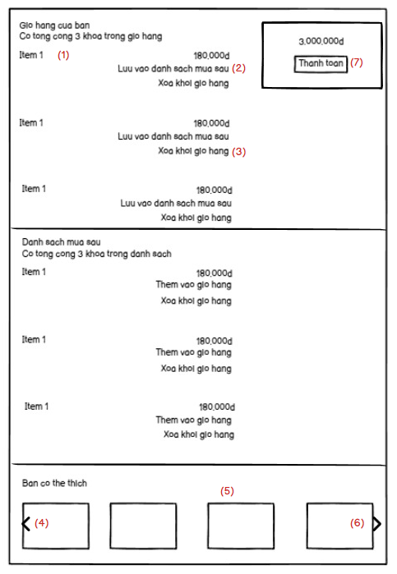

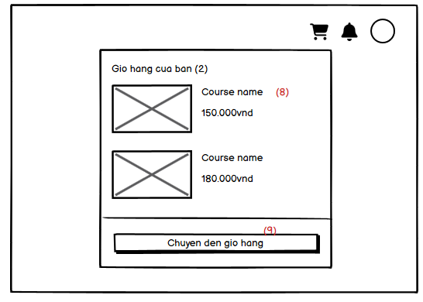

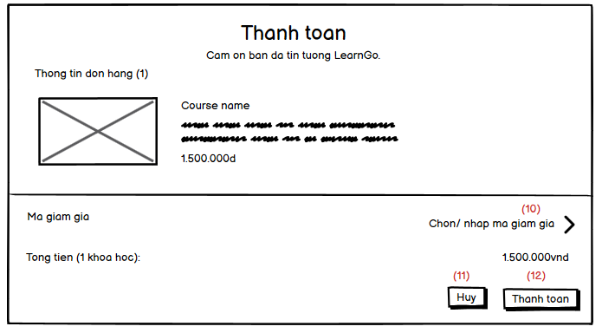

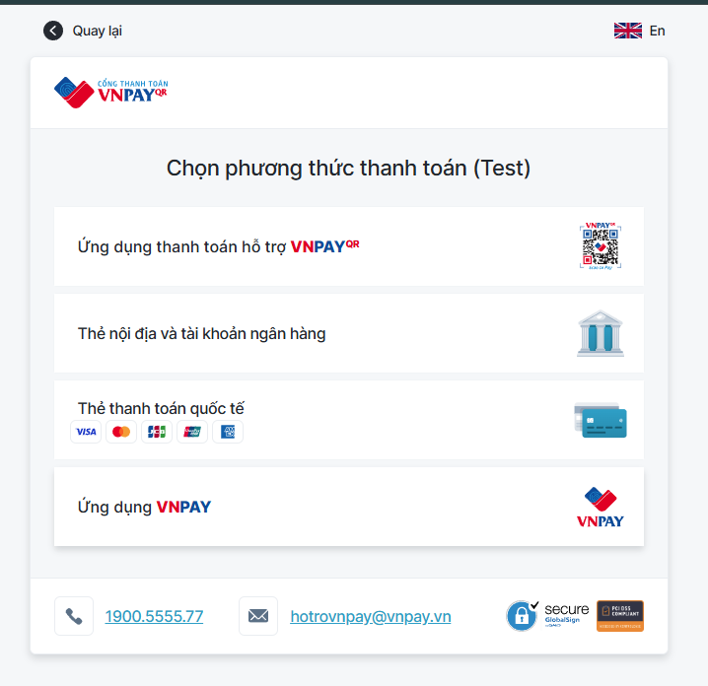

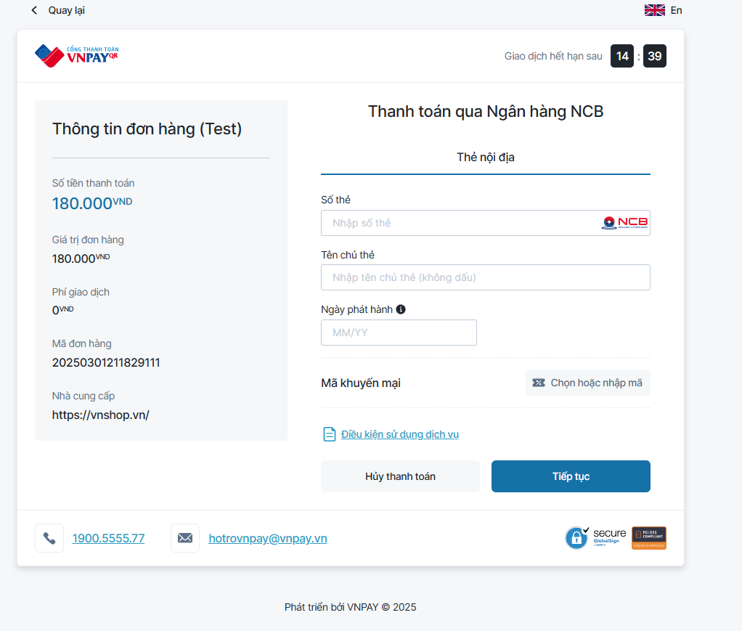

* In the cart popup, display all course in the cart (scrollable) and a button to go to the cart page
* In the cart page, there are 4 main parts:
  + Course for purchasing: these will be add to the order for purchasing
  + Course in purchase later list: although they still in the cart, but user don’t have to purchase it in current order
  + Suggest course: Base on user course in the cart, display all the course that have same subjects as them
  + The summary price of the order and button to purchase

| **No** | **Field** | **Description/Function of field** |
| --- | --- | --- |
| 01 | Single course in cart | When click, user will be redirected to course details page of that course clicked |
| 02 | Luu vao danh mua sau button | Add the course in cart to the purchase later list (remove it from the order) |
| 03 | Delete from cart button | Delete course in the cart. |
| 04 | Previous button | Go to the previous course slider |
| 05 | Single course in slider | When click, go to that course details page |
| 06 | Next button | Go to the next course slider |
| 07 | Purchase button | Open the order details modal |
| 08 | Single course in cart modal | When click, go to that course page details |
| 09 | Go to cart page button | Go to the cart page. (/cart) |
| 10 | Select coupon | Open the modal to select to coupon to apply the order |
| 11 | Cancel button | Close the purchase modal |
| 12 | Purchase button | Redirect user to vn pay payment page. User will pay the cost here. |

## 29. Lessons view

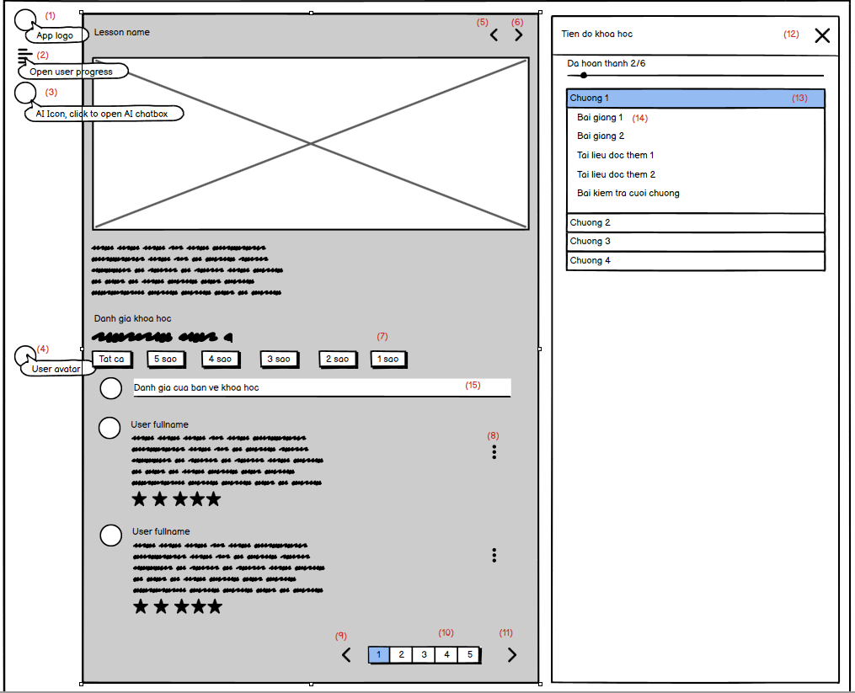

* The lessons view page include:
  + Sidebar: there are web logo, open user progress, open AI chatbox, user avatar
  + Lesson content: the playing video, the description of video and the rating of the course
  + The user progress: completion of the course, chapters list, and in each chapter there are lessons list for user to select

| **No** | **Field** | **Description/Function of field** |
| --- | --- | --- |
| 01 | Web logo | When click, user will be redirected to home page |
| 02 | Open user progress sidebar button | When click, open the user progress sidebar. If the AI chatbox is opening, close it before open the user progress sidebar. |
| 03 | Open AI chat box | When click, open the AI chatbox. If the user progress is opening, close it before open the AI chatbox. |
| 04 | User avatar | When click, open the popover. |
| 05 | Previous lesson button | When click, go the previous lessons |
| 06 | Next lesson button | When click, go the next lessons |
| 07 | Star filter | When click, display only the rating that have stars equals the star select |
| 08 | Dot button | Display the modal that has report button |
| 09 | Previous page button | Go to the cart page. (/cart) |
| 10 | Page number button | Open the modal to select to coupon to apply the order |
| 11 | Next page button | Close the purchase modal |
| 12 | Close button | Redirect user to vn pay payment page. User will pay the cost here. |
| 13 | Single chapters | When click, open lessons list in the chapter |
| 14 | Single lessons | When click, open the lesson |
| 15 | Rating input | User can input their rating here |

## 30. Update subject

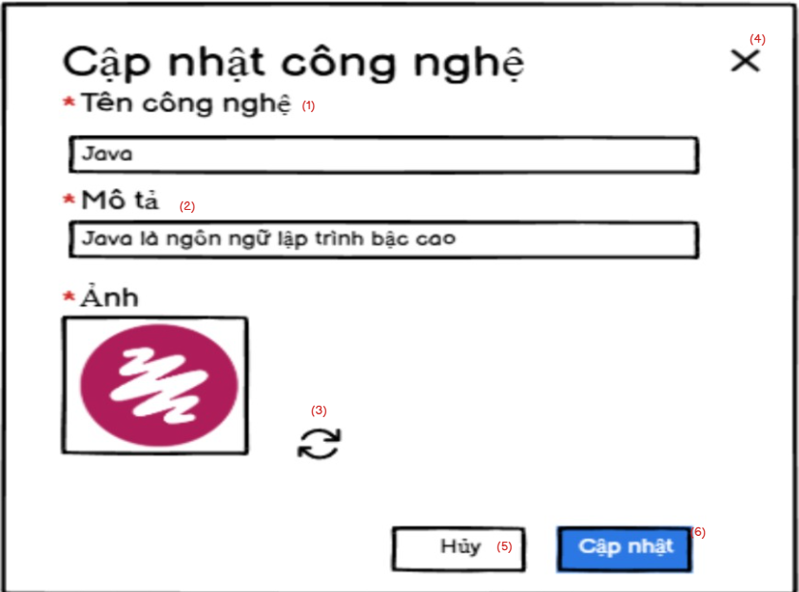

* This page allows the expert to update the subject by inputting the name, description and thumbnail of the subject.
* Expert can cancel the update process by clicking on the “Hủy” button or the “X” icon..
* Experts click on the “Cập nhật” button to finish the create process.

| **No** | **Field** | **Description/Function of field** |
| --- | --- | --- |
| 01 | Name | Experts input the name of the subject. This field can not be duplicated |
| 02 | Description | Experts input the description of the subject |
| 03 | Thumbnail | Experts change the thumbnail of the subject. The numbnail must be JPG, JDPG, PNG |
| 04 | “X” icon | Experts can cancel the update process by clicking on this icon. |
| 05 | “Hủy” button | Experts can cancel the update process by clicking on this icon. |
| 06 | “Cập nhật” button | Experts can finish the update process by clicking on this button. |

## 31. Create question

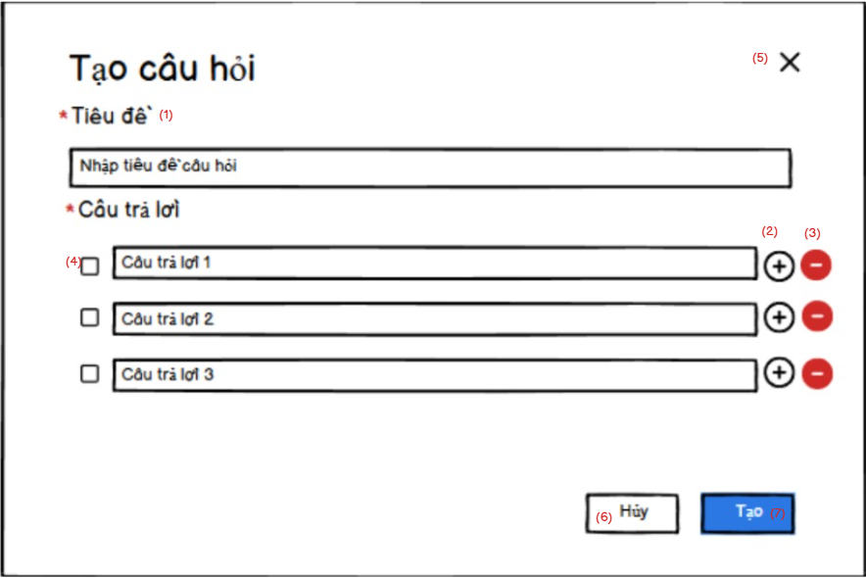

* This page allows the expert to create a new question by inputting title, answers including the correct or wrong answers
* Experts can add the input field answer by clicking on the “+” icon.
* Experts can remove the input field answer by clicking on the “-” icon.
* Experts can choose the correct answer by clicking on the check box beside the answer field.
* Experts can cancel the create process by clicking on the “Hủy” button or the “X” icon..
* Experts click on the “Tạo” button to finish the create process.

| **No** | **Field** | **Description/Function of field** |
| --- | --- | --- |
| 01 | Title | Experts input the title of the question. This field can not be duplicated |
| 02 | Add answer | Experts click on this icon to add more answers for the question. |
| 03 | Remove answer | Experts click on this icon to remove the answer for the question. |
| 04 | Choose correct answer | Experts click on this icon to confirm that these answers are correct answers for the question. |
| 05 | “X” icon | Experts can cancel the creation process by clicking on this icon. |
| 06 | “Hủy” button | Experts can cancel the creation process by clicking on this icon. |
| 07 | “Tạo” button | Experts can finish the creation process by clicking on this button. |

## 32. Update question

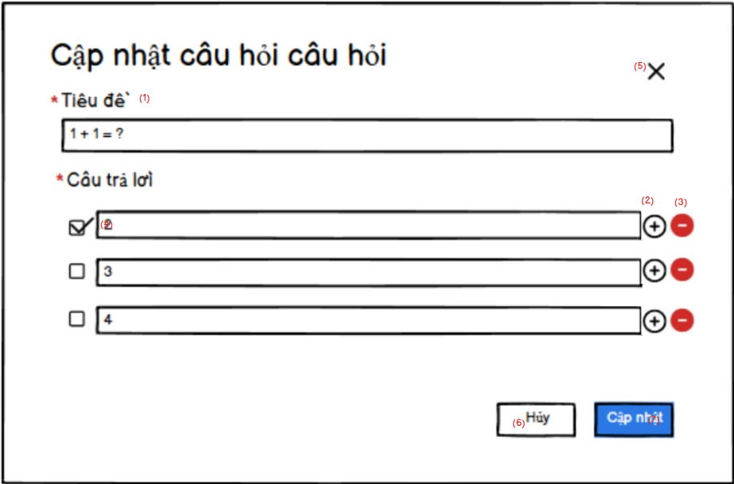

* This page allows the expert to update the question by inputting title, answers including the correct or wrong answers
* Experts can add the input field answer by clicking on the “+” icon.
* Experts can remove the input field answer by clicking on the “-” icon.
* Experts can choose the correct answer by clicking on the check box beside the answer field.
* Experts can cancel the update process by clicking on the “Hủy” button or the “X” icon..
* Experts click on the “Cập nhật” button to finish the update process.

| **No** | **Field** | **Description/Function of field** |
| --- | --- | --- |
| 01 | Title | Experts input the title of the question. This field can not be duplicated |
| 02 | Add answer | Experts click on this icon to add more answers for the question. |
| 03 | Remove answer | Experts click on this icon to remove the answer for the question. |
| 04 | Choose correct answer | Experts click on this icon to confirm that these answers are correct answers for the question. |
| 05 | “X” icon | Experts can cancel the update process by clicking on this icon. |
| 06 | “Hủy” button | Experts can cancel the update process by clicking on this icon. |
| 07 | “Cập nhật” button | Experts can finish the update process by clicking on this button. |

## 33. Notifications (User)

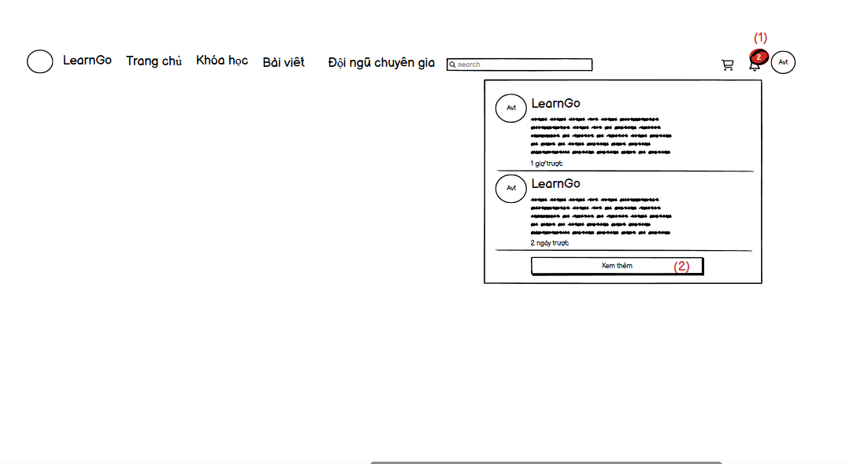

* When the user has a notification, the notification number will appear next to the bell icon. When pressed, the entire notification and a small part of the content will appear.

| **No** | **Field** | **Description/Function of field** |
| --- | --- | --- |
| 01 | Bell | The number of notifications will be displayed near the bell icon. When clicking on the icon, the user can see 3 newest notifications. |
| 02 | “Xem them” button | Go to the notification detail page |

## 34. Notifications details (User)

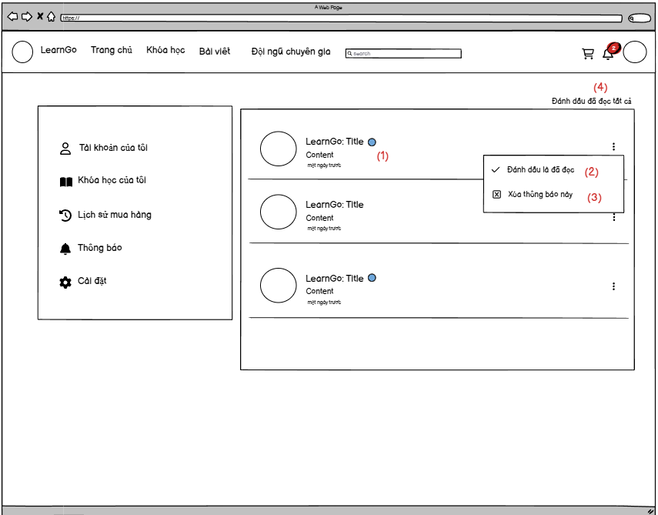

* When the user clicks on see more, it will lead to the all notifications page, when clicking on it, the notification content can be viewed. Can delete notifications, mark 1 notification or all notifications as read

| **No** | **Field** | **Description/Function of field** |
| --- | --- | --- |
| 01 | Notification | When clicking a notification, the user can view all the content of the notification, and this notification will disappear blue dot |
| 02 | “Danh dau da doc” | Allows readers to mark the notification as read without having to click to view the content |
| 03 | “Xoa thong bao” | Allow users to delete notifications whether read or not |
| 04 | “Danh dau da doc tat ca” | Allows users to mark all notifications as read without viewing the content of each notification |

## 35. Notifications list (Admin)

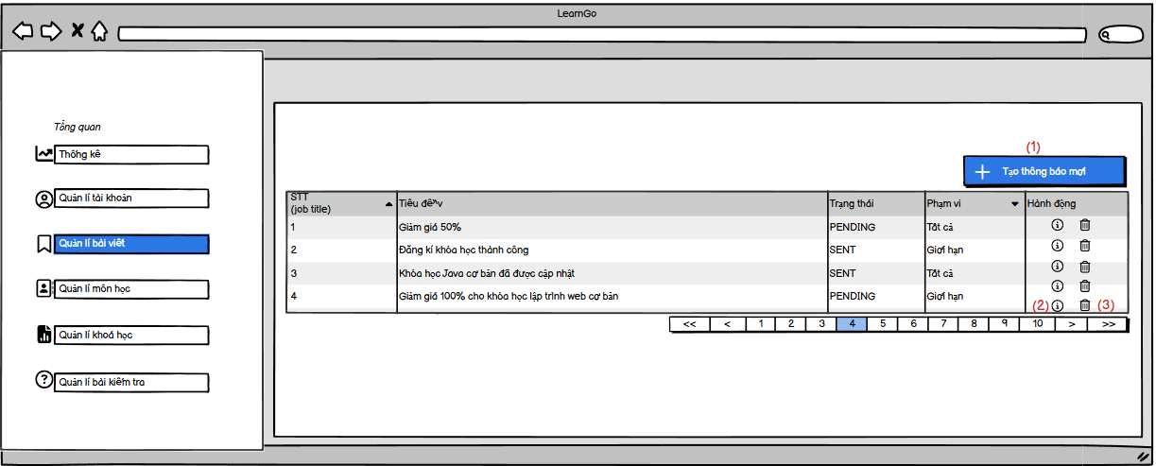

* Admin can manage the notification, can next page to view another notification

| **No** | **Field** | **Description/Function of field** |
| --- | --- | --- |
| 01 | Create notification | Allow admin create a new notification |
| 02 | View detail icon | Allows admin view detail a notification |
| 03 | Delete notification | Allow admin delete a notification |

## 36. Create notification

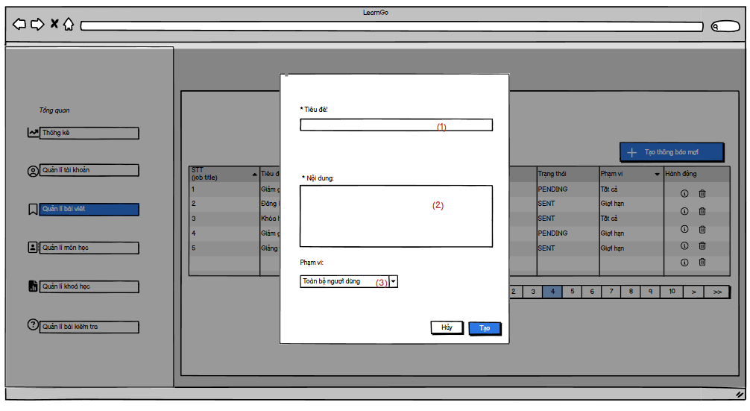

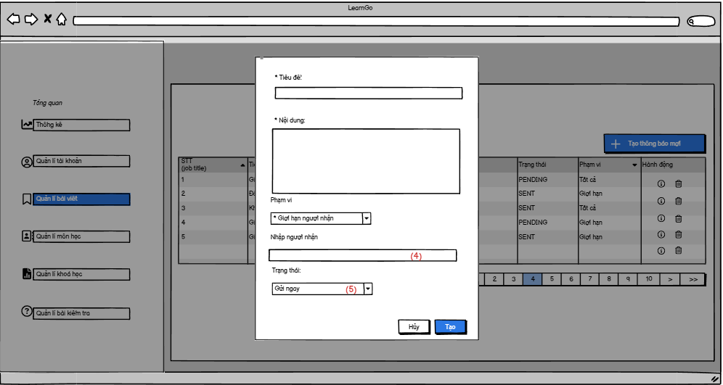

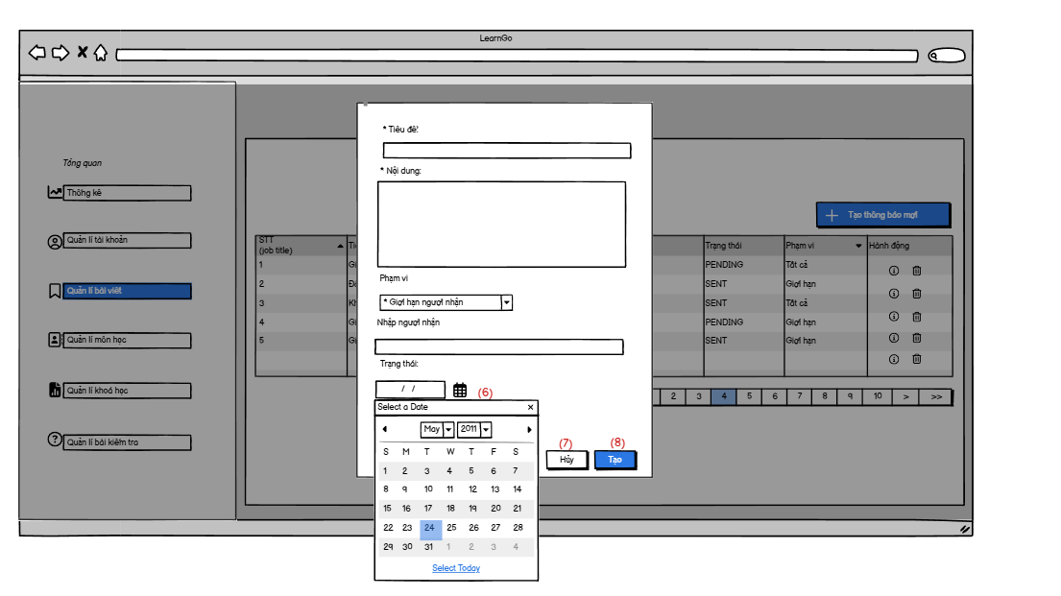

* Admin can create a new notification.
* A notification will have 2 options receiver and 2 options status.
  + 2 options receiver:
    - All: All user can receive this notification
    - Limited: Some user who selected to receive this notification
  + 2 options status:
    - PENDING: This notice will be scheduled to be sent.
    - SENT: This notice will be sent immediately.

| **No** | **Field** | **Description/Function of field** |
| --- | --- | --- |
| 01 | Title field | Input title of notification |
| 02 | Content field | Input content of notification |
| 03 | Recipient scope | Recipient Limitation |
| 04 | Input receiver | Specify notification recipients |
| 05 | Status | Choosing the status of notification |
| 06 | Set date | Setup date to auto send notification |
| 07 | Cancel button | Cancel create notification |
| 08 | Create button | Create notification |

## 37. Notifications details (Admin)

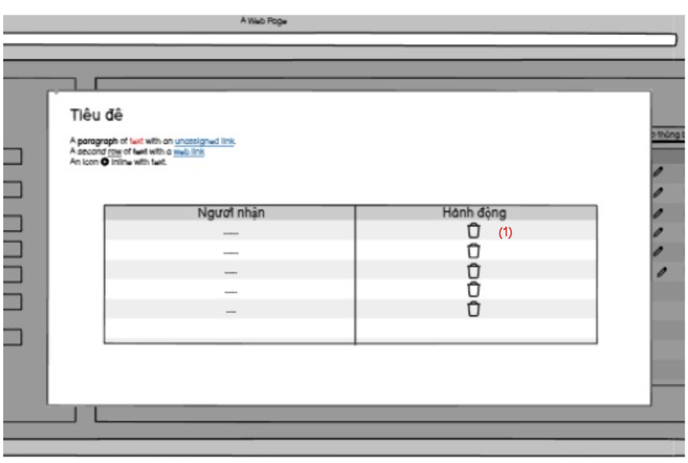

* Admin can view title, content, and who receive a notification.
* Admin can delete receiver

| **No** | **Field** | **Description/Function of field** |
| --- | --- | --- |
| 01 | Delete receiver | Delete a receiver |

## 38. Blog list (Admin)

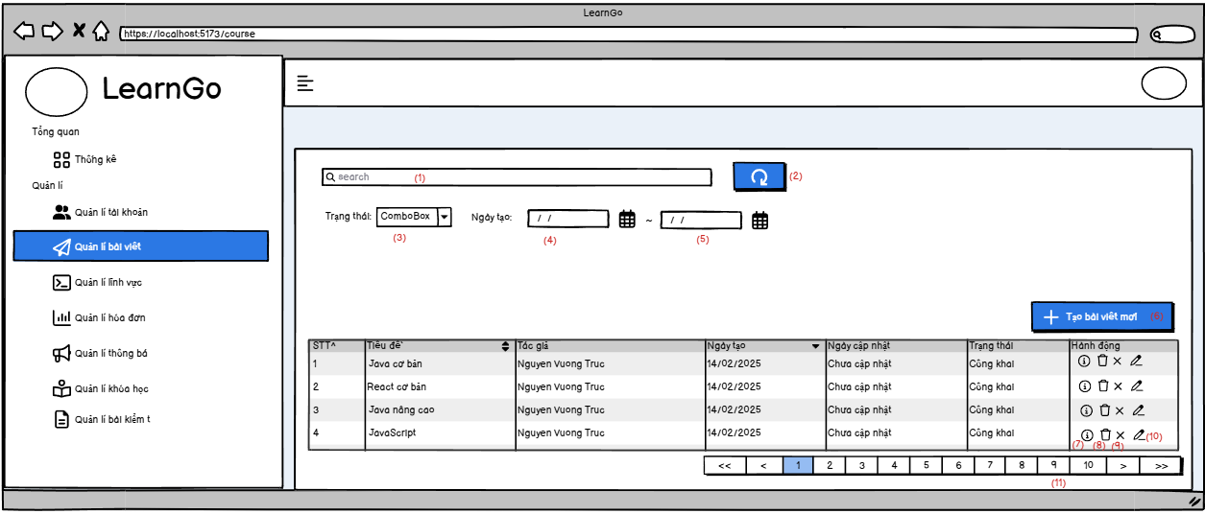

* Marketing and expert can see all their posts.
* They can search blog by name, status, and created at.

| **No** | **Field** | **Description/Function of field** |
| --- | --- | --- |
| *01* | *Search blog* | *Allow search blog by name* |
| *02* | *Button reset* | *Click to refresh page* |
| *03* | *Status* | *Search by status* |
| *04* | *Created From* | *Find by created at greater than or equal created from* |
| *05* | *Created To* | *Find by created at less than or equal created to* |
| *06* | *Create a blog button* | *Allow expert and marketing create a blog* |
| *07* | *Blog detail* | *View details of 1 blog* |
| *08* | *Delete blog* | *Allow expert and admin can delete a blog* |
| *09* | *Change status a blog* | *Allow expert and marketing change status of blog* |
| *10* | *Update a blog* | *Allow expert and marketing update a blog* |
| *11* | *Change page* | *Change page to view another blog* |

## 39. Blog details (Admin)

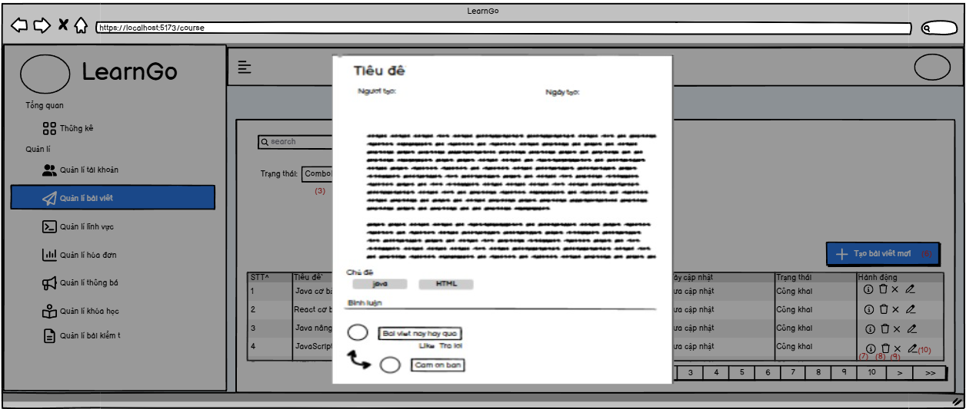

* Marketing and expert can view detail a their blog, comment of blog.

## 40. Update blog

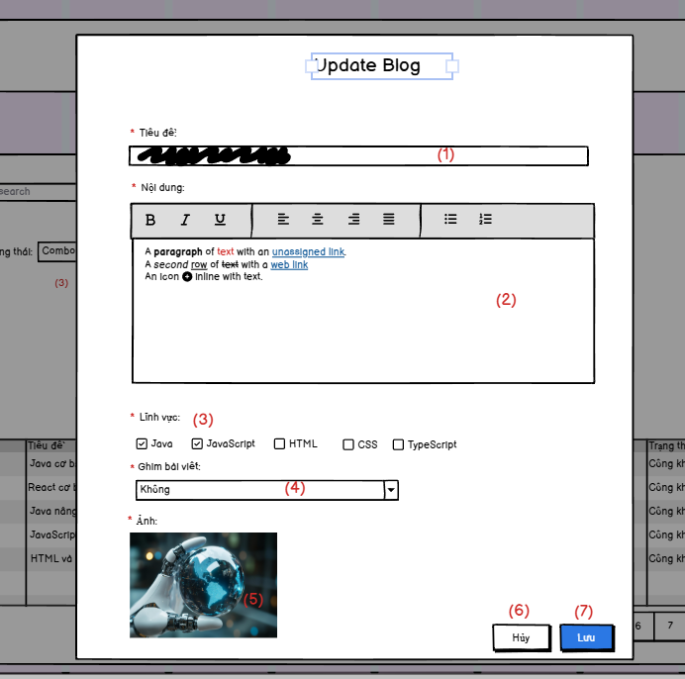

* Marketing and expert can update a their blog.
* If one of all fields is empty, they can not update blog.

| **No** | **Field** | **Description/Function of field** |
| --- | --- | --- |
| *01* | *Titile field* | *Input title of blog* |
| *02* | *Content field* | *Input content of blog* |
| *03* | *Category of blog* | *Choose categories of blog* |
| *04* | *Accept pinned* | *Allow accepted pinned* |
| *05* | *Thumbnail field* | *Choose a thumbnail of blog* |
| *06* | *Cancel Button* | *Cancel form create blog* |
| *07* | *Save Button* | *Save form blog.* |

## 41. Create blog

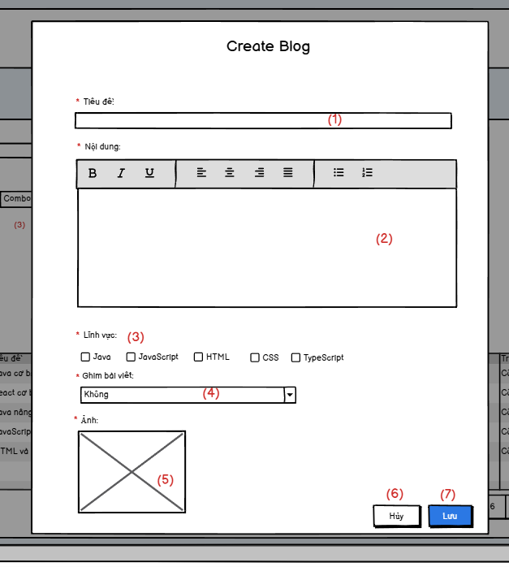

* Marketing and expert can fill all the fields to create a blog.
* If one of all fields is empty, they can not create blog.

| **No** | **Field** | **Description/Function of field** |
| --- | --- | --- |
| *01* | *Titile field* | *Input title of blog* |
| *02* | *Content field* | *Input content of blog* |
| *03* | *Category of blog* | *Choose categories of blog* |
| *04* | *Accept pinned* | *Allow accepted pinned* |
| *05* | *Thumbnail field* | *Choose a thumbnail of blog* |
| *06* | *Cancel Button* | *Cancel form create blog* |
| *07* | *Save Button* | *Save form blog.* |

## 42. AI Integration

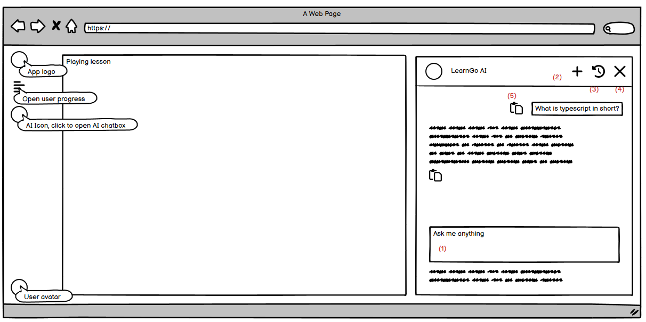

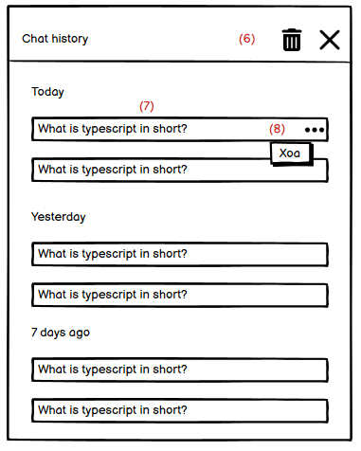

* The AI chat box include:
  + Header: Some button and AI name
  + Chat content: the user’s questions and chat responses
  + Question input
* Chat history include:
  + Delete all chat icon
  + All chat history (last 7 days) if more than 7 days, they will not display

| **No** | **Field** | **Description/Function of field** |
| --- | --- | --- |
| 01 | Question/Prompt input | User can input the question they want to ask the AI |
| 02 | New chat button | Open + Create a new chat |
| 03 | Open the history sidebar button | Open the history sidebar |
| 04 | Close AI button | Close the AI chat box |
| 05 | Copy button | When click, copy the content to clipboard (question or chat response) |
| 06 | Delete all button | When click, open the modal to confirm, if they enter yes, delete all chat history |
| 07 | Single chat history | When click, open the clicked chat |
| 08 | Dot button | When click, open the delete single chat history button, when they click the delete button, delete this history |

## 43. Do quiz

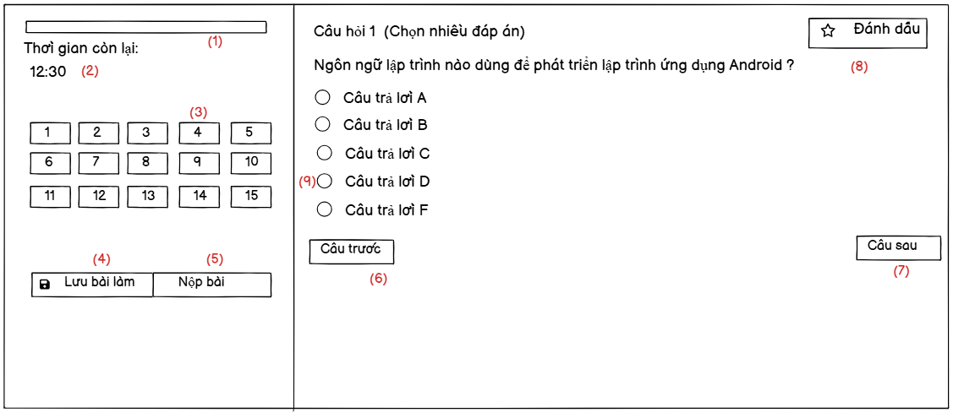

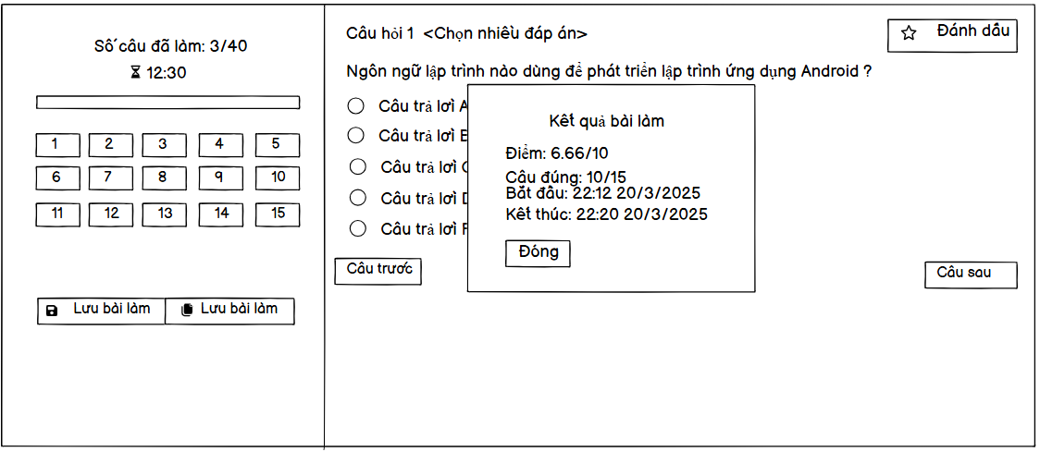

* When the user clicks on Do the test now, a test form will appear.
* The user will do the test by checking the available answers, the user can change the question using the two change button below or click directly on the question board on the left, can mark the question, after a period of time the test will be automatically saved, the user can also actively save.
* When clicking submit, the user will be notified to confirm the submission, how many questions have been done.
* When the time is up, the result will be displayed.

| **No** | **Field** | **Description/Function of field** |
| --- | --- | --- |
| *01* | *Progress* | *User can view progress of quiz* |
| *02* | *Time left* | *User can view time left* |
| *03* | *Question Button* | *User can click to move to question* |
| *04* | *Save* | *User can click to save the quiz* |
| *05* | *Submit* | *User can submit the quiz* |
| *06* | *Previous question* | *User can move to previous question* |
| *07* | *Next question* | *User can move to next question* |
| *08* | *Mark question* | *User can mark the question* |
| *09* | *Check answer* | *User can click to check answer* |

## 44. Quiz review

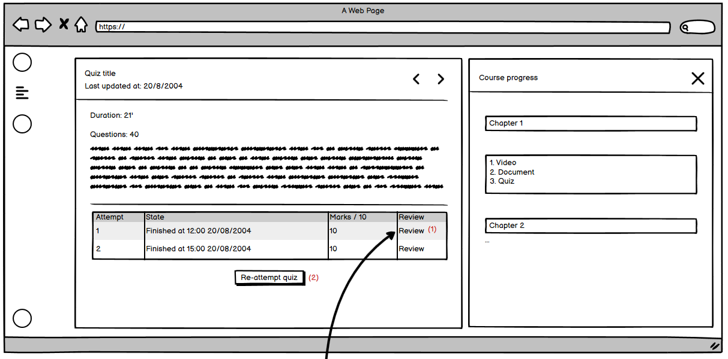

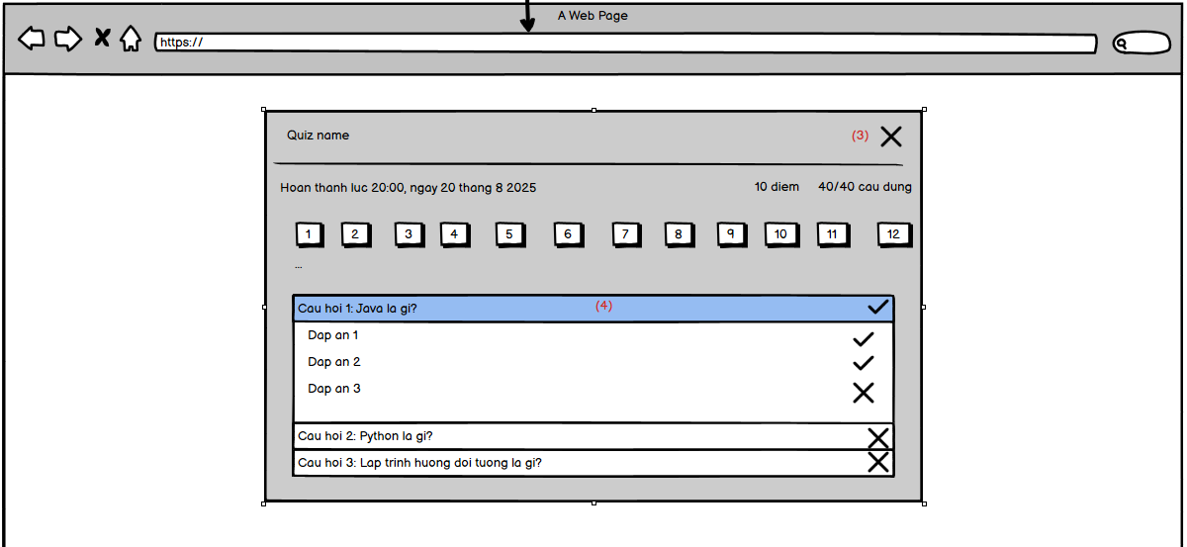

* When users visit this page, they will see the quiz information, and all of their attempts. Each attempt, they will see the status (Completed or still in progress), if the quiz is in progress, they can continue to do that quiz, if the quiz is completed, they can see the finished time and marks, number of correct questions. And if the expert allows students to see answers, they can see the review button. If they click on that button, show the review quiz dialog.
* In the review quiz dialog, they also see the information about the quiz, number of correct questions and marks. They can all the answers in each question and their chosen answers

| **No** | **Field** | **Description/Function of field** |
| --- | --- | --- |
| 01 | Review button | Open the review quiz dialog, if the expert do not allow to see answer, the button will be hide |
| 02 | Re attempt quiz | Users can click here to do a quiz again, this button will display a different base on the user's attempt of this quiz. If is 0 (means user do not attempt yet), show the start button, if >0, show re-attempt button |
| 03 | Close dialog button | On click, close the quiz review dialog |
| 04 | Single question answer accordion | On click, show/hide the answers of question |

## 

## 45. Create/Update lessons

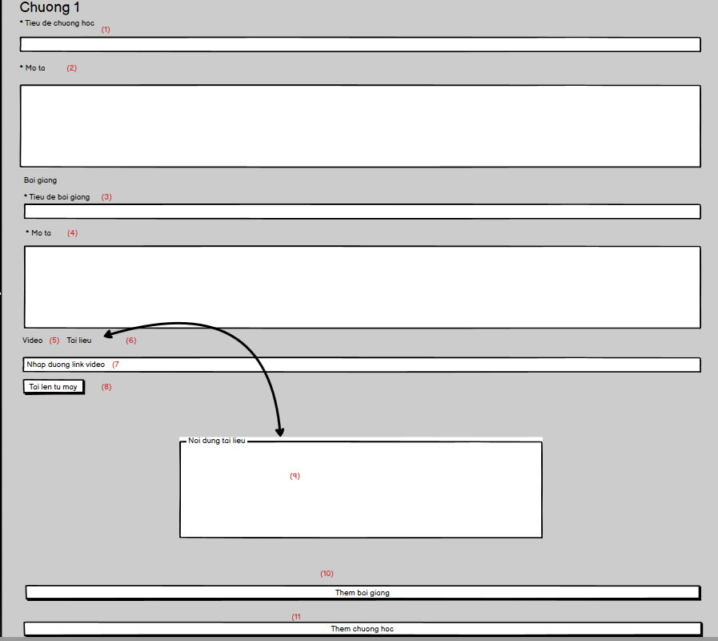

* This page will display all existed chapters of the course (if has), user can fill the form for updating or creating lessons for course

| **No** | **Field** | **Description/Function of field** |
| --- | --- | --- |
| 01 | Title of chapter | Input title for the chapter, the title cannot be more than 20 words |
| 02 | Description | Input the description |
| 03 | Title of lesson | Input title for lesson |
| 04 | Description of lesson | Input description for lesson |
| 05 | Video type lesson | On click, show the video input, user can input video url or upload video from local |
| 06 | Document type lesson | On click, show the document content input |
| 07 | Video url | Input video url |
| 08 | Upload video button | Upload video from the local device |
| 09 | Document content input | Input the document content |
| 10 | Add lesson button | Add a lesson in the current chapter |
| 11 | Add chapter button | Add more chapter to the current course |

## 

## 46. Rating a course

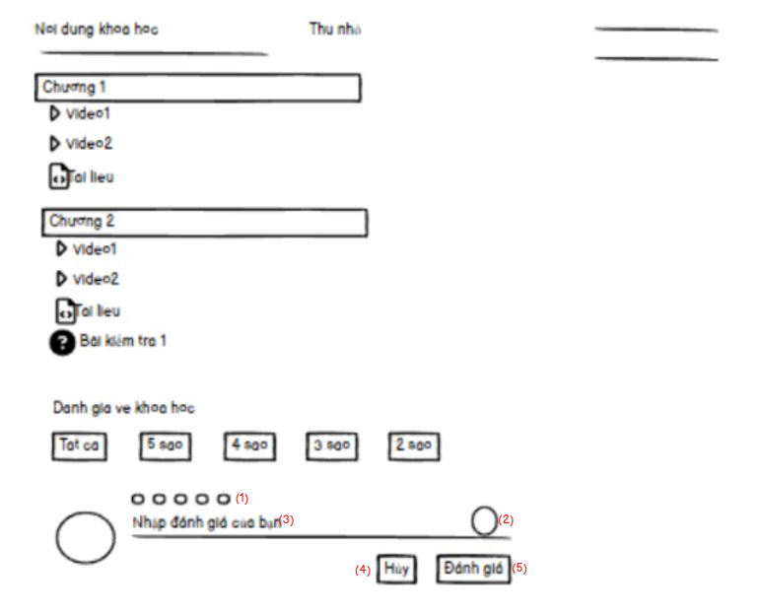

* This page allows students to rate the registered courses by giving stars from 1 to 5 and their opinion about the course.

| **No** | **Field** | **Description/Function of field** |
| --- | --- | --- |
| 01 | Number of stars | Student can give the level stars from 1 to 5 |
| 02 | Icon list | Student can add the icon on your rating |
| 03 | The rating | Student can give their opinion about the course |
| 04 | “Hủy” button | Students can cancel the rating process by clicking on this button. |
| 05 | “Đánh giá” button | Students can finish the rating process by clicking on this button. |

## 

* When students click on the button “Xóa”, the modal confirm deleting will appear.
* Students click to “Hủy” button to cancel the deleting course process.
* Students click to “Xóa” button to finish the deleting course process.

| **No** | **Field** | **Description/Function of field** |
| --- | --- | --- |
| 01 | “Xóa” button | Students click on this button to open modal deleting. |
| 02 | “Hủy” button | Students can cancel the deleting process by clicking on this button. |
| 03 | “Xóa” button | Students can finish the deleting process by clicking on this button. |

## 

* This page allows students to update their rating of the registered courses by giving stars from 1 to 5 and their opinion about the course after clicking on the “Chỉnh sửa” button.

| **No** | **Field** | **Description/Function of field** |
| --- | --- | --- |
| 01 | Number of stars | Student can give the level stars from 1 to 5 |
| 02 | Icon list | Student can add the icon on your rating |
| 03 | The rating | Student can give their opinion about the course |
| 04 | “Hủy” button | Students can cancel the updating process by clicking on this button. |
| 05 | “Đánh giá” button | Students can finish the updating process by clicking on this button. |
| 06 | “Chỉnh sửa” button | Students click on this button to update |

## 

## 47. Create coupons

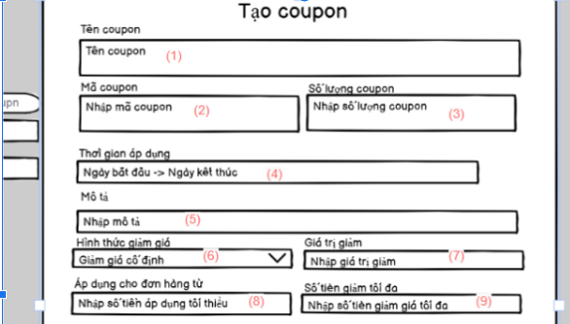

Allow expert,admin,marketing to create coupon for course, information cannot be empty except max discount value.

| **No** | **Field** | **Description/Function of field** |
| --- | --- | --- |
| 01 | Name coupon | input name of coupon, coupon name cannot more than 40 characters |
| 02 | Code coupon | input code of coupon, cannot more than 5 characters |
| 03 | Coupon number | input number of max used coupon, must be a number and greater than 0 |
| 04 | Start time - endtime | the time that coupon started and end |
| 05 | Coupon description | Description of a coupon, |
| 06 | Discount type | Have 2 type: fixed, percentage . If fixed from 1000 - 1000000, if percentage from 1%-99% |
| 07 | Discount value | input discount value of coupon, it less than min order value |
| 08 | Min order value | input min order value to apply coupon |
| 09 | Max discount amount | input max discount amount when apply coupon , it can have or not |
|  |  |  |

## 48. Update coupons

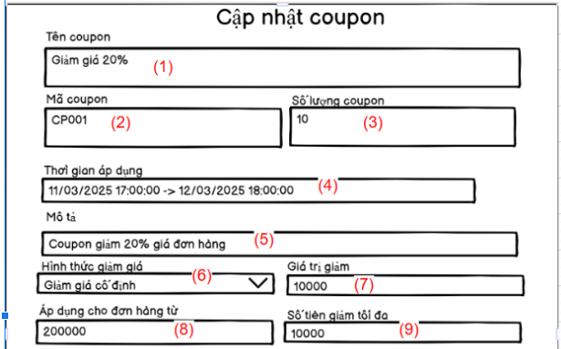

Allow expert,admin,marketing to update coupon for course, information cannot be empty excep max discount value.

| **No** | **Field** | **Description/Function of field** |
| --- | --- | --- |
| 01 | Name coupon | input name of coupon, coupon name cannot more than 40 characters |
| 02 | Code coupon | input code of coupon, cannot more than 5 characters |
| 03 | Coupon number | input number of max used coupon, must be a number and greater than 0 |
| 04 | Start time - endtime | the time that coupon started and end |
| 05 | Coupon description | Description of a coupon, |
| 06 | Discount type | Have 2 type: fixed, percentage . If fixed from 1000 - 1000000, if percentage from 1%-99% |
| 07 | Discount value | input discount value of coupon, it less than min order value |
| 08 | Min order value | input min order value to apply coupon |
| 09 | Max discount amount | input max discount amount when apply coupon , it can have or not |
|  |  |  |

## 

## 49. Coupons list(Admin)

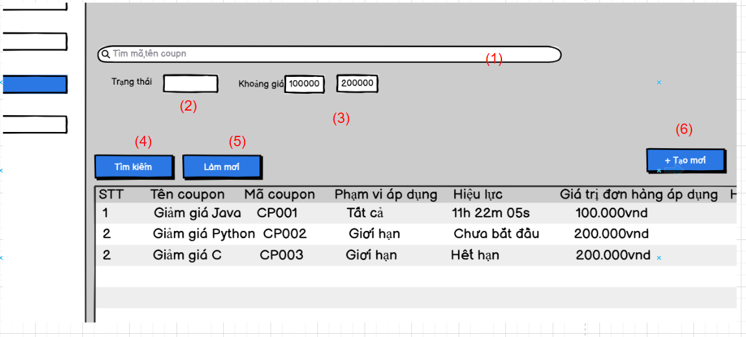

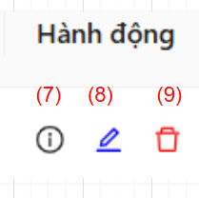

Allow expert,admin,marketing manage coupon, search coupon by coupon code, name coupon. status of coupon, price range of coupon

| **No** | **Field** | **Description/Function of field** |
| --- | --- | --- |
| 01 | Search bar | input name of coupon or coupon code to search |
| 02 | Status of coupon | it have 2 status: all and limit courses, filter to search |
| 03 | Price range of coupon | input minimum price to max price of discount value of coupon to search |
| 04 | Search button | allow to search with filter |
| 05 | Refresh button | refresh content of search bar and status |
| 06 | Create button | open create coupon modal |
| 07 | View detail button | open view detail modal |
| 08 | Edit coupon button | open update modal coupon |
| 09 | Delete coupon button | Delete coupon |

## 

## 50. Comment and like on blog

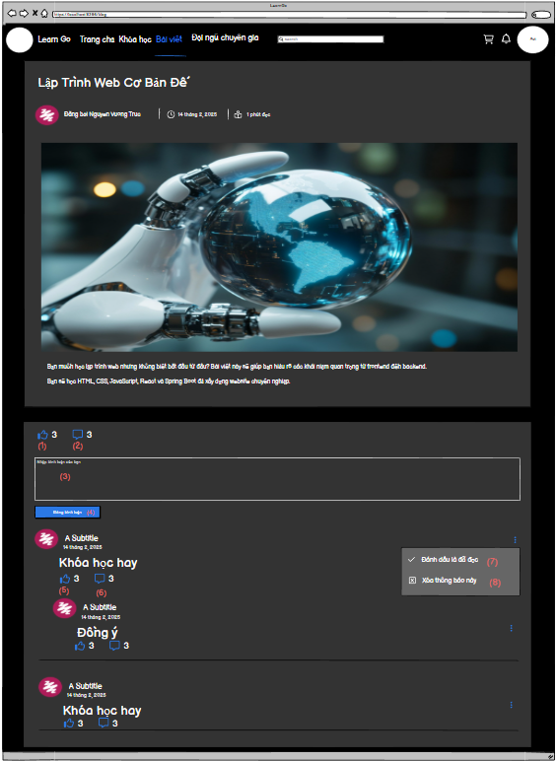

* Allow user can comment and like a blog. Users can like, reply to each other's comments

| **No** | **Field** | **Description/Function of field** |
| --- | --- | --- |
| 01 | Like blog | Allow user like a blog |
| 02 | Comment blog | When click, a textfield will appear. |
| 03 | Textfield comment | User can input their comment |
| 04 | Button up comment | Click this button, comment will be push |
| 05 | Like comment | Allow user like a comment |
| 06 | Reply comment | When click, textfield will appear. User can input content of comment reply |
| 07 | Delete comment | Allow user can delete their comment |
| 07 | Report comment | Report a comment of another user |

## 

## 51. My order

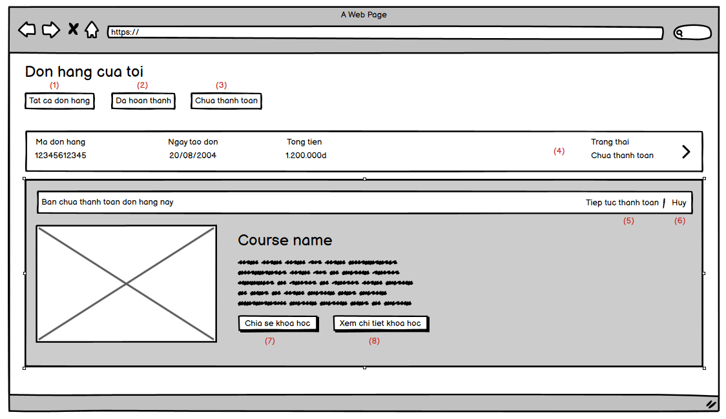

* User can see all their orders which are paid or pending for paying. The order only valid for 15 minutes, if expired, the order cannot be pay. The system will automatically delete all expired orders each 15 minutes.
* The user can see all courses in the order, see some details of that course.

| **No** | **Field** | **Description/Function of field** |
| --- | --- | --- |
| 01 | All orders button | Get all user orders that are not expired |
| 02 | Completed orders button | Get all user completed orders |
| 03 | Pending orders button | Get all pending orders and not expired |
| 04 | Order accordion | When click, show all the course of order |
| 05 | Continue button | Router user to the vn pay payment page to continue pay for the order |
| 06 | Cancel button | On click, delete the order, if the order contains a coupon, return the coupon (user count - 1) |
| 07 | Share button | Show the link of course to share to others |
| 08 | View details of course | Go to the course details page |

## 

## 52. Experts List (User)

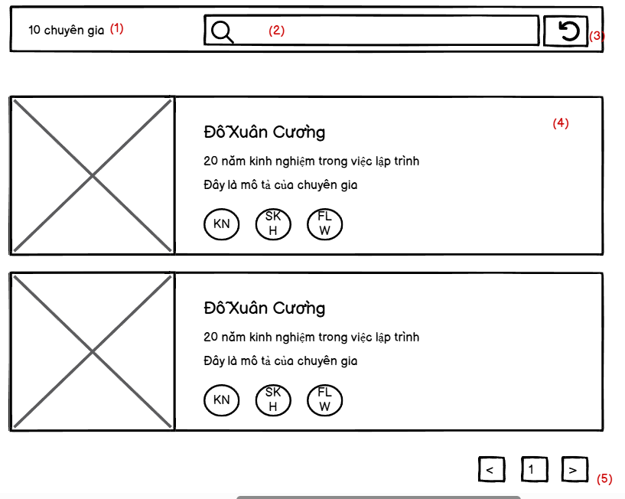

* User can see all the list of expert in the system with expert’s information including name, experience years, number of courses, followers and description..

| **No** | **Field** | **Description/Function of field** |
| --- | --- | --- |
| 01 | Number of current record | Show the number of records. |
| 02 | Search bar | Input keyword to search expert by name, description |
| 03 | Refresh button | Refresh all the field search |
| 04 | Expert information | Show expert’s information including name, experience years, number of courses, followers and description.. |

## 

## 53. My following experts (User)

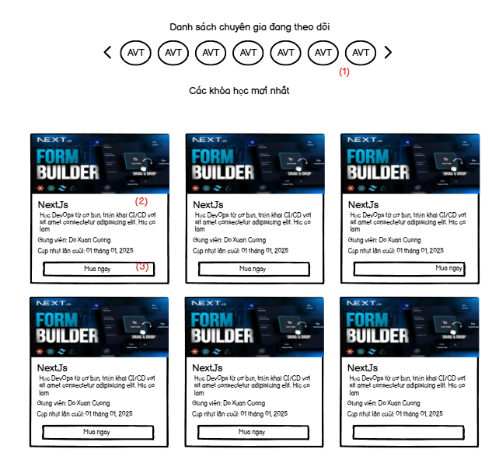

* This page allows students to view their following expert list.
* Students can view the top 12 latest courses of the expert who they followed.
* Students can view the information of invoice like invoice code, create date, total amount, status.
* Students can click on the “Mua ngay” button to buy the course.

| **No** | **Field** | **Description/Function of field** |
| --- | --- | --- |
| 01 | List following experts | Students can view their following experts |
| 02 | Course’s information | Students can view the information of course like thumbnail, name, description, … |
| 03 | “Mua ngay” button | Students can click on this button to buy the course if they still have not bought this course. |

## 

## 54. My courses (User)

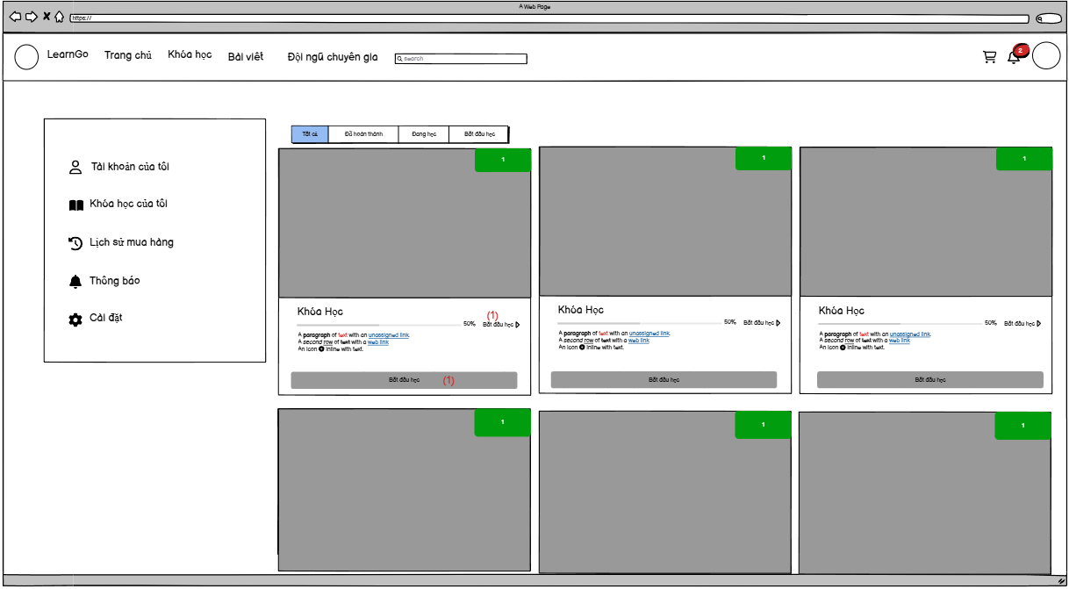

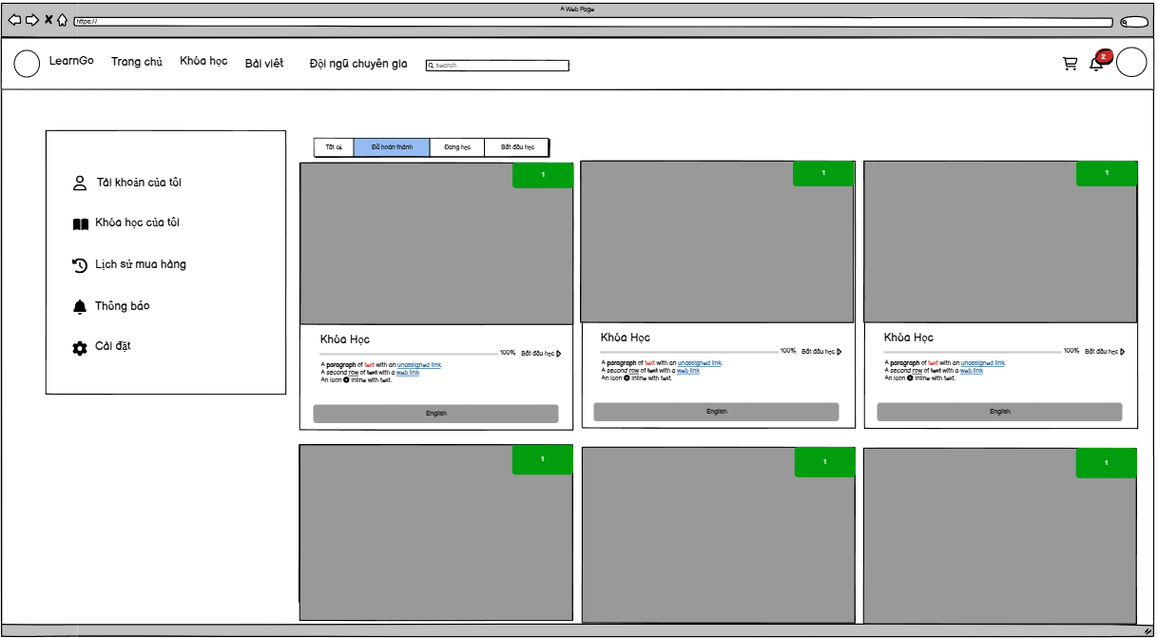

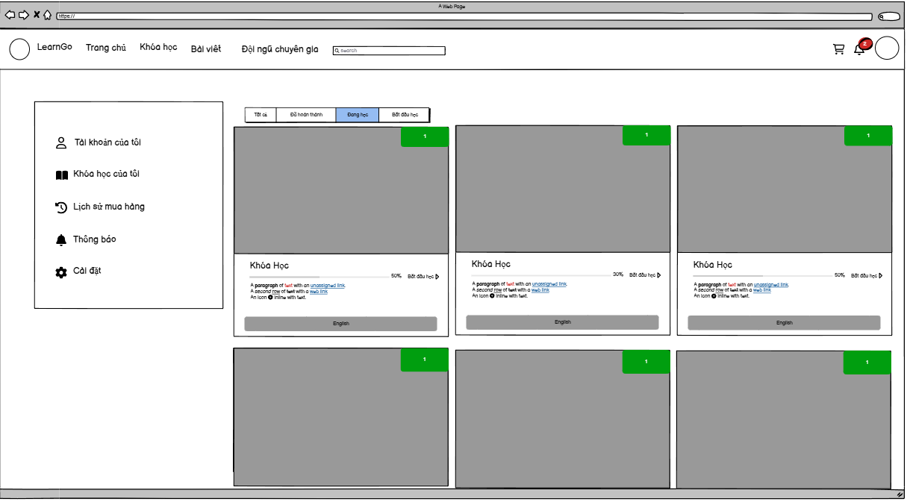

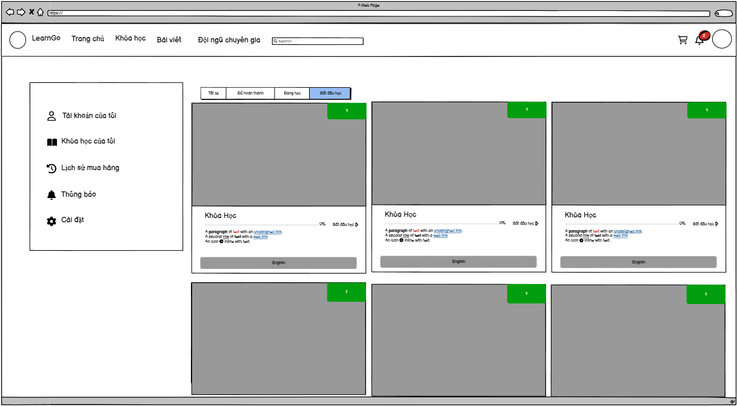

* Course Filter: Users can filter courses by status: All, Completed, In Progress, Starting to Learn
* Course List: Each course is displayed as a card with a large representative image, progress status is displayed as a percentage of completion, each course has a "Start Learning" button to continue the lesson, the language of the course is displayed at the bottom.

| **No** | **Field** | **Description/Function of field** |
| --- | --- | --- |
| 01 | Start course | Users can click to start the course. |

## 

## 55. Course details (admin)

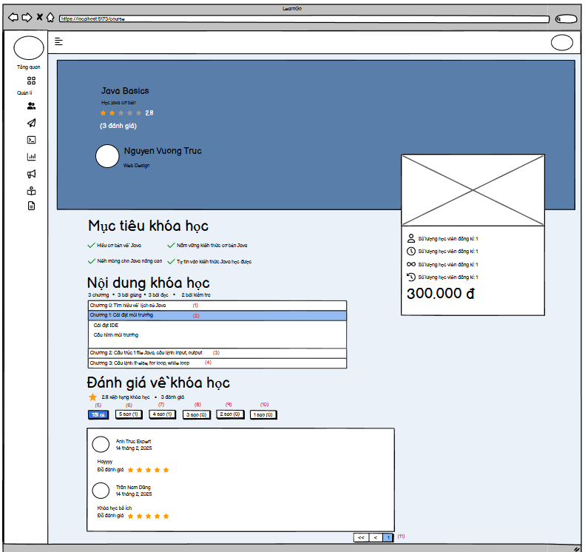

* Admin and expert can see details of course.

## 56. Course coupon (user)

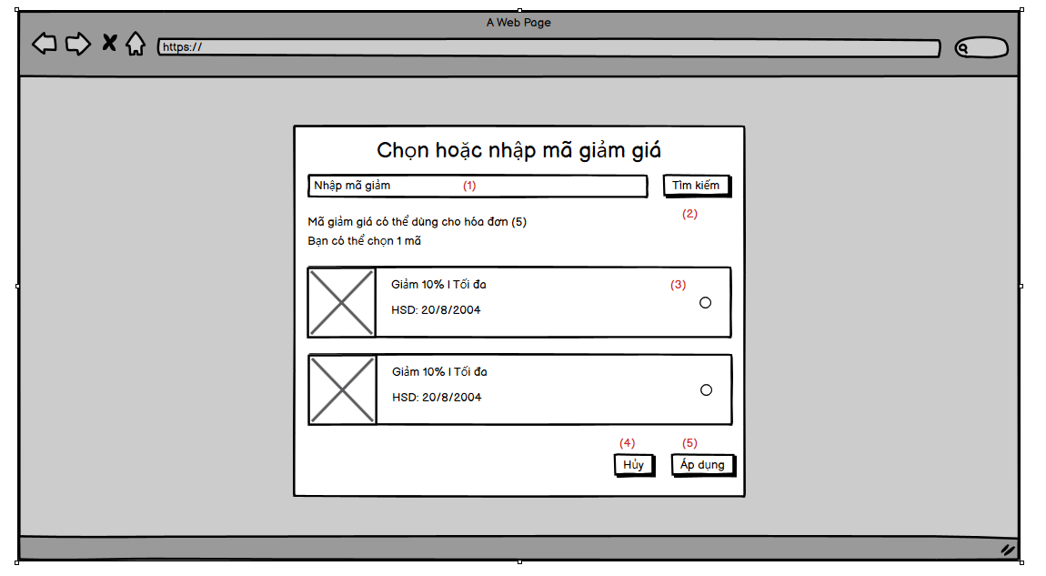

* User can see the list of coupons available for current order, the coupons list is displayed from the most valuable to the least valuable (for example: the coupon sale 10% of the order which total price is 1.500.000d must be place before the coupon sale 100k)
* The user can also search the coupon by the coupon code

| **No** | **Field** | **Description/Function of field** |
| --- | --- | --- |
| 01 | Search input | User can input the coupon code to search |
| 02 | Search button | When hit enter or click this button, search the coupon by the keyword user input |
| 03 | Coupon checkbox | User can click this button to select the coupon to apply, or click again to deselect the coupon |
| 04 | Cancel button | Close the select coupons modal |
| 05 | Apply button | Apply the select coupon (if has) to the order and close the modal |

## 57. List campaign (Admin)

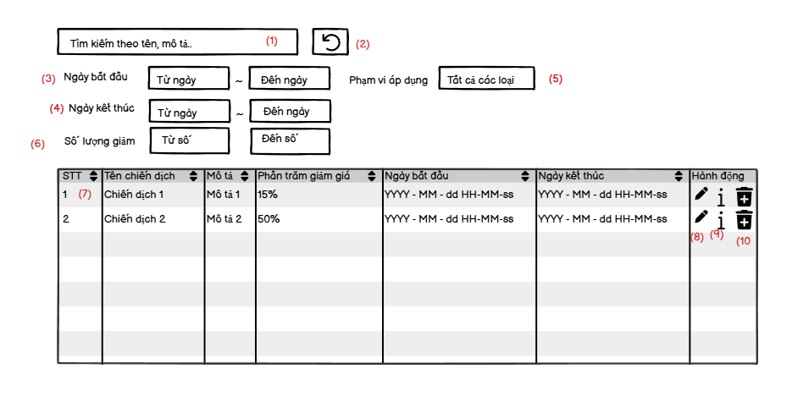

* This page allows Admin/Expert/Marketing to manage the campaign including view all the campaign, search by keyword, filters. They can add a new campaign, update and view detail the campaign
* When they click on the “Pen” icon. The popup screen will be appear to update the campaign
* When they click on the “i” icon. The drawer screen will appear to show the information of the campaign.
* When they click on the “Trash” icon. They can delete the campaign.

| **No** | **Field** | **Description/Function of field** |
| --- | --- | --- |
| 01 | Search bar | Used to search campaign for name, description |
| 02 | Refresh button | Used to refresh all the status |
| 03 | Filter start date | Used to filter the campaign by start date |
| 04 | Filter end date | Used to filter the campaign by end date |
| 05 | Filter applyment range | Used to filter the campaign by applyment range like Alls, All, Course |
| 06 | Filter number of percentage | Used to filter the campaign by number of percentage |
| 07 | Campaign’s information | Show the basic information of the campaign like name, description, percentage, start date, end date. |
| 08 | Update icon | When they click on the “Pen” icon. The popup screen will be appear to update the campaign |
| 09 | Update icon | When they click on the “i” icon. The drawer screen will appear to show the information of the campaign. |
| 10 | Delete icon | When they click on the “Trash” icon. They can delete the campaign. |

## 58. Adding campaign (Admin)

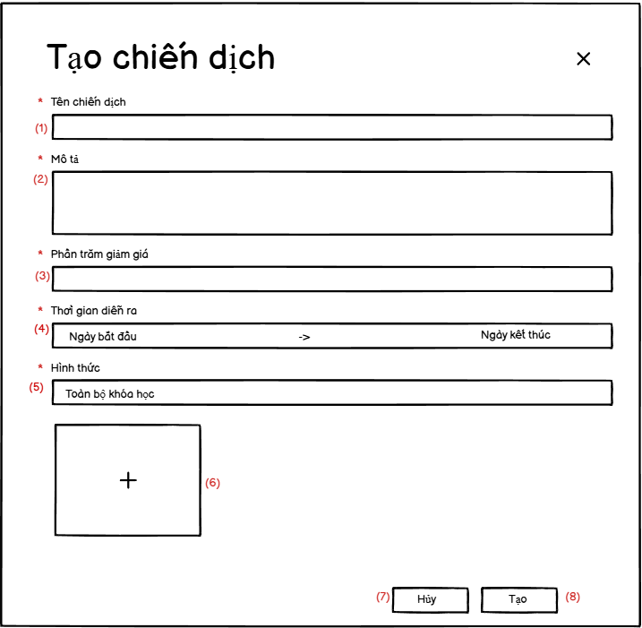

* This page allows Admin/Expert/Marketing to add the new campaign by inputting name, description, percentage, time, range and thumbnail.

| **No** | **Field** | **Description/Function of field** |
| --- | --- | --- |
| 01 | Name input | Input name of campaign |
| 02 | Description input | Input description of campaign |
| 03 | Percentage input | Input Percentage of campaign |
| 04 | Time range input | Input Time range of campaign |
| 05 | range applyment | Input range applyment of campaign |
| 06 | thumbnail | Input thumbnail of campaign |
| 07 | Cancel button | Cancel the create process |
| 08 | Create button | Finish create process |

## 59. Show campaign’s information (Admin)

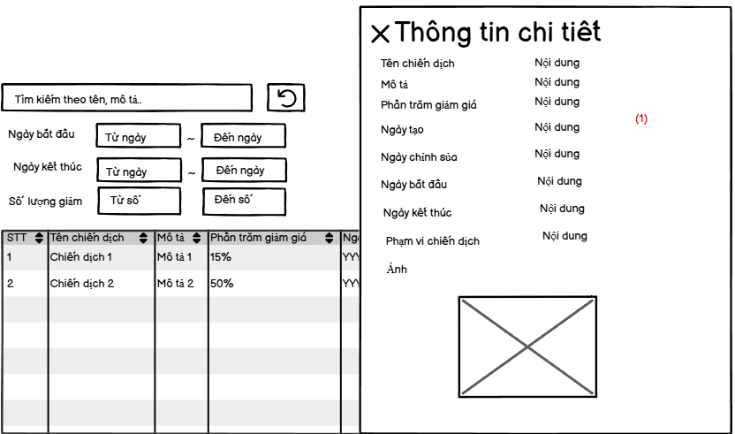

* This page allows Admin/Expert/Marketing to view detail information of campaign including name, description, percentage, create date, update date, start date, end date, range and thumbnail

| **No** | **Field** | **Description/Function of field** |
| --- | --- | --- |
| 01 | Campaign information | Show the detailed information of campaign including name, description, percentage, create date, update date, start date, end date, range and thumbnail |

## 60. Updating campaign (Admin)

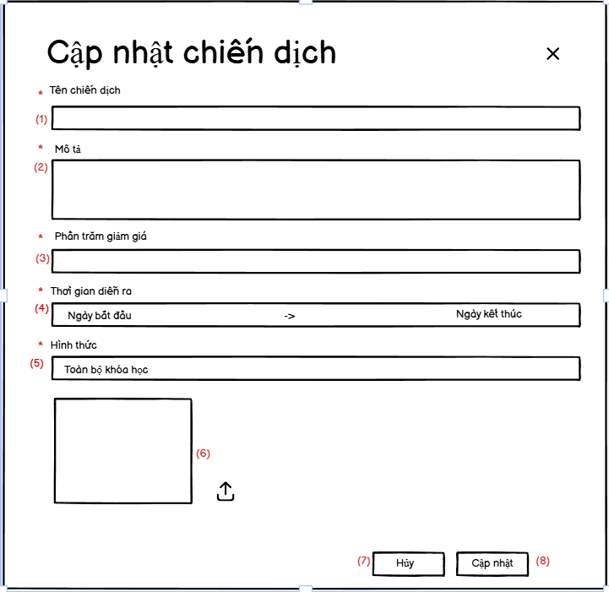

* This page allows Admin/Expert/Marketing to update the new campaign by inputting name, description, percentage, time, range and thumbnail.

| **No** | **Field** | **Description/Function of field** |
| --- | --- | --- |
| 01 | Name input | Input name of campaign |
| 02 | Description input | Input description of campaign |
| 03 | Percentage input | Input Percentage of campaign |
| 04 | Time range input | Input Time range of campaign |
| 05 | range applyment | Input range applyment of campaign |
| 06 | thumbnail | Input thumbnail of campaign |
| 07 | Cancel button | Cancel the update process |
| 08 | Update button | Finish updateprocess |

## 

# III. System Design

## 1. Database Design

### 1.1 ERD Diagrams

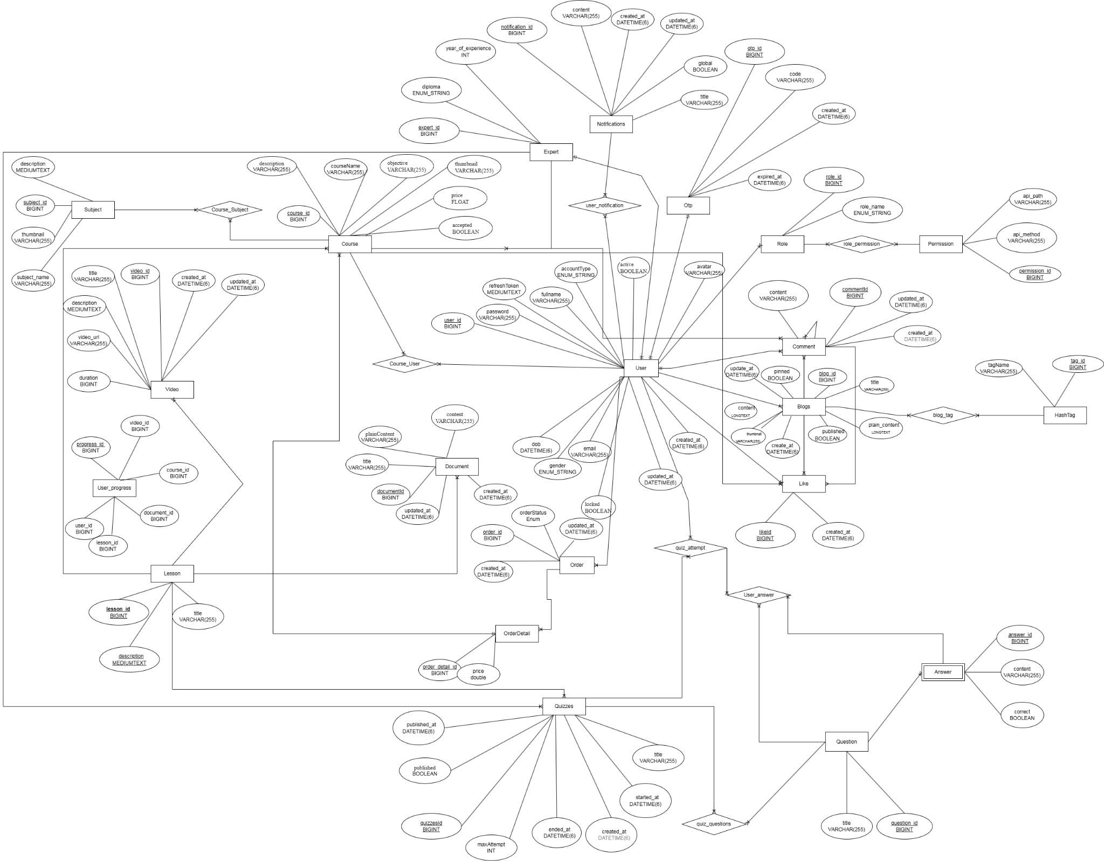

<https://app.diagrams.net/#G1R2o8y6Xk8oA0G3jE9W31oqjXf_lMbqLT#%7B%22pageId%22%3A%22R2lEEEUBdFMjLlhIrx00%22%7D>

### 1.2 Database Diagrams

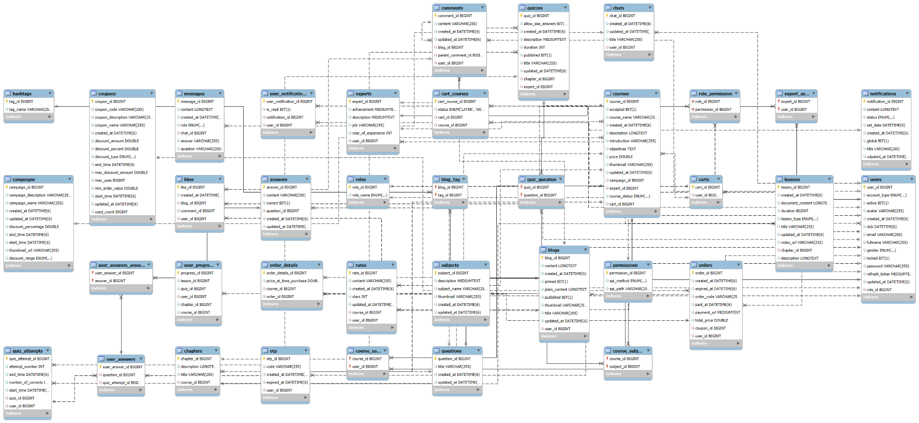

### 1.3 Table Descriptions

| **#** | **Entity** | **Description** |
| --- | --- | --- |
| 1 | answers | `answer_id` bigint NOT NULL AUTO_INCREMENT,  `content` varchar(255) DEFAULT NULL,  `correct` bit(1) DEFAULT NULL,  `question_id` bigint DEFAULT NULL,  `created_at` datetime(6) DEFAULT NULL,  `updated_at` datetime(6) DEFAULT NULL,  PRIMARY KEY (`answer_id`),  KEY `FK3erw1a3t0r78st8ty27x6v3g1` (`question_id`),  CONSTRAINT `FK3erw1a3t0r78st8ty27x6v3g1` FOREIGN KEY (`question_id`) REFERENCES `questions` (`question_id`) |
| 2 | blog_tag | `blog_id` bigint NOT NULL,  `tag_id` bigint NOT NULL,  PRIMARY KEY (`blog_id`,`tag_id`),  KEY `FK3c6t9f1bjwx4qic9vwi0kbqos` (`tag_id`),  CONSTRAINT `FK3c6t9f1bjwx4qic9vwi0kbqos` FOREIGN KEY (`tag_id`) REFERENCES `hashtags` (`tag_id`),  CONSTRAINT `FKdl2hedc2u6i0kw0q5lg31ipmw` FOREIGN KEY (`blog_id`) REFERENCES `blogs` (`blog_id`) |
| 3 | blogs | `blog_id` bigint NOT NULL AUTO_INCREMENT,  `content` longtext,  `created_at` datetime(6) DEFAULT NULL,  `pinned` bit(1) DEFAULT NULL,  `plain_content` longtext,  `published` bit(1) DEFAULT NULL,  `thumbnail` varchar(255) DEFAULT NULL,  `title` varchar(255) DEFAULT NULL,  `updated_at` datetime(6) DEFAULT NULL,  `user_id` bigint DEFAULT NULL,  PRIMARY KEY (`blog_id`),  KEY `FKpg4damav6db6a6fh5peylcni5` (`user_id`),  CONSTRAINT `FKpg4damav6db6a6fh5peylcni5` FOREIGN KEY (`user_id`) REFERENCES `users` (`user_id`) |
| 4 | campaigns | `campaign_id` bigint NOT NULL AUTO_INCREMENT,  `campaign_description` varchar(255) DEFAULT NULL,  `campaign_name` varchar(255) DEFAULT NULL,  `created_at` datetime(6) DEFAULT NULL,  `updated_at` datetime(6) DEFAULT NULL,  `discount_percentage` double DEFAULT NULL,  `end_time` datetime(6) DEFAULT NULL,  `start_time` datetime(6) DEFAULT NULL,  `thumbnail_url` varchar(255) DEFAULT NULL,  `discount_range` enum('ALL','COURSES') DEFAULT NULL,  PRIMARY KEY (`campaign_id`) |
| 5 | cart_courses | `cart_course_id` bigint NOT NULL AUTO_INCREMENT,  `status` enum('LATER','NOW') DEFAULT NULL,  `cart_id` bigint DEFAULT NULL,  `course_id` bigint DEFAULT NULL,  PRIMARY KEY (`cart_course_id`),  KEY `FK5ungrehmiuancpo0t49d1w0ln` (`cart_id`),  KEY `FKsqi9btt9o3wa75exnrxgergyf` (`course_id`),  CONSTRAINT `FK5ungrehmiuancpo0t49d1w0ln` FOREIGN KEY (`cart_id`) REFERENCES `carts` (`cart_id`),  CONSTRAINT `FKsqi9btt9o3wa75exnrxgergyf` FOREIGN KEY (`course_id`) REFERENCES `courses` (`course_id`) |
| 6 | carts | `cart_id` bigint NOT NULL AUTO_INCREMENT,  `user_id` bigint DEFAULT NULL,  PRIMARY KEY (`cart_id`),  UNIQUE KEY `UK64t7ox312pqal3p7fg9o503c2` (`user_id`),  CONSTRAINT `FKb5o626f86h46m4s7ms6ginnop` FOREIGN KEY (`user_id`) REFERENCES `users` (`user_id`) |
| 7 | chapters | `chapter_id` bigint NOT NULL AUTO_INCREMENT,  `description` longtext,  `title` varchar(255) DEFAULT NULL,  `course_id` bigint DEFAULT NULL,  PRIMARY KEY (`chapter_id`),  KEY `FK6h1m0nrtdwj37570c0sp2tdcs` (`course_id`),  CONSTRAINT `FK6h1m0nrtdwj37570c0sp2tdcs` FOREIGN KEY (`course_id`) REFERENCES `courses` (`course_id`) |
| 8 | chats | `chat_id` bigint NOT NULL AUTO_INCREMENT,  `created_at` datetime(6) DEFAULT NULL,  `updated_at` datetime(6) DEFAULT NULL,  `title` varchar(255) DEFAULT NULL,  `user_id` bigint DEFAULT NULL,  PRIMARY KEY (`chat_id`),  KEY `FKmolqi1xj49bg3jjr33674limy` (`user_id`),  CONSTRAINT `FKmolqi1xj49bg3jjr33674limy` FOREIGN KEY (`user_id`) REFERENCES `users` (`user_id`) |
| 9 | comments | `comment_id` bigint NOT NULL AUTO_INCREMENT,  `content` varchar(255) DEFAULT NULL,  `created_at` datetime(6) DEFAULT NULL,  `updated_at` datetime(6) DEFAULT NULL,  `blog_id` bigint DEFAULT NULL,  `parent_comment_id` bigint DEFAULT NULL,  `user_id` bigint DEFAULT NULL,  PRIMARY KEY (`comment_id`),  KEY `FK9aakob3a7aghrm94k9kmbrjqd` (`blog_id`),  KEY `FK7h839m3lkvhbyv3bcdv7sm4fj` (`parent_comment_id`),  KEY `FK8omq0tc18jd43bu5tjh6jvraq` (`user_id`),  CONSTRAINT `FK7h839m3lkvhbyv3bcdv7sm4fj` FOREIGN KEY (`parent_comment_id`) REFERENCES `comments` (`comment_id`),  CONSTRAINT `FK8omq0tc18jd43bu5tjh6jvraq` FOREIGN KEY (`user_id`) REFERENCES `users` (`user_id`),  CONSTRAINT `FK9aakob3a7aghrm94k9kmbrjqd` FOREIGN KEY (`blog_id`) REFERENCES `blogs` (`blog_id`) |
| 10 | coupons | `coupon_id` bigint NOT NULL AUTO_INCREMENT,  `coupon_code` varchar(255) DEFAULT NULL,  `coupon_description` varchar(255) DEFAULT NULL,  `coupon_name` varchar(255) DEFAULT NULL,  `created_at` datetime(6) DEFAULT NULL,  `discount_amount` double DEFAULT NULL,  `discount_percent` double DEFAULT NULL,  `discount_type` enum('FIXED','PERCENTAGE') DEFAULT NULL,  `end_time` datetime(6) DEFAULT NULL,  `max_discount_amount` double DEFAULT NULL,  `max_uses` bigint DEFAULT NULL,  `min_order_value` double DEFAULT NULL,  `start_time` datetime(6) DEFAULT NULL,  `updated_at` datetime(6) DEFAULT NULL,  `used_count` bigint DEFAULT NULL,  PRIMARY KEY (`coupon_id`) |
| 11 | course_user | `course_id` bigint NOT NULL,  `user_id` bigint NOT NULL,  PRIMARY KEY (`course_id`,`user_id`),  KEY `FKf2f9pdami9tgornv4vld7pfea` (`user_id`),  CONSTRAINT `FK8lwf41pgqkmlkfvklvf22pmcb` FOREIGN KEY (`course_id`) REFERENCES `courses` (`course_id`),  CONSTRAINT `FKf2f9pdami9tgornv4vld7pfea` FOREIGN KEY (`user_id`) REFERENCES `users` (`user_id`) |
| 12 | course_subject | `course_id` bigint NOT NULL,  `subject_id` bigint NOT NULL,  PRIMARY KEY (`course_id`,`subject_id`),  KEY `FKdgqvcdk05rc11txucpjrqai5n` (`subject_id`),  CONSTRAINT `FKdgqvcdk05rc11txucpjrqai5n` FOREIGN KEY (`subject_id`) REFERENCES `subjects` (`subject_id`),  CONSTRAINT `FKq0h1llihdiqg9ak6xhntlgyk1` FOREIGN KEY (`course_id`) REFERENCES `courses` (`course_id`) |
| 13 | courses | `course_id` bigint NOT NULL AUTO_INCREMENT,  `accepted` bit(1) DEFAULT NULL,  `course_name` varchar(255) DEFAULT NULL,  `created_at` datetime(6) DEFAULT NULL,  `description` longtext,  `introduction` varchar(255) DEFAULT NULL,  `objectives` text,  `price` double DEFAULT NULL,  `thumbnail` varchar(255) DEFAULT NULL,  `updated_at` datetime(6) DEFAULT NULL,  `campaign_id` bigint DEFAULT NULL,  `expert_id` bigint DEFAULT NULL,  `course_status` enum('DRAFT','PROCESSING','REJECT','SUCCESS') DEFAULT NULL,  `cart_id` bigint DEFAULT NULL,  PRIMARY KEY (`course_id`),  KEY `FK7l13d4e1nvy06049rlobu4wq8` (`campaign_id`),  KEY `FKaog0x4gdi738saifl8upy44sb` (`expert_id`),  KEY `FKb60up8k0778lggpd5ykw21kfi` (`cart_id`),  CONSTRAINT `FK7l13d4e1nvy06049rlobu4wq8` FOREIGN KEY (`campaign_id`) REFERENCES `campaigns` (`campaign_id`),  CONSTRAINT `FKaog0x4gdi738saifl8upy44sb` FOREIGN KEY (`expert_id`) REFERENCES `experts` (`expert_id`),  CONSTRAINT `FKb60up8k0778lggpd5ykw21kfi` FOREIGN KEY (`cart_id`) REFERENCES `carts` (`cart_id`) |
| 14 | expert_user | `expert_id` bigint NOT NULL,  `user_id` bigint NOT NULL,  PRIMARY KEY (`expert_id`,`user_id`),  KEY `FK27s6rcj7h83qrn59yipsmi23k` (`user_id`),  CONSTRAINT `FK27s6rcj7h83qrn59yipsmi23k` FOREIGN KEY (`user_id`) REFERENCES `users` (`user_id`),  CONSTRAINT `FKn4dtwbtnefruftss8p21v96aj` FOREIGN KEY (`expert_id`) REFERENCES `experts` (`expert_id`) |
| 15 | experts | `expert_id` bigint NOT NULL AUTO_INCREMENT,  `achievement` mediumtext,  `description` mediumtext,  `job` varchar(255) DEFAULT NULL,  `year_of_experience` int DEFAULT NULL,  `user_id` bigint DEFAULT NULL,  PRIMARY KEY (`expert_id`),  UNIQUE KEY `UK66kp2njuac7qdaov6pocl0896` (`user_id`),  CONSTRAINT `FK5os9nnfapw3vwad4yac038kvk` FOREIGN KEY (`user_id`) REFERENCES `users` (`user_id`) |
| 16 | hashtags | `tag_id` bigint NOT NULL AUTO_INCREMENT,  `tag_name` varchar(255) DEFAULT NULL,  PRIMARY KEY (`tag_id`) |
| 17 | lessons | `lesson_id` bigint NOT NULL AUTO_INCREMENT,  `created_at` datetime(6) DEFAULT NULL,  `document_content` longtext,  `duration` bigint DEFAULT NULL,  `lesson_type` enum('DOCUMENT','VIDEO') DEFAULT NULL,  `title` varchar(255) DEFAULT NULL,  `updated_at` datetime(6) DEFAULT NULL,  `video_url` varchar(255) DEFAULT NULL,  `chapter_id` bigint DEFAULT NULL,  `description` longtext,  PRIMARY KEY (`lesson_id`),  KEY `FKmb78vk1f2oljr16oj1hpo45ma` (`chapter_id`),  CONSTRAINT `FKmb78vk1f2oljr16oj1hpo45ma` FOREIGN KEY (`chapter_id`) REFERENCES `chapters` (`chapter_id`) |
| 18 | likes | `like_id` bigint NOT NULL AUTO_INCREMENT,  `created_at` datetime(6) DEFAULT NULL,  `blog_id` bigint DEFAULT NULL,  `comment_id` bigint DEFAULT NULL,  `user_id` bigint DEFAULT NULL,  PRIMARY KEY (`like_id`),  KEY `FKl0jvfq4a7glp0xeuhd8hm05yt` (`blog_id`),  KEY `FKe4guax66lb963pf27kvm7ikik` (`comment_id`),  KEY `FKnvx9seeqqyy71bij291pwiwrg` (`user_id`),  CONSTRAINT `FKe4guax66lb963pf27kvm7ikik` FOREIGN KEY (`comment_id`) REFERENCES `comments` (`comment_id`),  CONSTRAINT `FKl0jvfq4a7glp0xeuhd8hm05yt` FOREIGN KEY (`blog_id`) REFERENCES `blogs` (`blog_id`),  CONSTRAINT `FKnvx9seeqqyy71bij291pwiwrg` FOREIGN KEY (`user_id`) REFERENCES `users` (`user_id`) |
| 19 | messages | `message_id` bigint NOT NULL AUTO_INCREMENT,  `content` longtext,  `created_at` datetime(6) DEFAULT NULL,  `role` enum('FUNCTION','MODEL','SYSTEM','USER') DEFAULT NULL,  `chat_id` bigint DEFAULT NULL,  `answer` varchar(255) DEFAULT NULL,  `question` varchar(255) DEFAULT NULL,  PRIMARY KEY (`message_id`),  KEY `FK64w44ngcpqp99ptcb9werdfmb` (`chat_id`),  CONSTRAINT `FK64w44ngcpqp99ptcb9werdfmb` FOREIGN KEY (`chat_id`) REFERENCES `chats` (`chat_id`) |
| 20 | notifications | `notification_id` bigint NOT NULL AUTO_INCREMENT,  `content` longtext,  `status` enum('PENDING','SENT') DEFAULT NULL,  `set_date` datetime(6) DEFAULT NULL,  `created_at` datetime(6) DEFAULT NULL,  `global` bit(1) DEFAULT NULL,  `title` varchar(255) DEFAULT NULL,  `udpated_at` datetime(6) DEFAULT NULL,  PRIMARY KEY (`notification_id`) |
| 21 | order_details | `order_details_id` bigint NOT NULL AUTO_INCREMENT,  `price_at_time_purchase` double DEFAULT NULL,  `course_id` bigint DEFAULT NULL,  `order_id` bigint DEFAULT NULL,  PRIMARY KEY (`order_details_id`),  KEY `FKtc2uxybe6r9ak6sd66whjd27` (`course_id`),  KEY `FKjyu2qbqt8gnvno9oe9j2s2ldk` (`order_id`),  CONSTRAINT `FKjyu2qbqt8gnvno9oe9j2s2ldk` FOREIGN KEY (`order_id`) REFERENCES `orders` (`order_id`),  CONSTRAINT `FKtc2uxybe6r9ak6sd66whjd27` FOREIGN KEY (`course_id`) REFERENCES `courses` (`course_id`) |
| 22 | orders | `order_id` bigint NOT NULL AUTO_INCREMENT,  `created_at` datetime(6) DEFAULT NULL,  `expired_at` datetime(6) DEFAULT NULL,  `order_code` varchar(255) DEFAULT NULL,  `paid_at` datetime(6) DEFAULT NULL,  `payment_url` mediumtext,  `total_price` double DEFAULT NULL,  `coupon_id` bigint DEFAULT NULL,  `user_id` bigint DEFAULT NULL,  PRIMARY KEY (`order_id`),  KEY `FKn1d1gkxckw648m2n2d5gx0yx5` (`coupon_id`),  KEY `FK32ql8ubntj5uh44ph9659tiih` (`user_id`),  CONSTRAINT `FK32ql8ubntj5uh44ph9659tiih` FOREIGN KEY (`user_id`) REFERENCES `users` (`user_id`),  CONSTRAINT `FKn1d1gkxckw648m2n2d5gx0yx5` FOREIGN KEY (`coupon_id`) REFERENCES `coupons` (`coupon_id`) |
| 23 | otp | `otp_id` bigint NOT NULL AUTO_INCREMENT,  `code` varchar(255) DEFAULT NULL,  `created_at` datetime(6) DEFAULT NULL,  `expired_at` datetime(6) DEFAULT NULL,  `user_id` bigint DEFAULT NULL,  PRIMARY KEY (`otp_id`),  UNIQUE KEY `UK4mkxc1wpojj1vymcvurokktwm` (`user_id`),  CONSTRAINT `FKs0hlsjury48cekfbfusk11lyr` FOREIGN KEY (`user_id`) REFERENCES `users` (`user_id`) |
| 24 | permissions | `permission_id` bigint NOT NULL AUTO_INCREMENT,  `api_method` enum('DELETE','GET','PATCH','POST','PUT') DEFAULT NULL,  `api_path` varchar(255) DEFAULT NULL,  PRIMARY KEY (`permission_id`) |
| 25 | questions | `question_id` bigint NOT NULL AUTO_INCREMENT,  `title` varchar(255) DEFAULT NULL,  `created_at` datetime(6) DEFAULT NULL,  `updated_at` datetime(6) DEFAULT NULL,  PRIMARY KEY (`question_id`) |
| 26 | quiz_attempts | `quiz_attempt_id` bigint NOT NULL AUTO_INCREMENT,  `attempt_number` int DEFAULT NULL,  `end_time` datetime(6) DEFAULT NULL,  `number_of_corrects` int DEFAULT NULL,  `start_time` datetime(6) DEFAULT NULL,  `quiz_id` bigint DEFAULT NULL,  `user_id` bigint DEFAULT NULL,  PRIMARY KEY (`quiz_attempt_id`),  KEY `FKfwipvfipnnwsoacoyv5k7fbxc` (`quiz_id`),  KEY `FKpj4a9hw0iv1mo1ut6rppg594u` (`user_id`),  CONSTRAINT `FKfwipvfipnnwsoacoyv5k7fbxc` FOREIGN KEY (`quiz_id`) REFERENCES `quizzes` (`quiz_id`),  CONSTRAINT `FKpj4a9hw0iv1mo1ut6rppg594u` FOREIGN KEY (`user_id`) REFERENCES `users` (`user_id`) |
| 27 | quiz_question | `quiz_id` bigint NOT NULL,  `question_id` bigint NOT NULL,  PRIMARY KEY (`quiz_id`,`question_id`),  KEY `FKqeltu3y1r2onimmphk1s8eirs` (`question_id`),  CONSTRAINT `FKkf4iskp1r4oogyx3cikwdj0i0` FOREIGN KEY (`quiz_id`) REFERENCES `quizzes` (`quiz_id`),  CONSTRAINT `FKqeltu3y1r2onimmphk1s8eirs` FOREIGN KEY (`question_id`) REFERENCES `questions` (`question_id`) |
| 28 | quizzes | `quiz_id` bigint NOT NULL AUTO_INCREMENT,  `allow_see_answers` bit(1) DEFAULT NULL,  `created_at` datetime(6) DEFAULT NULL,  `description` mediumtext,  `duration` int DEFAULT NULL,  `published` bit(1) DEFAULT NULL,  `title` varchar(255) DEFAULT NULL,  `updated_at` datetime(6) DEFAULT NULL,  `chapter_id` bigint DEFAULT NULL,  `expert_id` bigint DEFAULT NULL,  PRIMARY KEY (`quiz_id`),  UNIQUE KEY `UK8t7yvf83h97wti5y48pouog65` (`chapter_id`),  KEY `FKjn5yj81ek8yx2s07hkje2wd98` (`expert_id`),  CONSTRAINT `FKbfcxv33pl1gl32wie5nobns7r` FOREIGN KEY (`chapter_id`) REFERENCES `chapters` (`chapter_id`),  CONSTRAINT `FKjn5yj81ek8yx2s07hkje2wd98` FOREIGN KEY (`expert_id`) REFERENCES `experts` (`expert_id`) |
| 29 | rates | `rate_id` bigint NOT NULL AUTO_INCREMENT,  `content` varchar(255) DEFAULT NULL,  `created_at` datetime(6) DEFAULT NULL,  `stars` int DEFAULT NULL,  `updated_at` datetime(6) DEFAULT NULL,  `course_id` bigint DEFAULT NULL,  `user_id` bigint DEFAULT NULL,  PRIMARY KEY (`rate_id`),  KEY `FKt5wuc6askynohbdaqeaj5wjeq` (`course_id`),  KEY `FKanlgavwqngljux10mtly8qr6f` (`user_id`),  CONSTRAINT `FKanlgavwqngljux10mtly8qr6f` FOREIGN KEY (`user_id`) REFERENCES `users` (`user_id`),  CONSTRAINT `FKt5wuc6askynohbdaqeaj5wjeq` FOREIGN KEY (`course_id`) REFERENCES `courses` (`course_id`) |
| 30 | role_permission | `role_id` bigint NOT NULL,  `permission_id` bigint NOT NULL,  KEY `FK2xn8qv4vw30i04xdxrpvn3bdi` (`permission_id`),  KEY `FKtfgq8q9blrp0pt1pvggyli3v9` (`role_id`),  CONSTRAINT `FK2xn8qv4vw30i04xdxrpvn3bdi` FOREIGN KEY (`permission_id`) REFERENCES `permissions` (`permission_id`),  CONSTRAINT `FKtfgq8q9blrp0pt1pvggyli3v9` FOREIGN KEY (`role_id`) REFERENCES `roles` (`role_id`) |
| 31 | roles | `role_id` bigint NOT NULL AUTO_INCREMENT,  `role_name` enum('ADMIN','EXPERT','MARKETING','USER') DEFAULT NULL,  PRIMARY KEY (`role_id`) |
| 32 | subjects | `subject_id` bigint NOT NULL AUTO_INCREMENT,  `description` mediumtext,  `subject_name` varchar(255) DEFAULT NULL,  `thumbnail` varchar(255) DEFAULT NULL,  `created_at` datetime(6) DEFAULT NULL,  `updated_at` datetime(6) DEFAULT NULL,  PRIMARY KEY (`subject_id`) |
| 33 | user_answers_answer | `user_answer_id` bigint NOT NULL,  `answer_id` bigint NOT NULL,  PRIMARY KEY (`user_answer_id`,`answer_id`),  KEY `FKtn33w5vhip5arxeo92e2uag8p` (`answer_id`),  CONSTRAINT `FK1udyf788y6qi8qy7yj4ht8p1i` FOREIGN KEY (`user_answer_id`) REFERENCES `user_answers` (`user_answer_id`) ON DELETE CASCADE,  CONSTRAINT `FKtn33w5vhip5arxeo92e2uag8p` FOREIGN KEY (`answer_id`) REFERENCES `answers` (`answer_id`) |
| 34 | user_notifications | `user_notification_id` bigint NOT NULL AUTO_INCREMENT,  `is_read` bit(1) DEFAULT NULL,  `notification_id` bigint DEFAULT NULL,  `user_id` bigint DEFAULT NULL,  PRIMARY KEY (`user_notification_id`),  KEY `FKovvx0ab3h8s9lrm6fppuadn7d` (`notification_id`),  KEY `FK9f86wonnl11hos1cuf5fibutl` (`user_id`),  CONSTRAINT `FK9f86wonnl11hos1cuf5fibutl` FOREIGN KEY (`user_id`) REFERENCES `users` (`user_id`),  CONSTRAINT `FKovvx0ab3h8s9lrm6fppuadn7d` FOREIGN KEY (`notification_id`) REFERENCES `notifications` (`notification_id`) |
| 35 | user_progress | `progress_id` bigint NOT NULL AUTO_INCREMENT,  `lesson_id` bigint DEFAULT NULL,  `quiz_id` bigint DEFAULT NULL,  `user_id` bigint DEFAULT NULL,  `chapter_id` bigint DEFAULT NULL,  `course_id` bigint DEFAULT NULL,  PRIMARY KEY (`progress_id`),  KEY `FKrt37sneeps21829cuqetjm5ye` (`user_id`),  CONSTRAINT `FKrt37sneeps21829cuqetjm5ye` FOREIGN KEY (`user_id`) REFERENCES `users` (`user_id`) |
| 36 | users | `user_id` bigint NOT NULL AUTO_INCREMENT,  `account_type` enum('CREDENTIALS','GITHUB','GOOGLE') DEFAULT NULL,  `active` bit(1) DEFAULT NULL,  `avatar` varchar(255) DEFAULT NULL,  `created_at` datetime(6) DEFAULT NULL,  `dob` datetime(6) DEFAULT NULL,  `email` varchar(255) DEFAULT NULL,  `fullname` varchar(255) DEFAULT NULL,  `gender` enum('FEMALE','MALE') DEFAULT NULL,  `locked` bit(1) DEFAULT NULL,  `password` varchar(255) DEFAULT NULL,  `refresh_token` mediumtext,  `updated_at` datetime(6) DEFAULT NULL,  `role_id` bigint DEFAULT NULL,  PRIMARY KEY (`user_id`),  KEY `FKp56c1712k691lhsyewcssf40f` (`role_id`),  CONSTRAINT `FKp56c1712k691lhsyewcssf40f` FOREIGN KEY (`role_id`) REFERENCES `roles` (`role_id`) |
| 37 | user_answers | `user_answer_id` bigint NOT NULL AUTO_INCREMENT,  `question_id` bigint DEFAULT NULL,  `quiz_attempt_id` bigint DEFAULT NULL,  PRIMARY KEY (`user_answer_id`),  KEY `FK6b46l4bb7a6wfxvmn6l7ig8vo` (`question_id`),  KEY `FKqy4lhxwoi677jc3u95au6qmxw` (`quiz_attempt_id`),  CONSTRAINT `FK6b46l4bb7a6wfxvmn6l7ig8vo` FOREIGN KEY (`question_id`) REFERENCES `questions` (`question_id`),  CONSTRAINT `FKqy4lhxwoi677jc3u95au6qmxw` FOREIGN KEY (`quiz_attempt_id`) REFERENCES `quiz_attempts` (`quiz_attempt_id`) |

## 2. Code Packages

### 2.1 Package Diagram

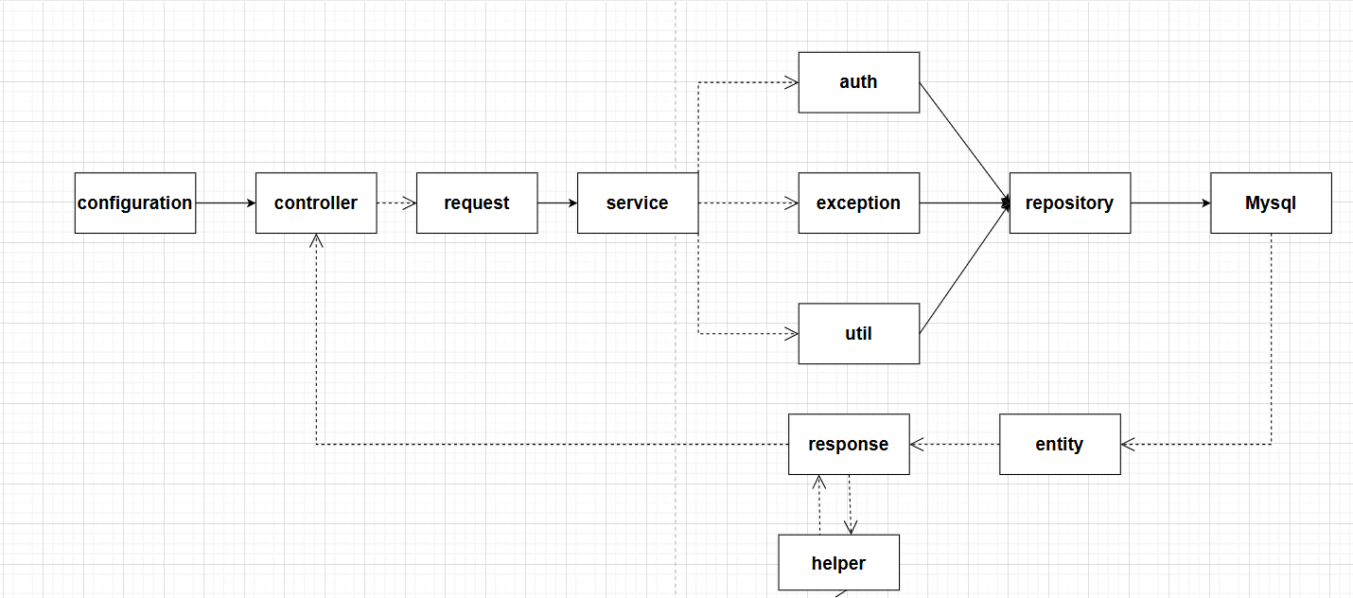

### 2.2 Package Descriptions

| **No** | **Package** | **Description** |
| --- | --- | --- |
| 01 | configuration | configuration include security and interceptor , check that user are valid to go into system or valid permission to go into this link |
| 02 | controller | that redirect user that they have click |
| 03 | request | with crud action, it have send data have request form, it send to service to solve logic |
| 04 | service | that have solve logic of entity |
| 06 | auth | that have authorization and authenticated of user. |
| 07 | exception | give exception before crud into database |
| 08 | util | have some util help to solve logic, change data format |
| 09 | repository | have some SpringDataJpa method to crud with database |
| 10 | mysql | database to manage data |
| 11 | entity | store attribute and method , help database to manage data of objects |
| 12 | response | after save entity into database success, response will format data need to response to view |
| 13 | helper | help response to convert into list of response or a response |